**MA_GBR_0650NAx0200**

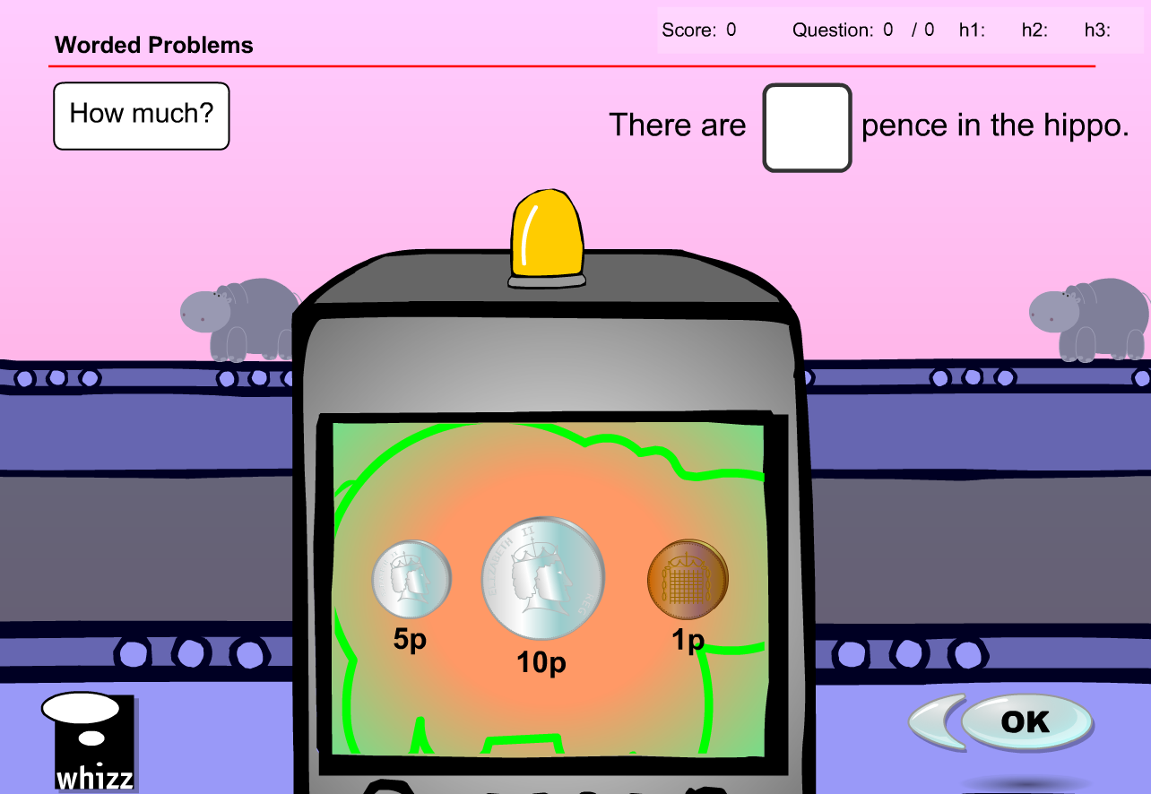

No NZ 1c coin so complete content change required as substituting with coins of different denominations would produce different answers

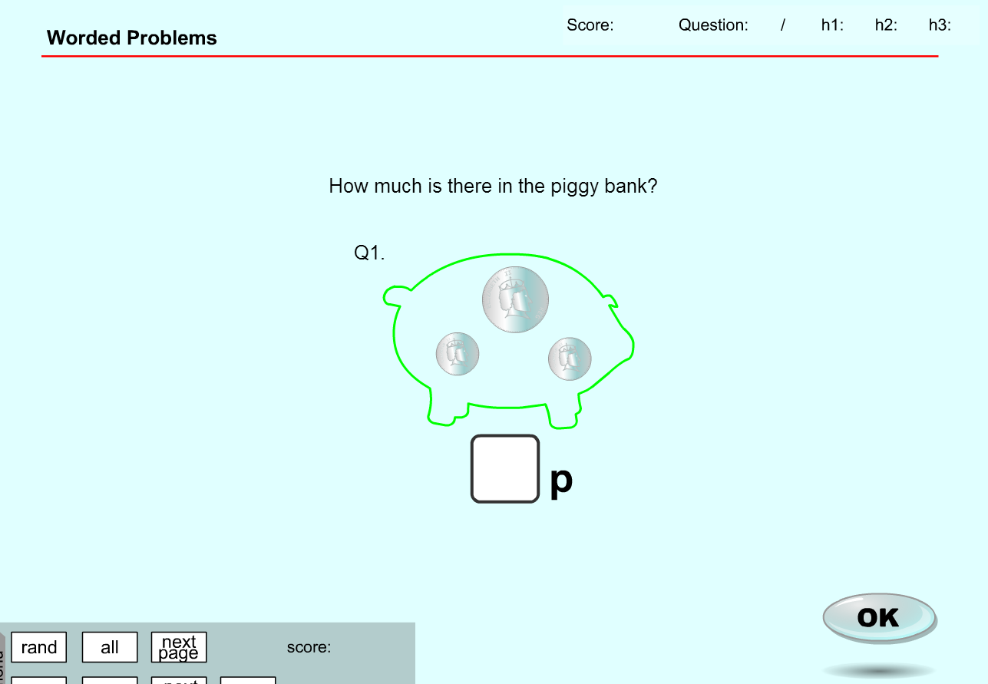

**MA_GBR_0650NAx0200– fixes**

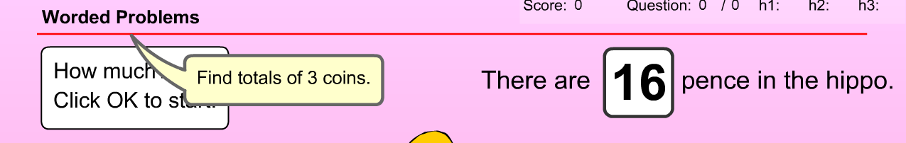

Will need to change the 6 coins (UK currency) to the 5 coins (NZ currency) 10c, 20c, 50c, $1 and $2

Change pence to cents, change ‘p’ to ‘c’

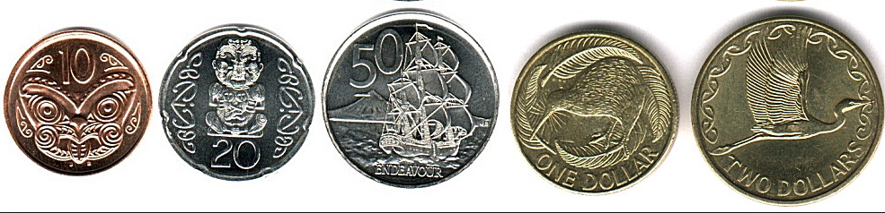

Voiceover needs removal for instructions. Voiceover is fine in the exercise questions.

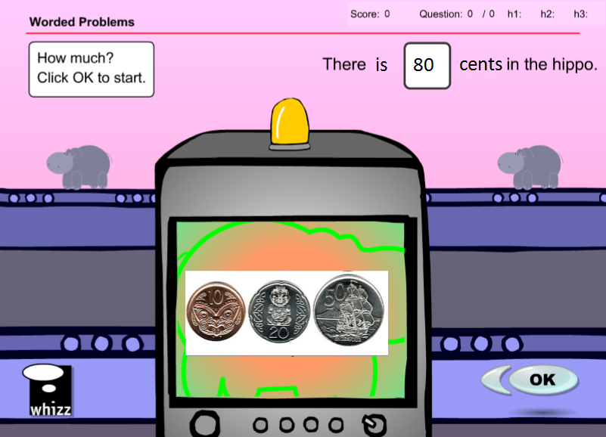

Exercise 1

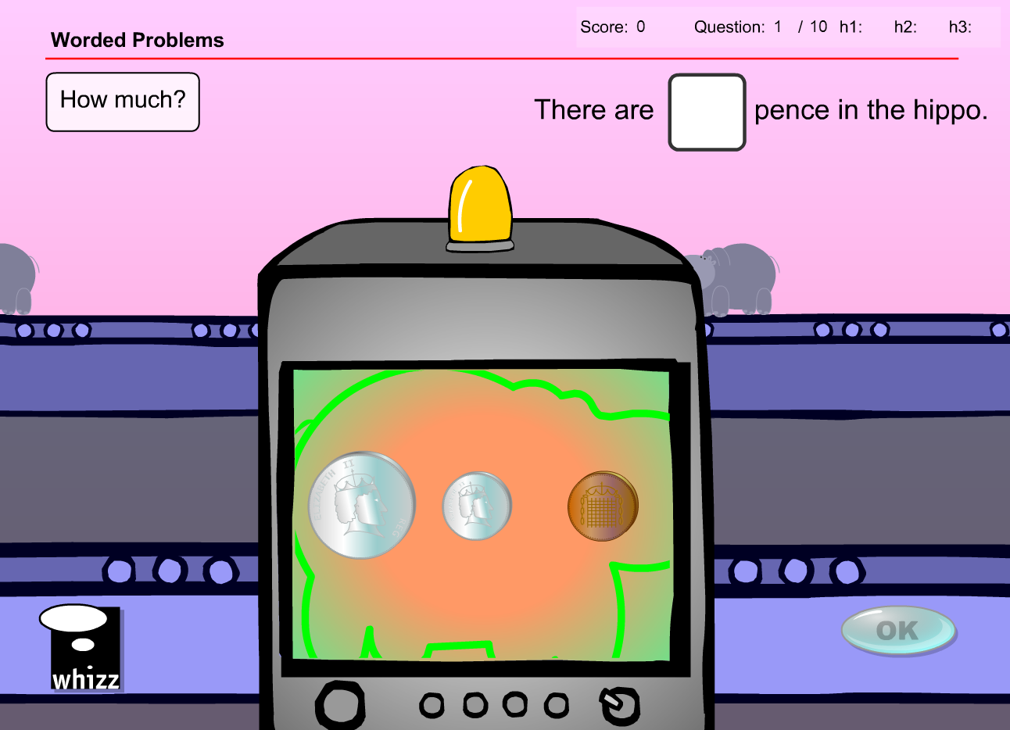

* Replace ‘pence’ with ‘cents’
* Change coins to 1 x 10c, 1 x 20c and 1 x $1
* Change answer to 130c

Exercise 2



* Replace ‘pence’ with ‘cents’
* Change coins to 1 x 10c, 1 x 50c and 1 x $1
* Change answer to 160c

Exercise 3



* Replace ‘pence’ with ‘cents’
* Change coins to 1 x 20c, 1 x 50c and 1 x $1
* Change answer to 170c

Exercise 4



* Replace ‘pence’ with ‘cents’
* Change coins to 1 x 10c, 1 x 20c and 1 x 50c
* Change answer to 80c

Exercise 5



* Replace ‘pence’ with ‘cents’
* Change coins to 1 x 10c, 1 x 20c and 1 x $2
* Change answer to 230c

Exercise 6



* Replace ‘pence’ with ‘cents’
* Change coins to 1 x 10c, 1 x 50c and 1 x $2
* Change answer to 260c

Exercise 7



* Replace ‘pence’ with ‘cents’
* Change coins to 1 x 10c, 1 x $1 and 1 x $2
* Change answer to 310c

Exercise 8



* Replace ‘pence’ with ‘cents’
* Change coins to 1 x 20c, 1 x $1 and 1 x $2
* Change answer to 320c

Exercise 9



* Replace ‘pence’ with ‘cents’
* Change coins to 1 x 20c, 1 x 50c and 1 x $2
* Change answer to 270c

Exercise 10



* Replace ‘pence’ with ‘cents’
* Change coins to 1 x 50c, 1 x $1 and 1 x $2
* Change answer to 350c

**Test content has the same issues/solution**

Change available coins from the 6 x UK ones to the 5 x NZ ones.

If there are more than 5 questions in the database I have suggested some extra questions as well.

Question 1

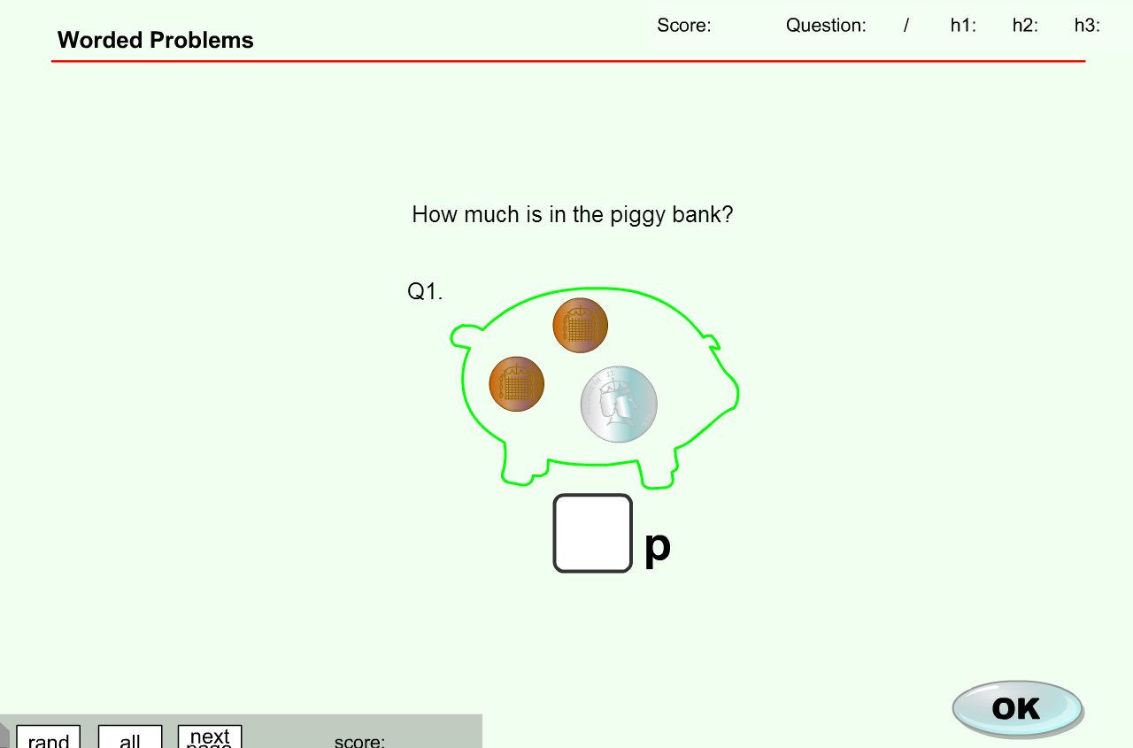

* Replace ‘p’ with ‘c’
* Change coins to 1 x 10c, 1 x $1 and 1 x $2
* Change answer to 310c

Question 2



* Replace ‘p’ with ‘c’
* Change coins to 1 x 10c, 1 x 20c and 1 x $2
* Change answer to 230c

Question 3



* Replace ‘p’ with ‘c’
* Change coins to 1 x 10c, 1 x 50c and 1 x $2
* Change answer to 260c

Question 4



* Replace ‘p’ with ‘c’
* Change coins to 1 x 20c, 1 x 50c and 1 x $1
* Change answer to 170c

Question 5



* Replace ‘p’ with ‘c’
* Change coins to 1 x 10c, 1 x 50c and 1 x $1
* Change answer to 160c

Question 6



* Replace ‘p’ with ‘c’
* Change coins to 1 x 10c, 1 x 20c and 1 x 50c
* Change answer to 80c

Question 7



* Replace ‘p’ with ‘c’
* Change coins to 1 x 10c, 1 x 20c and 1 x $2
* Change answer to 230c

**MA_GBR_0650NAx0300**

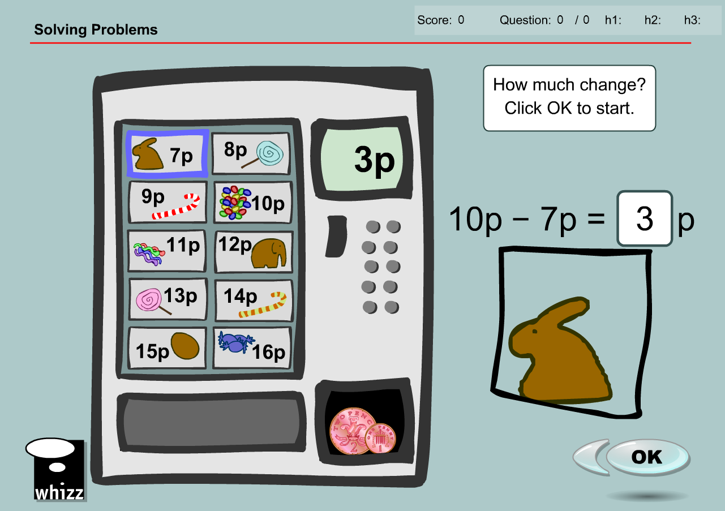

No NZ coin denominations less than 10c so many of the examples are not possible, and the change given is also not possible in NZ currency

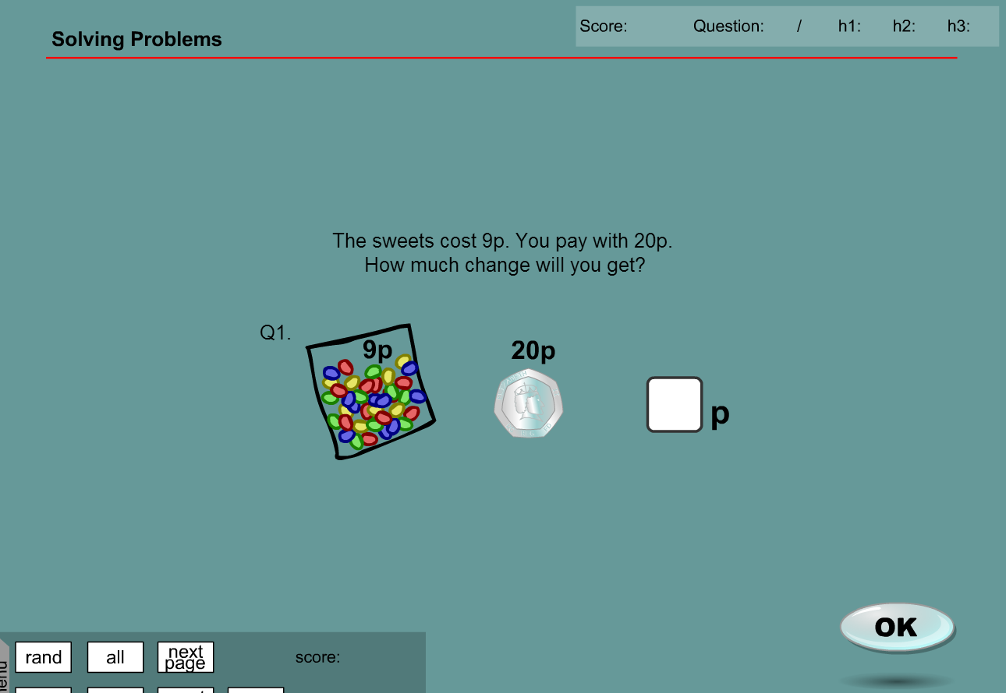

**MA_GBR_0650NAx0300– fixes**

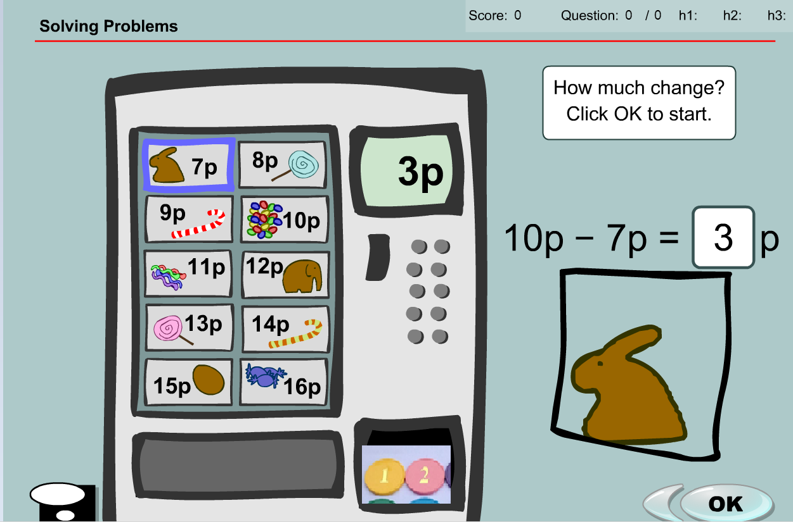

Content problem can be resolved by changing price from pence into a non-country specific currency e.g. tokens. Voiceover is fine as it does not mention currency.

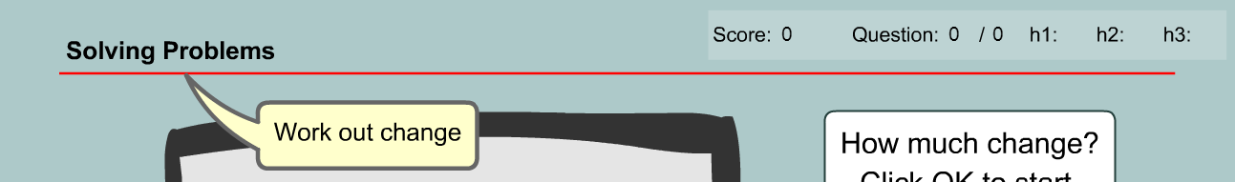

The achievement objective is not compromised as the underlying skill is a simple subtraction. The nature of the currency is irrelevant

Question 1

* Replace ‘9p’ with ‘9 tokens’
* Replace ‘10p’ with ’10 tokens’
* Answer changed from ‘1p’ to ‘1 token’

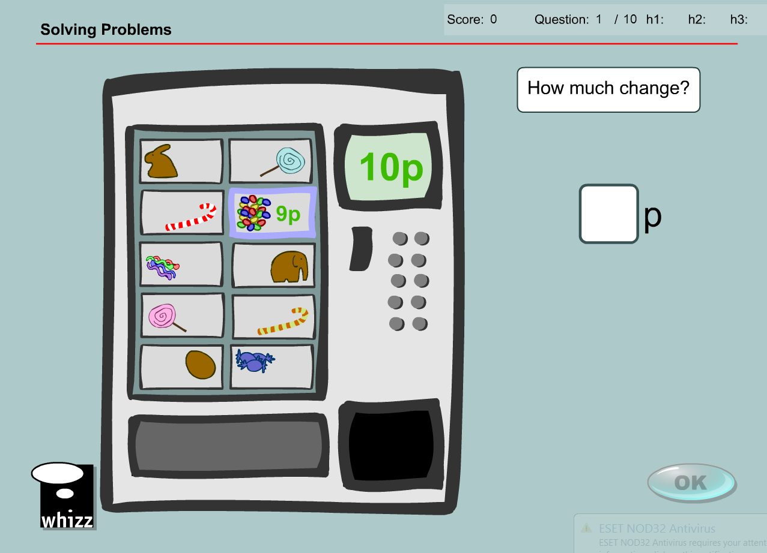

Question 2

* Replace ‘6p’ with ‘6 tokens’
* Replace ‘10p’ with ’10 tokens’
* Answer changed from ‘4p’ to ‘4 tokens’

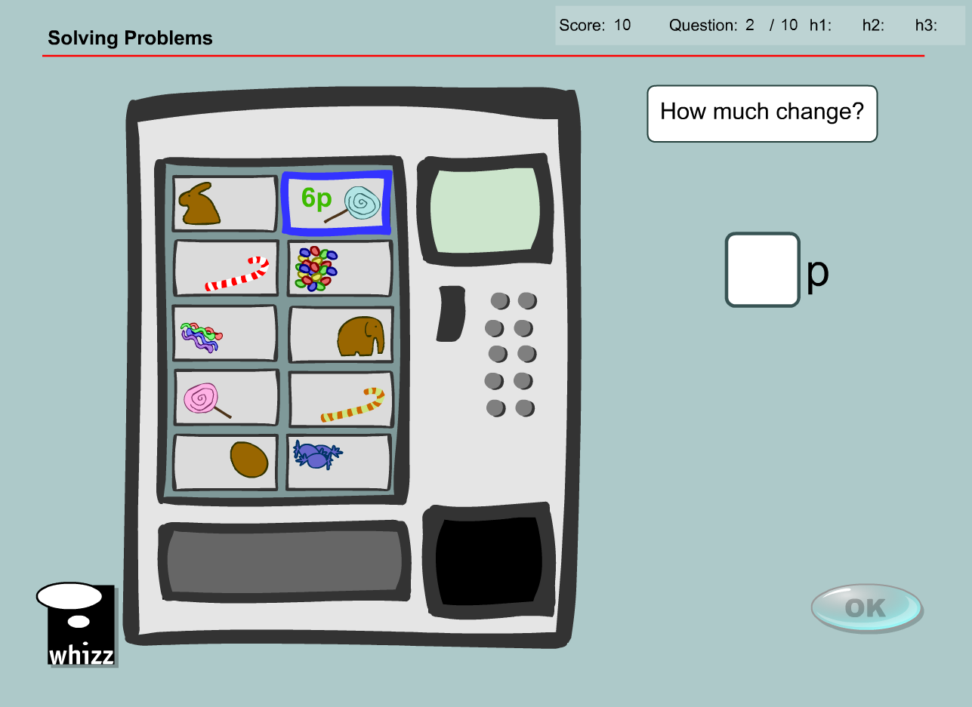

Question 3

* Replace ‘5p’ with ‘5 tokens’
* Replace ‘10p’ with ’10 tokens’
* Answer changed from ‘5p’ to ‘5 tokens’

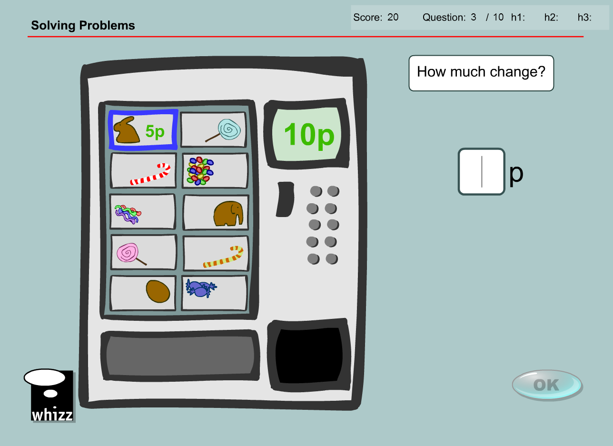

Question 4

* Replace ‘14p’ with ‘14 tokens’
* Replace ‘20p’ with ’20 tokens’
* Answer changed from ‘6p’ to ‘6 tokens’

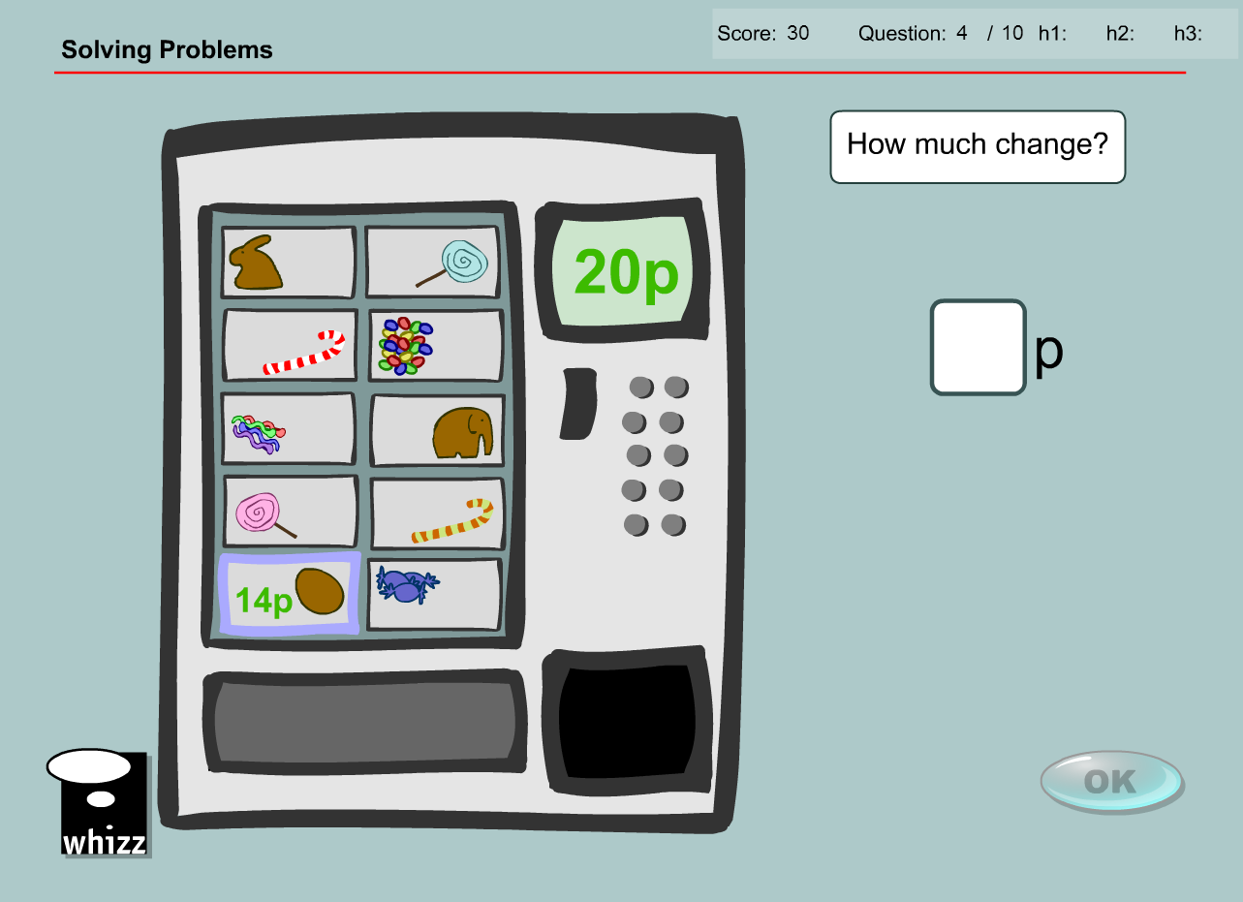

Question 5

* Replace ‘10p’ with ‘10 tokens’
* Replace ‘15p’ with ’15 tokens’
* Answer changed from ‘5p’ to ‘5 tokens’

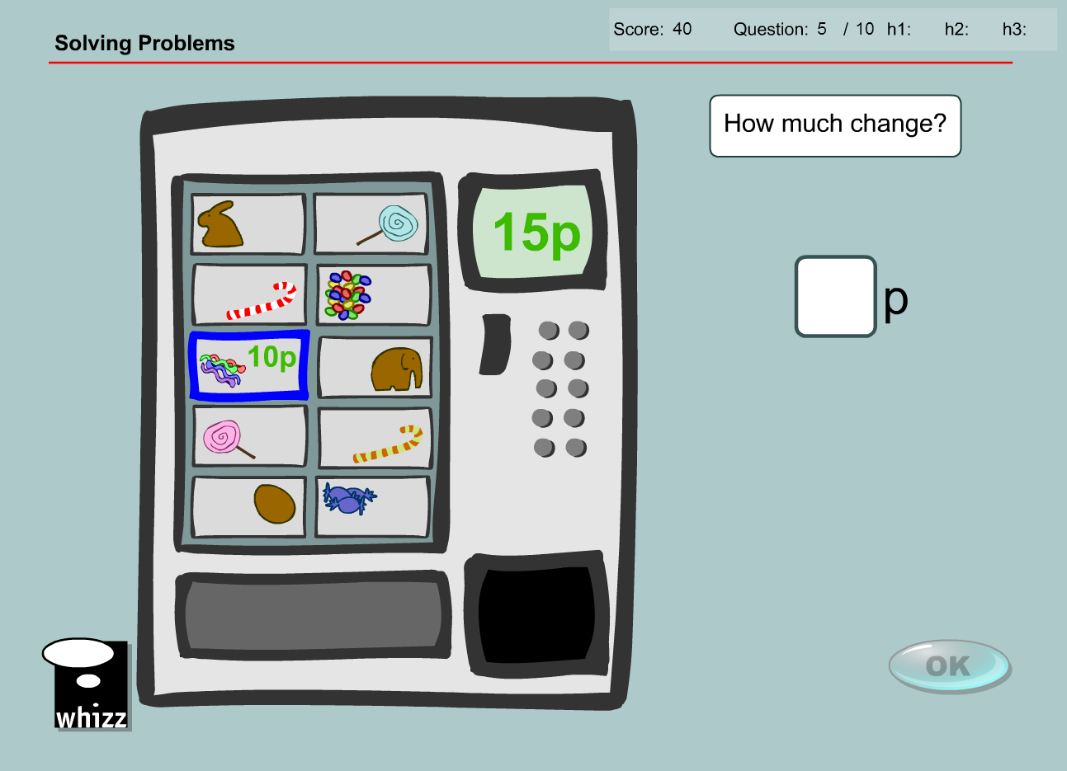

Question 6

* Replace ‘15p’ with ‘15 tokens’
* Replace ‘20p’ with ’20 tokens’
* Answer changed from ‘5p’ to ‘5 tokens’

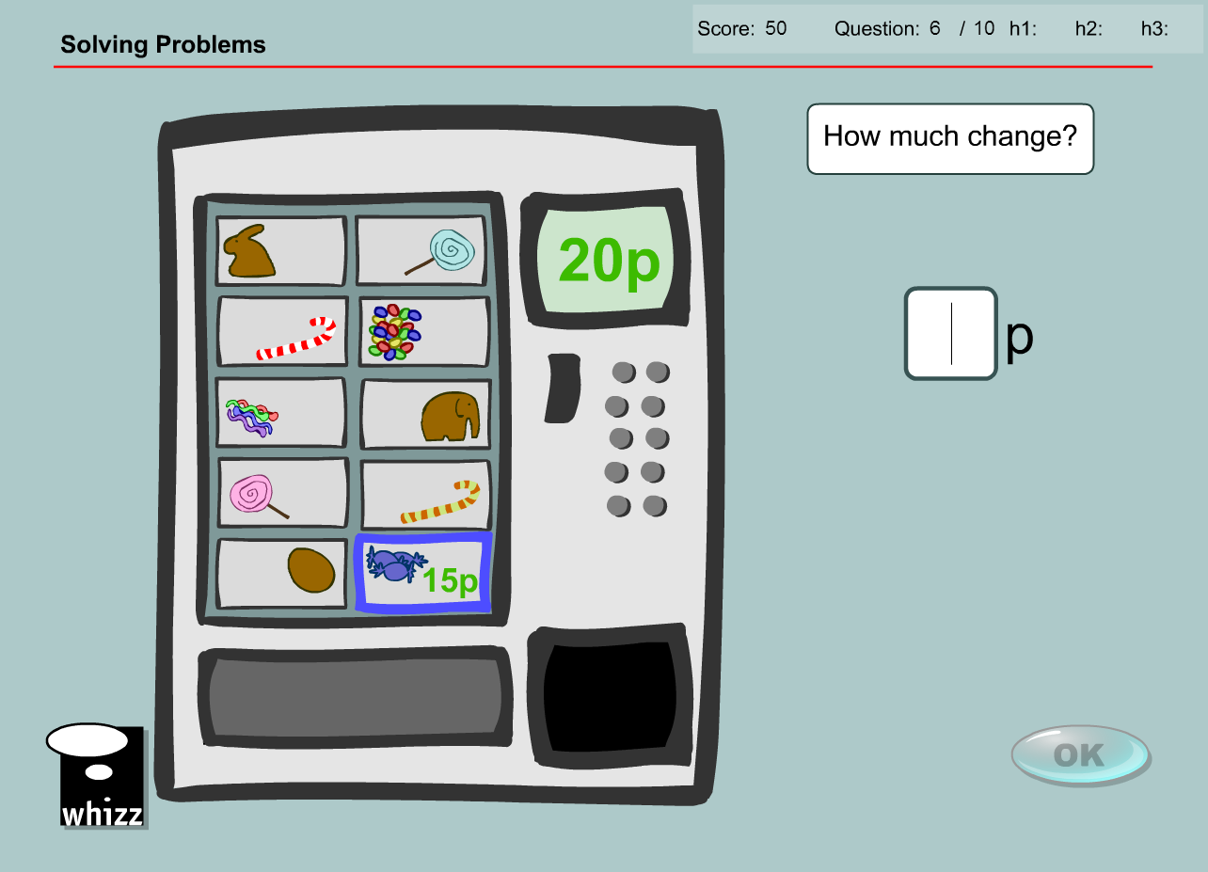

Question 7

* Replace ‘11p’ with ‘11 tokens’
* Replace ‘15p’ with ’15 tokens’
* Answer changed from ‘4p’ to ‘4 tokens’

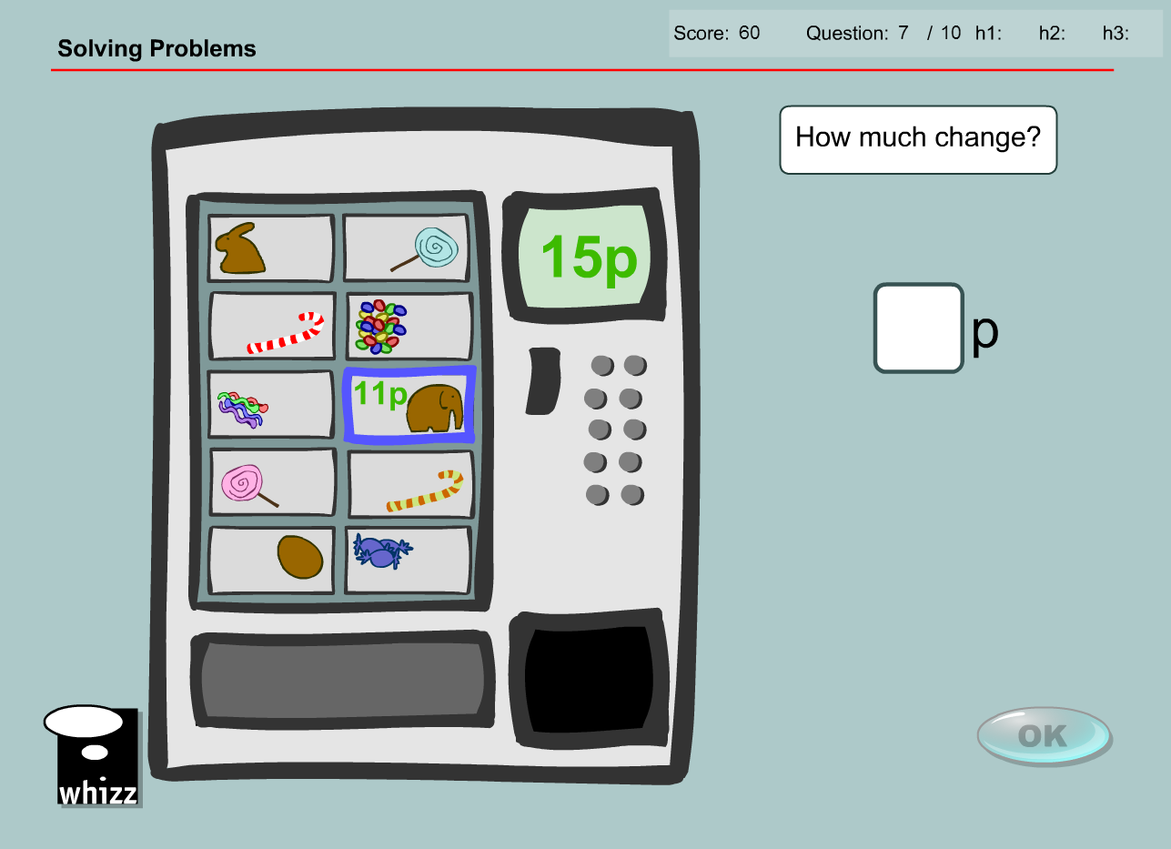

Question 8

* Replace ‘8p’ with ‘8 tokens’
* Replace ‘10p’ with ’10 tokens’
* Answer changed from ‘2p’ to ‘2 tokens’

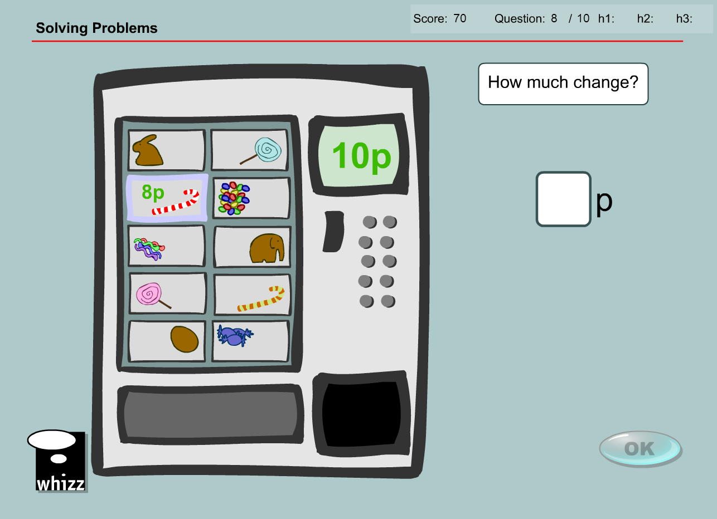

Question 9

* Replace ‘12p’ with ‘12 tokens’
* Replace ‘15p’ with ’15 tokens’
* Answer changed from ‘3p’ to ‘3 tokens’

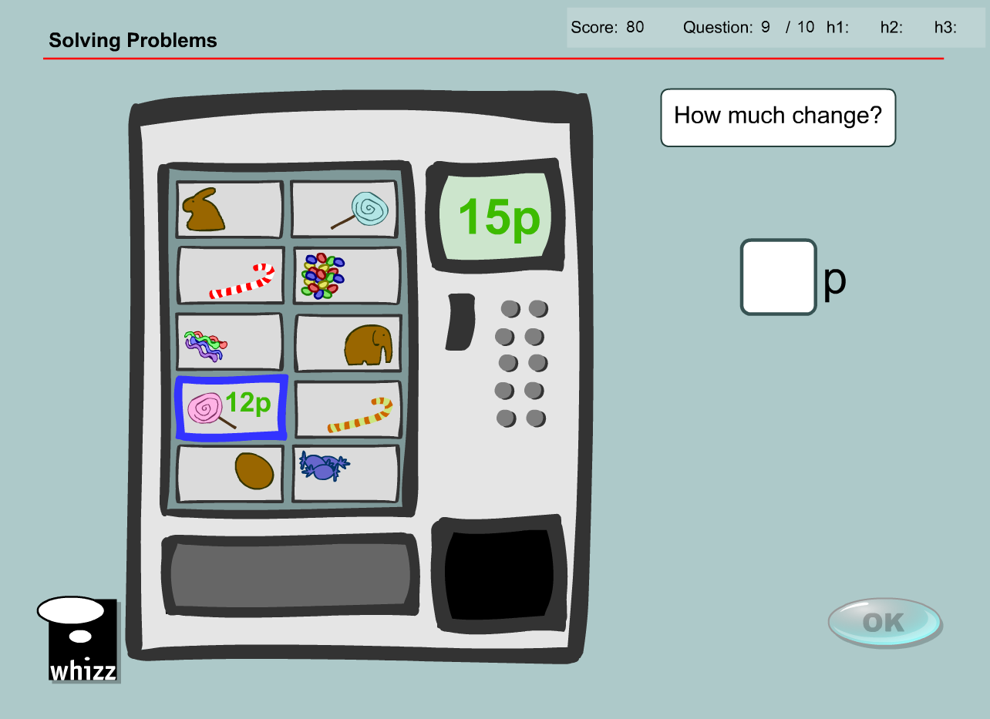

Question 10

* Replace ‘13p’ with ‘13 tokens’
* Replace ‘20p’ with ’20 tokens’
* Answer changed from ‘7p’ to ‘7 tokens’

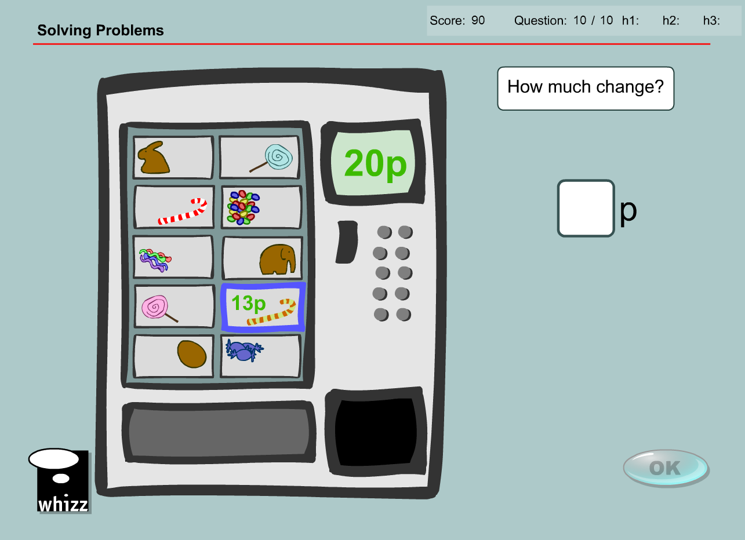

**Test content has the same issues/solution**

Change available coins to generic ‘tokens’

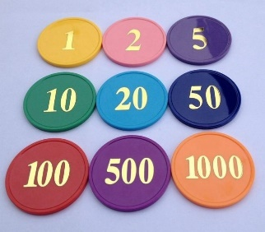

If there are more than 5 questions in the database I have suggested some extra questions as well.

Question 1

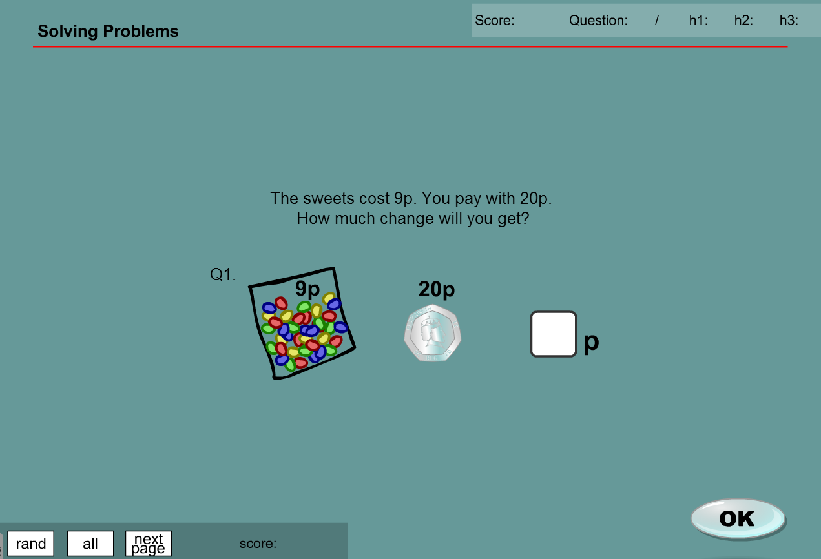

* Replace ‘9p’ with ‘9 tokens’
* Replace ‘20p’ with ’20 tokens’
* Answer changed from ‘11p’ to ‘11 tokens’

Question 2

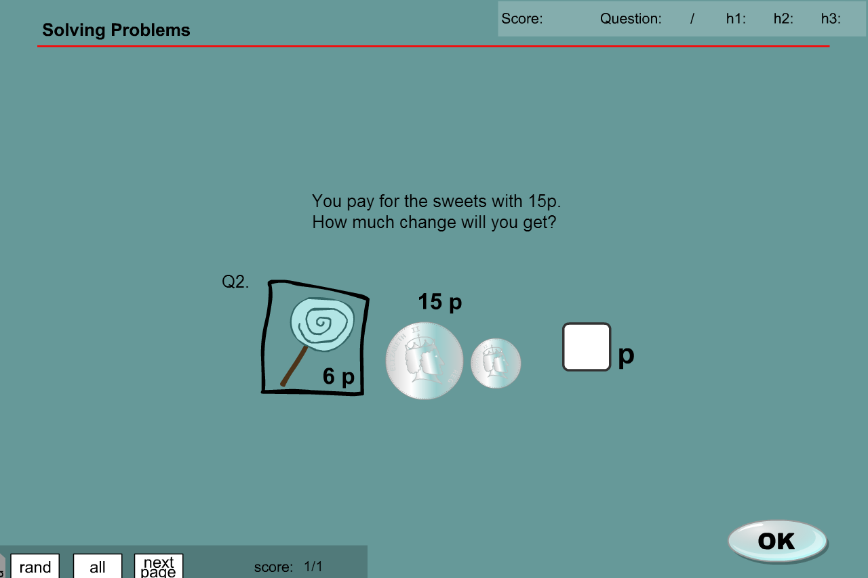

* Replace ‘6p’ with ‘6 tokens’
* Replace ‘15p’ with ’15 tokens’
* Answer changed from ‘9p’ to ‘9 tokens’

Question 3

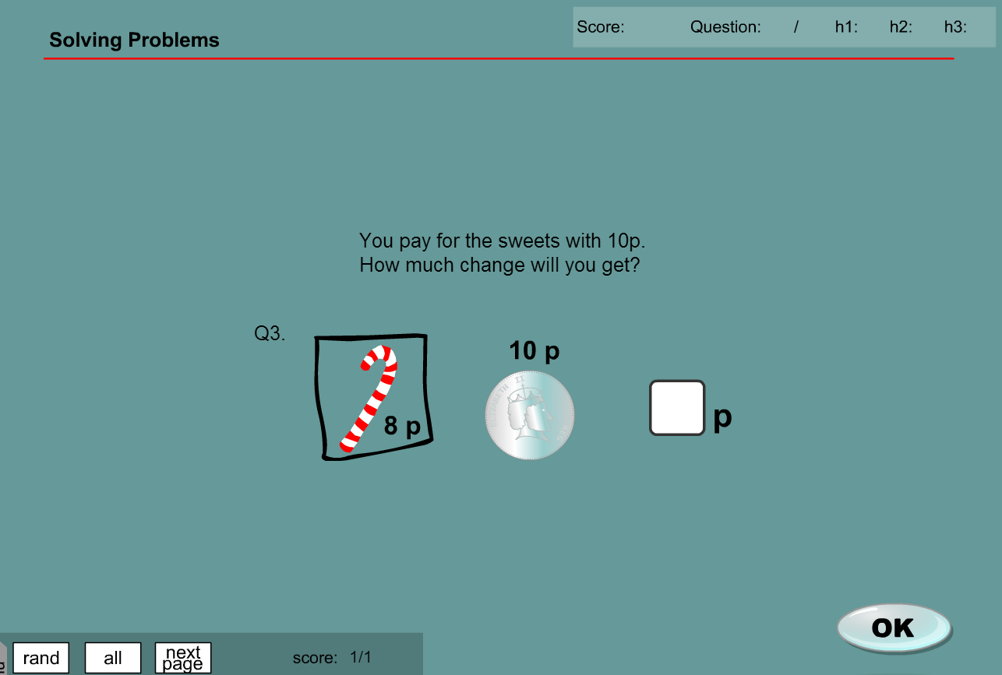

* Replace ‘8p’ with ‘8 tokens’
* Replace ‘10p’ with ’10 tokens’
* Answer changed from ‘2p’ to ‘2 tokens’

Question 4

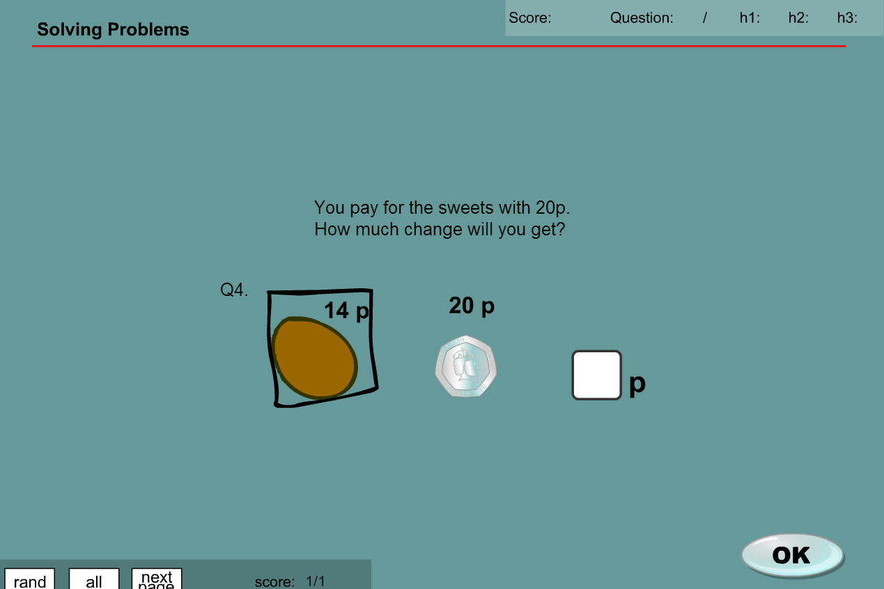

* Replace ‘14p’ with ‘14 tokens’
* Replace ‘20p’ with ’20 tokens’
* Answer changed from ‘6p’ to ‘6 tokens’

Question 5

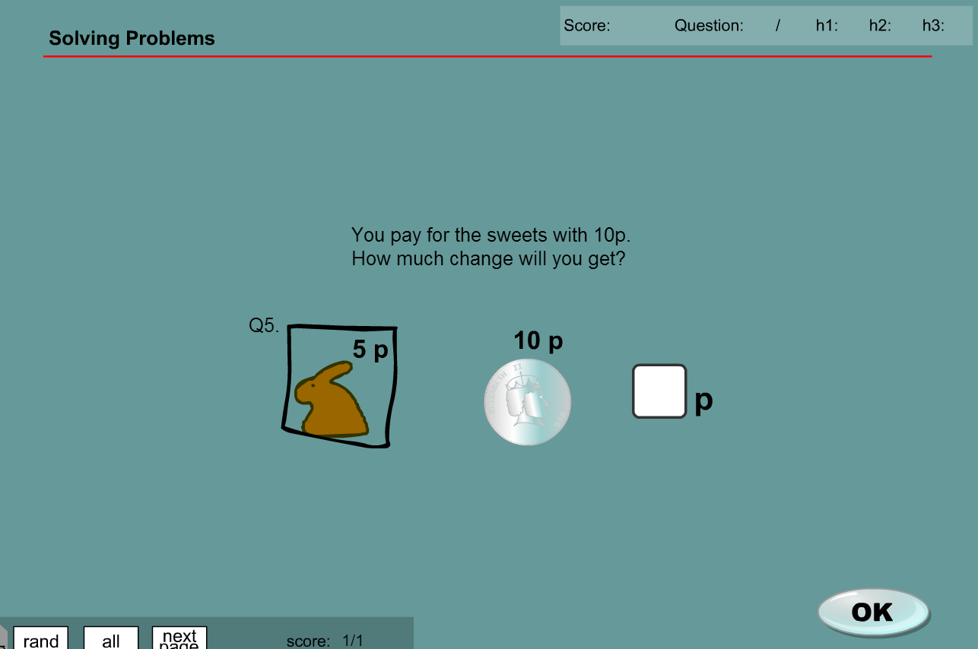

* Replace ‘5p’ with ‘5 tokens’
* Replace ‘10p’ with ’10 tokens’
* Answer changed from ‘5p’ to ‘5 tokens’

**MA_GBR_0650NAx0400**

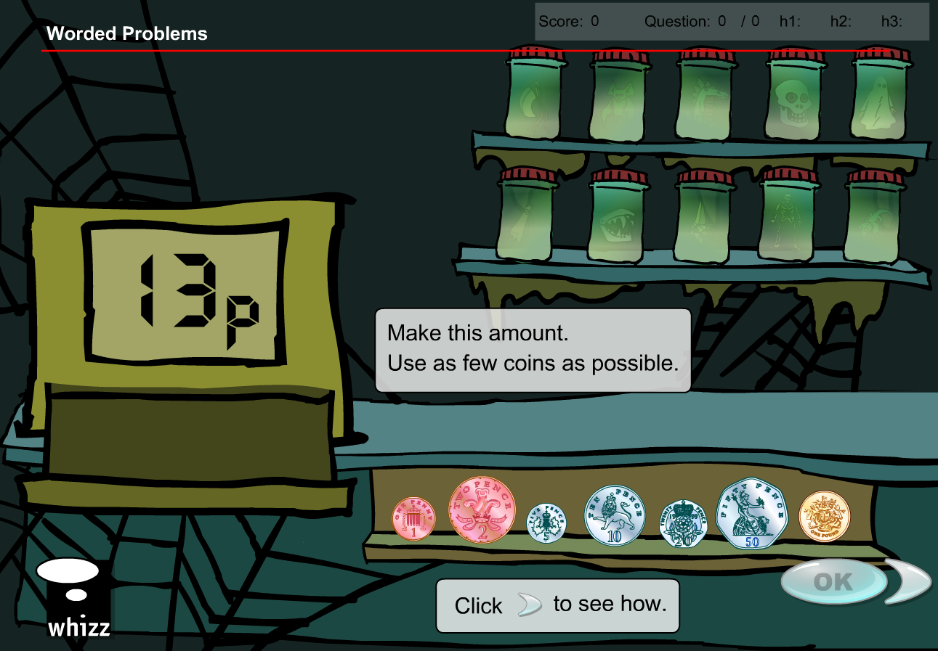

No NZ coin denominations less than 10c so the examples are not possible. Complete content change required as with new denominations, new answers would be required.

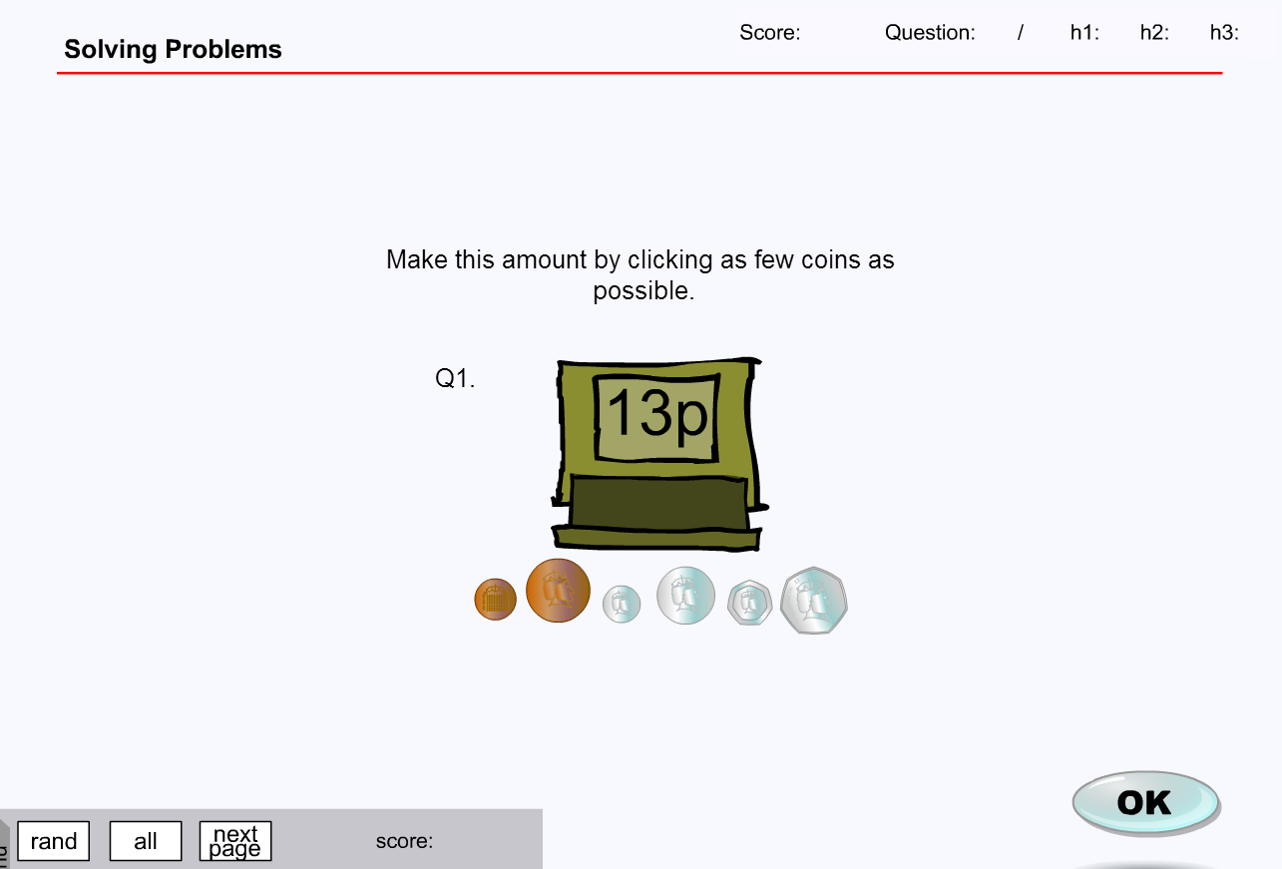

**MA_GBR_0650NAx0400 – fixes**

Underlying achievement objective does not rely on coin recognition and is a subtraction issue. The same questions can be asked by substituting the coins with tokens with relevant text change in the question.

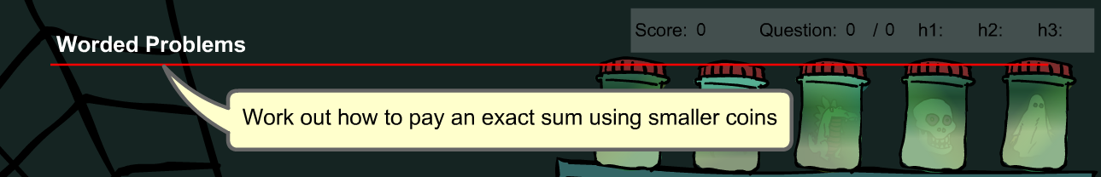

Some graphic design needed to generate tokens of the required denominations. Voiceover is fine as it does not mention currency.

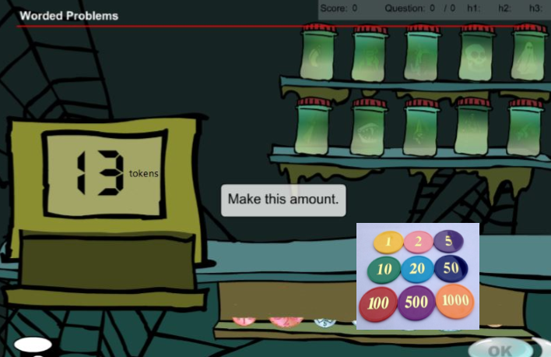

Question 1

* Replace ‘1, 2, 5, 10, 20, 50p, and 1 pound’ coins with ‘1, 2, 5, 10, 20, 50, and 100 value tokens’
* Replace ‘22p’ with ’22 tokens’
* Answer required will not change with student selecting 1 x 20 and 1 x 2 token denominations

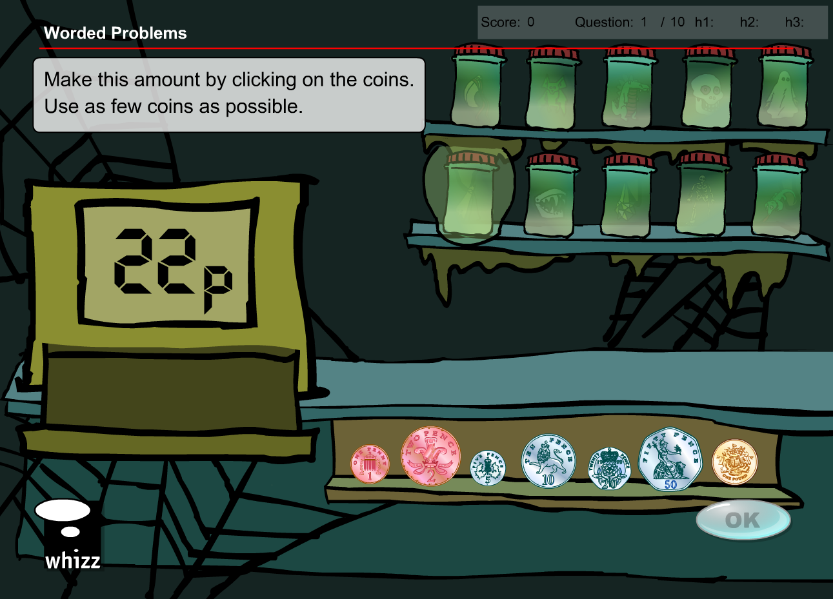

Question 2

* Replace ‘1, 2, 5, 10, 20, 50p, and 1 pound’ coins with ‘1, 2, 5, 10, 20, 50, and 100 value tokens’
* Replace ‘17p’ with ’17 tokens’
* Answer required will not change with student selecting 1 x 10, 1 x 5 and 1 x 2 token denominations

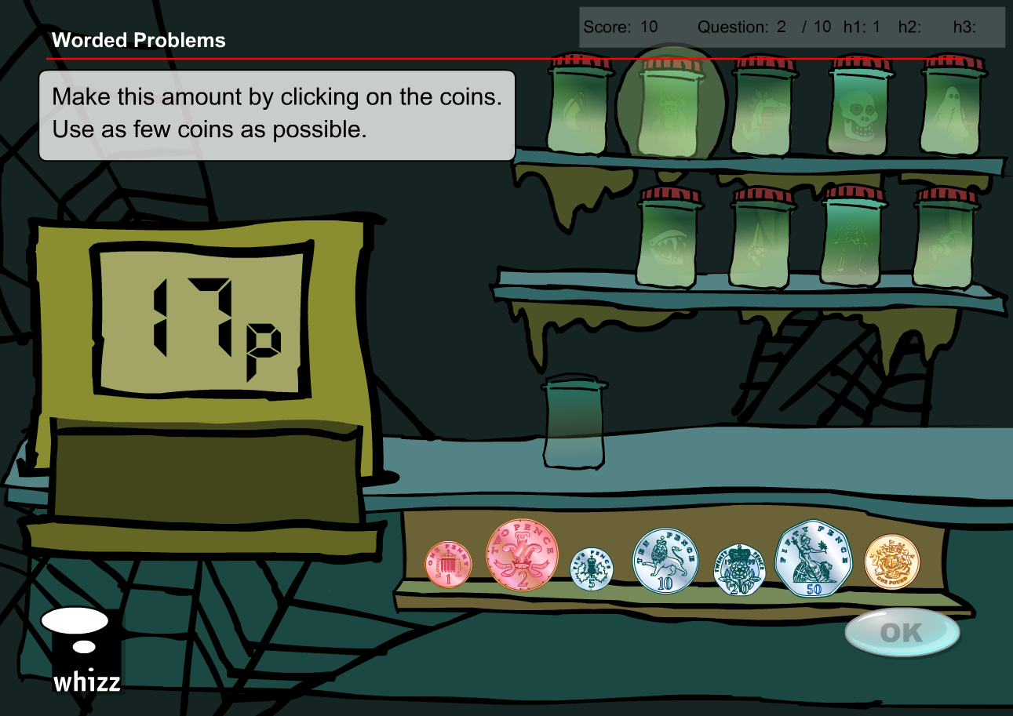

Question 3

* Replace ‘1, 2, 5, 10, 20, 50p, and 1 pound’ coins with ‘1, 2, 5, 10, 20, 50, and 100 value tokens’
* Replace ‘16p’ with ’16 tokens’
* Answer required will not change with student selecting 1 x 10, 1 x 5 and 1 x 1 token denominations

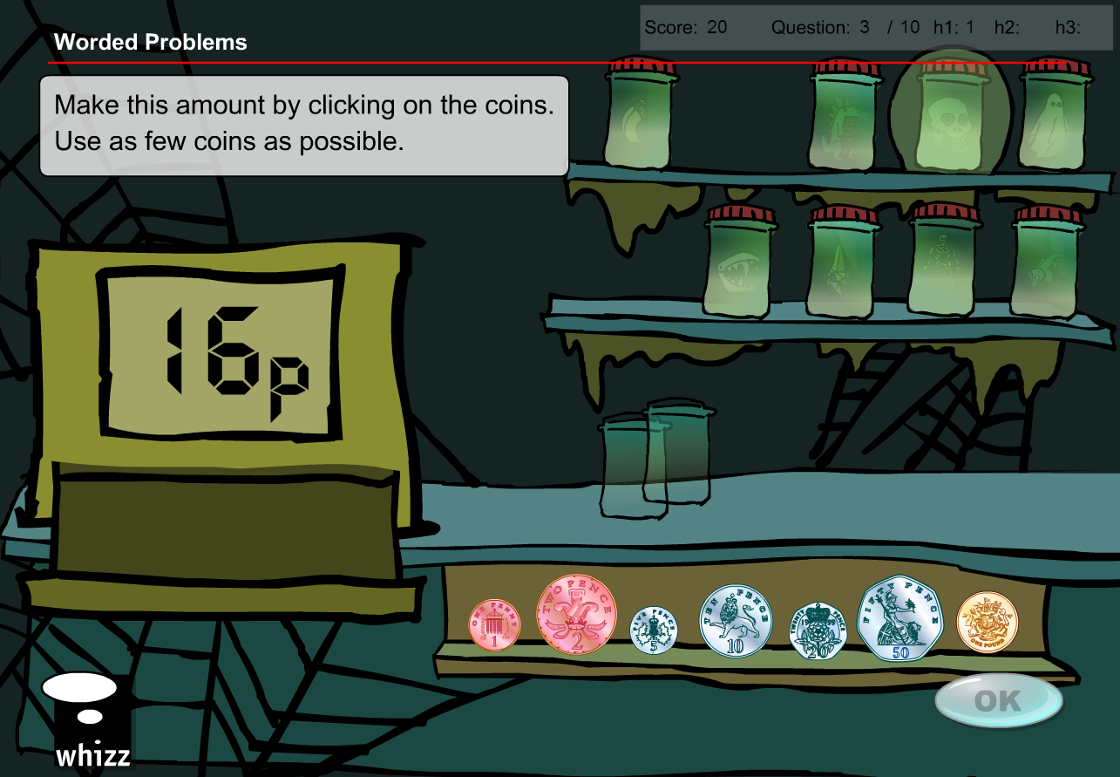

Question 4

* Replace ‘1, 2, 5, 10, 20, 50p, and 1 pound’ coins with ‘1, 2, 5, 10, 20, 50, and 100 value tokens’
* Replace ‘18p’ with ’18 tokens’
* Answer required will not change with student selecting 1 x 10, 1 x 5, 1 x 2 and 1 x 1 token denominations

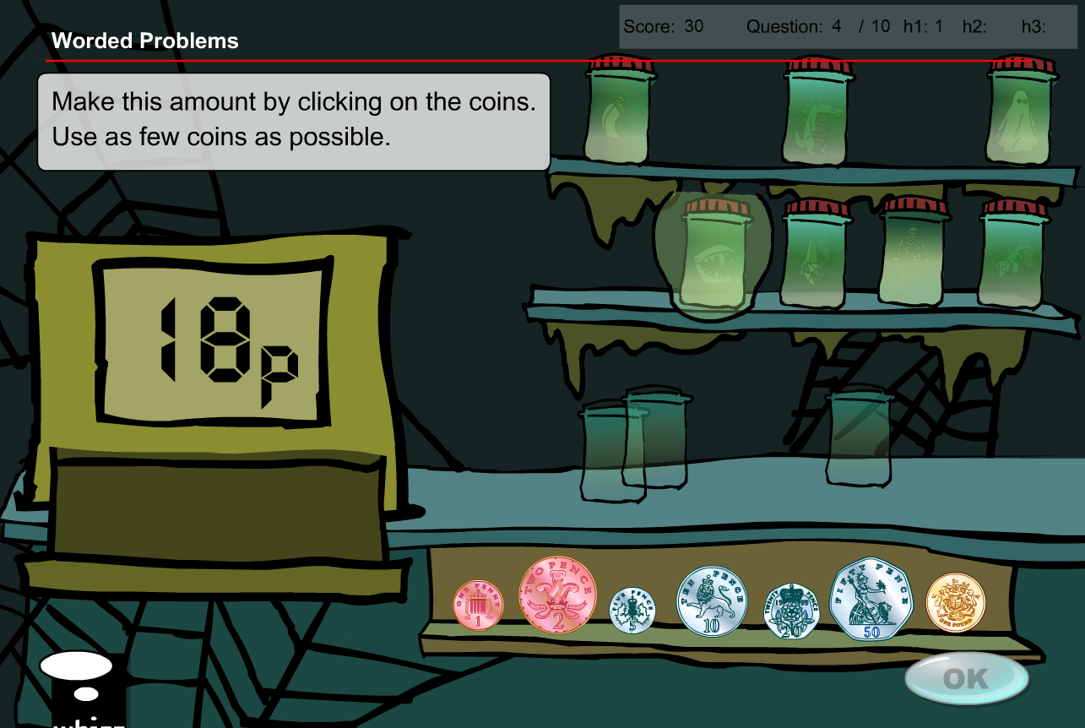

Question 5

* Replace ‘1, 2, 5, 10, 20, 50p, and 1 pound’ coins with ‘1, 2, 5, 10, 20, 50, and 100 value tokens’
* Replace ‘23p’ with ’23 tokens’
* Answer required will not change with student selecting 1 x 20, 1 x 2 and 1 x 1 token denominations

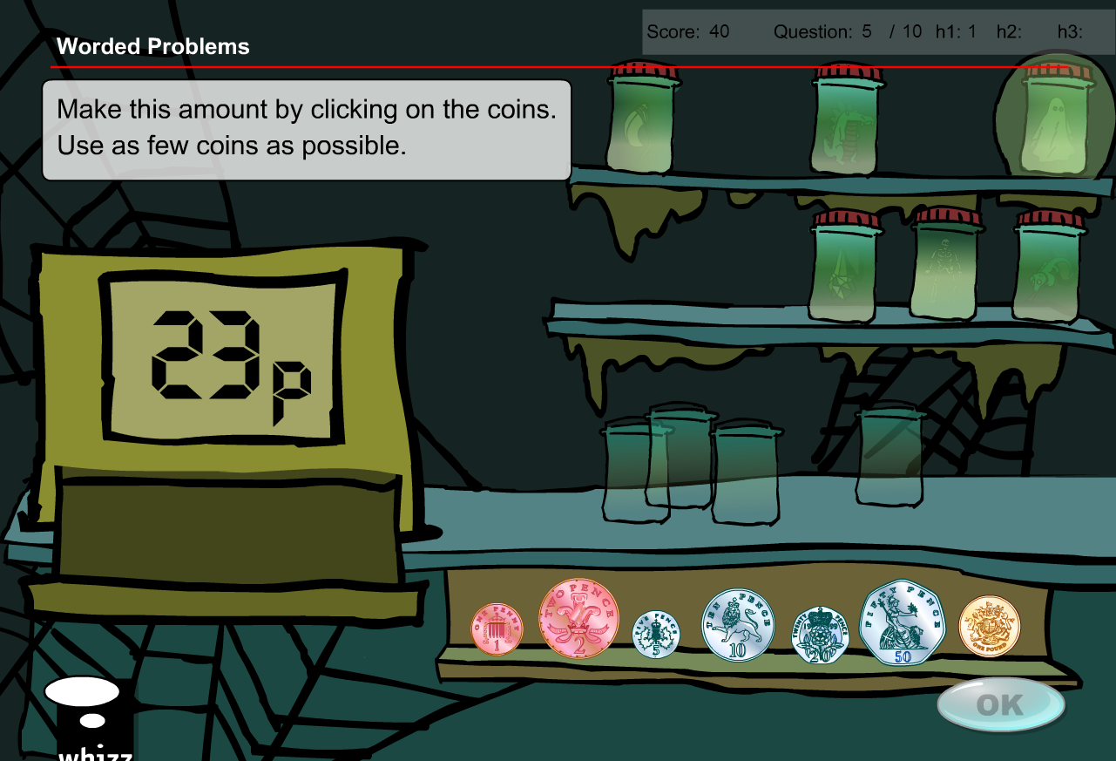

Question 6

* Replace ‘1, 2, 5, 10, 20, 50p, and 1 pound’ coins with ‘1, 2, 5, 10, 20, 50, and 100 value tokens’
* Replace ‘11p’ with ’11 tokens’
* Answer required will not change with student selecting 1 x 10, and 1 x 1 token denominations

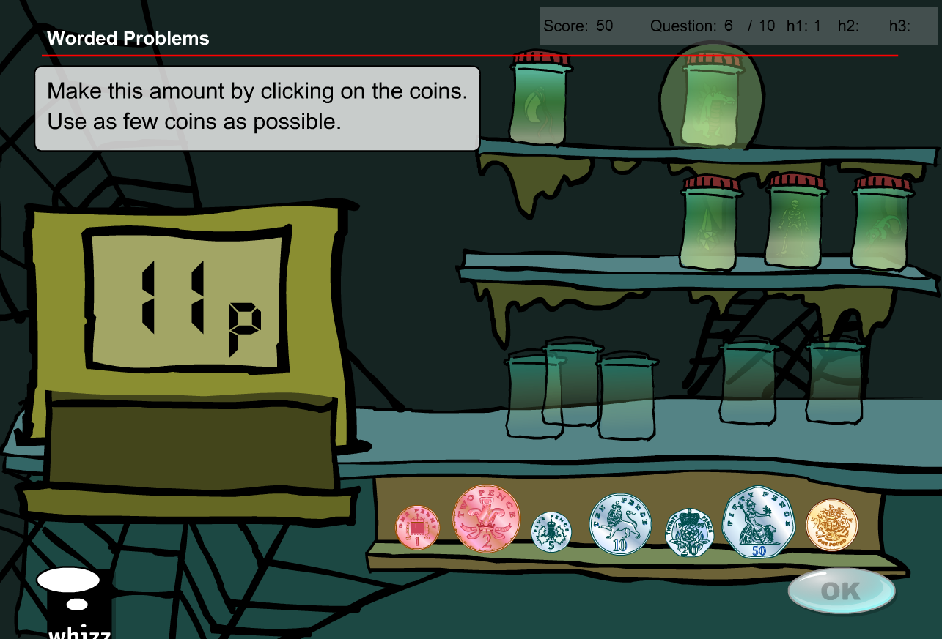

Question 7

* Replace ‘1, 2, 5, 10, 20, 50p, and 1 pound’ coins with ‘1, 2, 5, 10, 20, 50, and 100 value tokens’
* Replace ‘24p’ with ’24 tokens’
* Answer required will not change with student selecting 1 x 20, and 2 x 2 token denominations

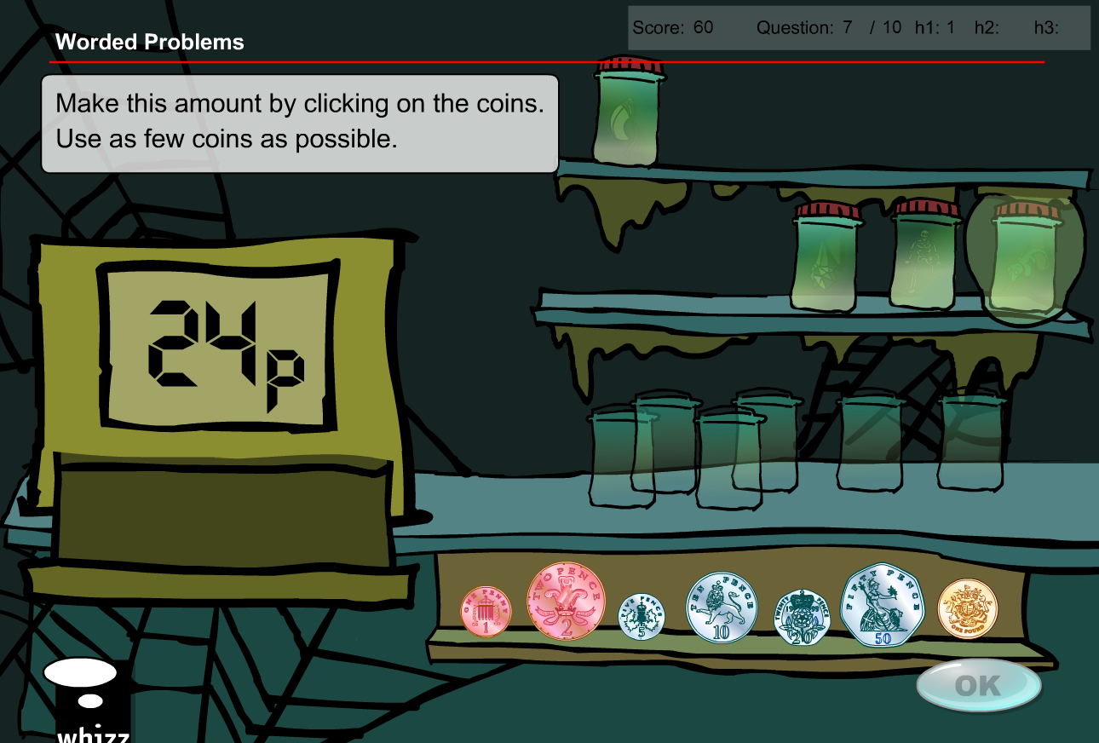

Question 8

* Replace ‘1, 2, 5, 10, 20, 50p, and 1 pound’ coins with ‘1, 2, 5, 10, 20, 50, and 100 value tokens’
* Replace ‘25p’ with ’25 tokens’
* Answer required will not change with student selecting 1 x 20 and 1 x 5 token denominations

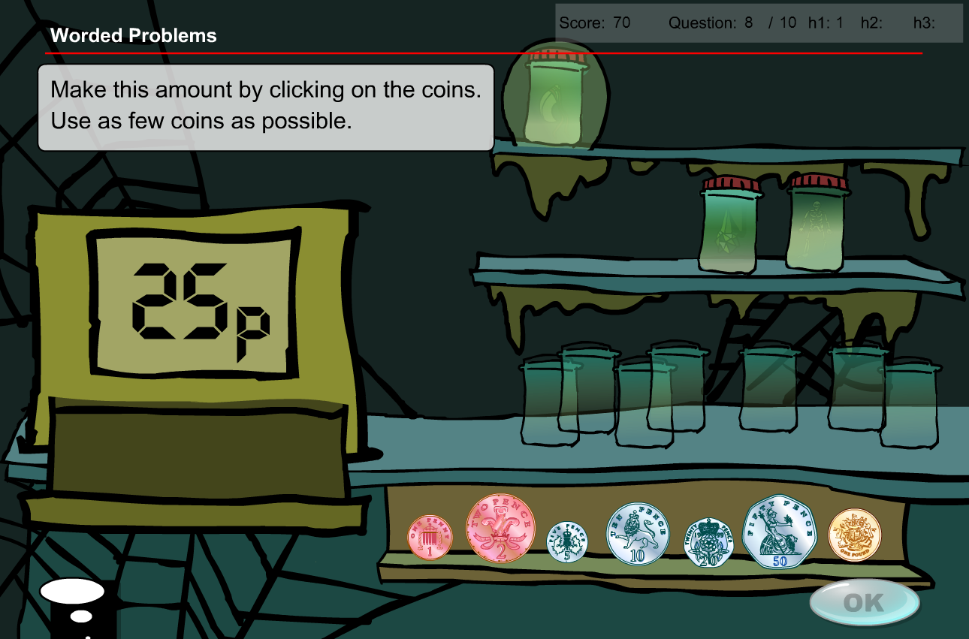

Question 9

* Replace ‘1, 2, 5, 10, 20, 50p, and 1 pound’ coins with ‘1, 2, 5, 10, 20, 50, and 100 value tokens’
* Replace ‘21p’ with ’21 tokens’
* Answer required will not change with student selecting 1 x 20 and 1 x 1 token denominations

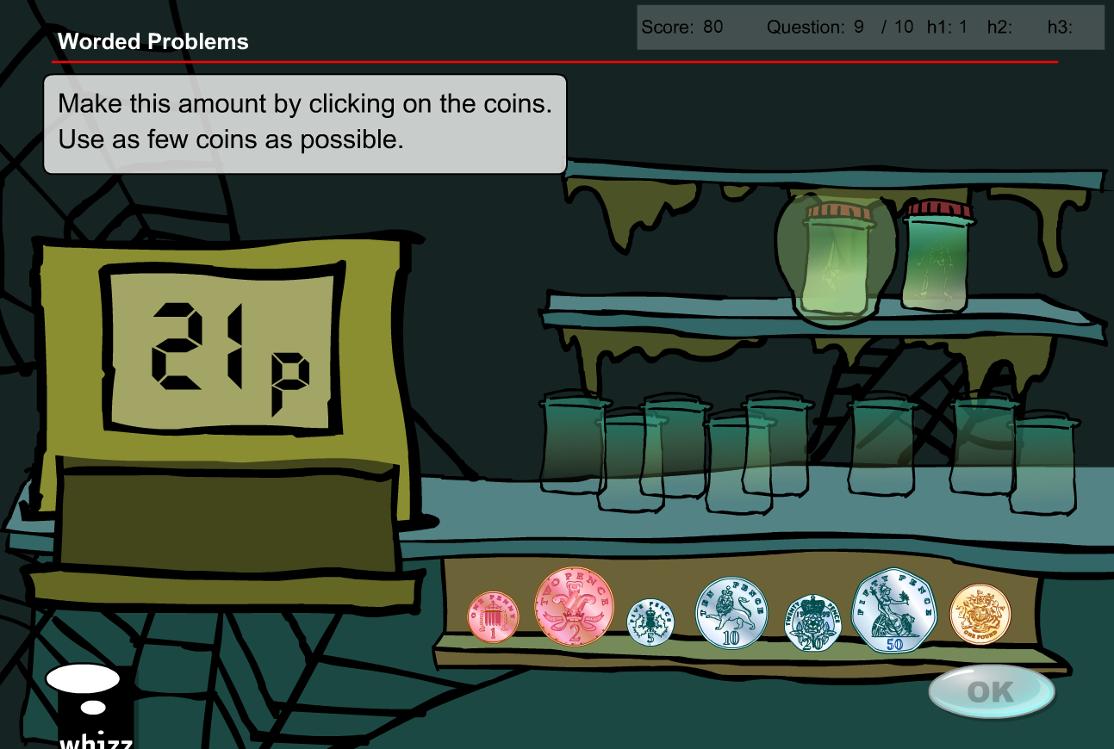

Question 10

* Replace ‘1, 2, 5, 10, 20, 50p, and 1 pound’ coins with ‘1, 2, 5, 10, 20, 50, and 100 value tokens’
* Replace ‘12p’ with ’12 tokens’
* Answer required will not change with student selecting 1 x 10, and 1 x 2 token denominations

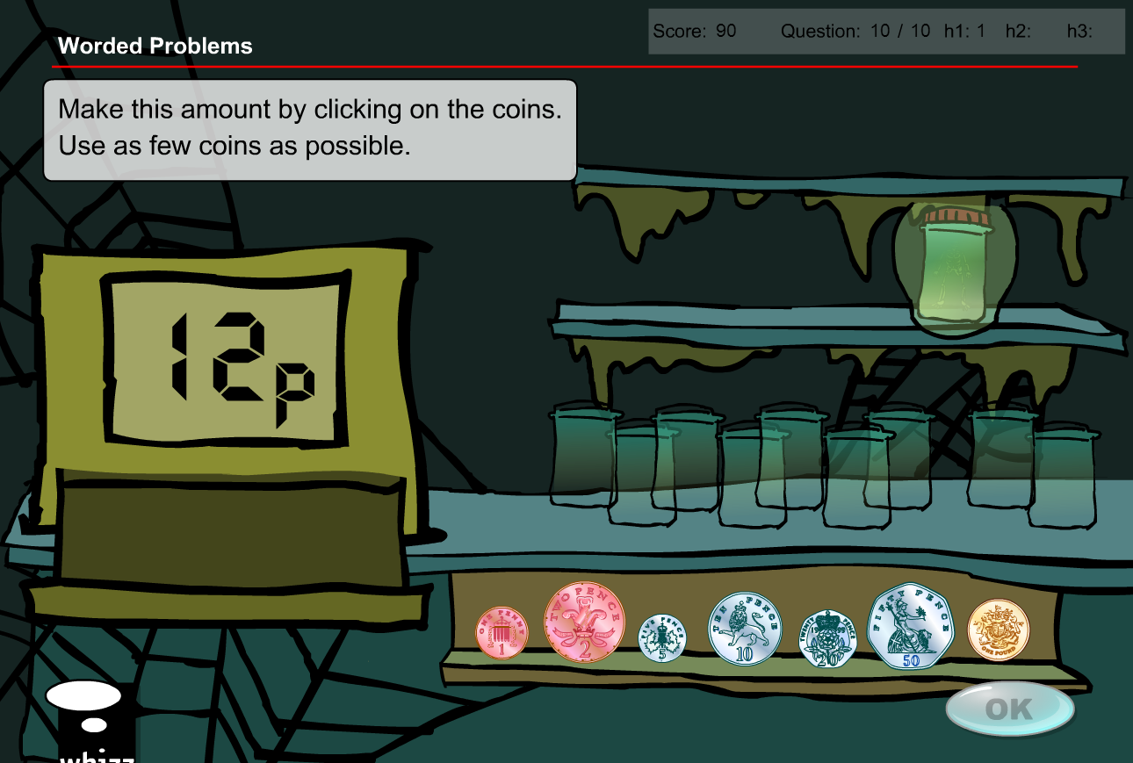

**Test content has the same issues/solution**

Change available coins to generic ‘tokens’



If there are more than 5 questions in the database I have suggested some extra questions as well.

Question 1

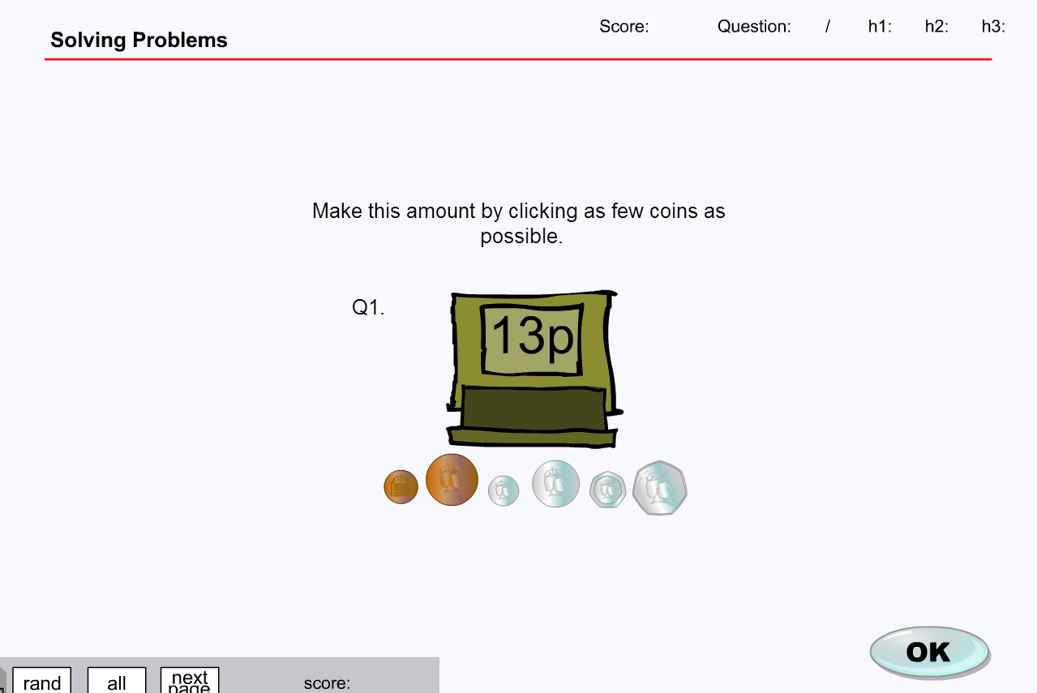

* Replace ‘1, 2, 5, 10, 20, 50p, and 1 pound’ coins with ‘1, 2, 5, 10, 20, 50, and 100 value tokens’
* Replace ‘13p’ with ’13 tokens’
* Answer required will not change with student selecting 1 x 10, 1 x 2 and 1 x 1 token denominations

Question 2

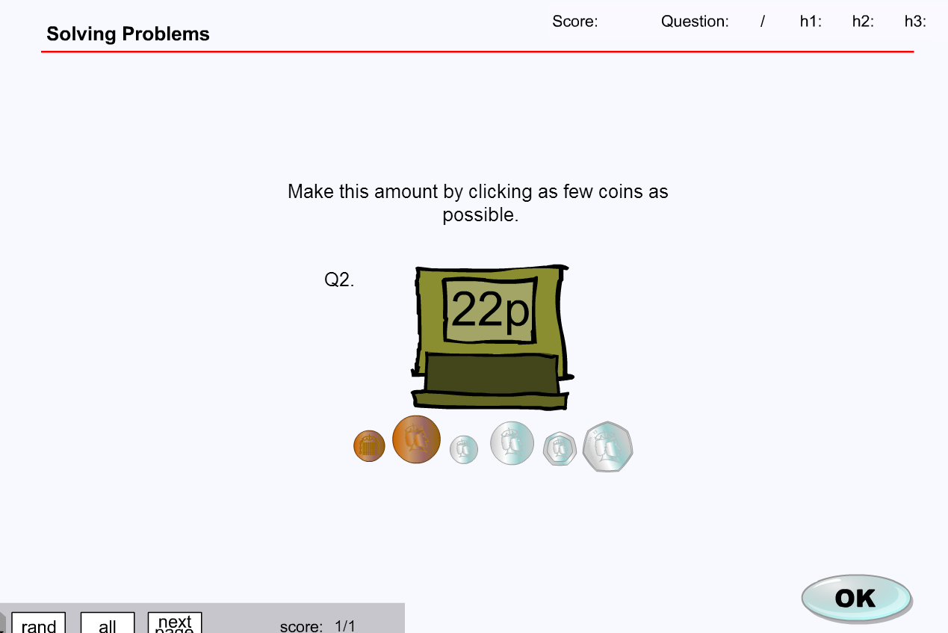

* Replace ‘1, 2, 5, 10, 20, 50p, and 1 pound’ coins with ‘1, 2, 5, 10, 20, 50, and 100 value tokens’
* Replace ‘22p’ with ’22 tokens’
* Answer required will not change with student selecting 1 x 20, and 1 x 2 token denominations

Question 3

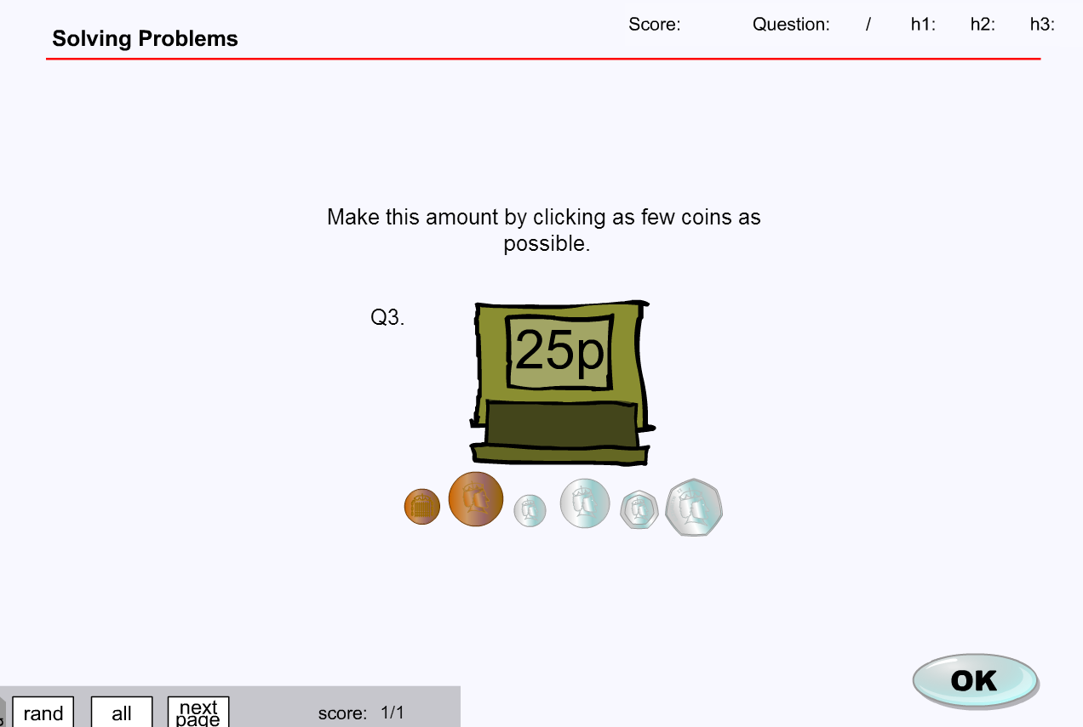

* Replace ‘1, 2, 5, 10, 20, 50p, and 1 pound’ coins with ‘1, 2, 5, 10, 20, 50, and 100 value tokens’
* Replace ‘25p’ with ’25 tokens’
* Answer required will not change with student selecting 1 x 20, and 1 x 5 token denominations

Question 4

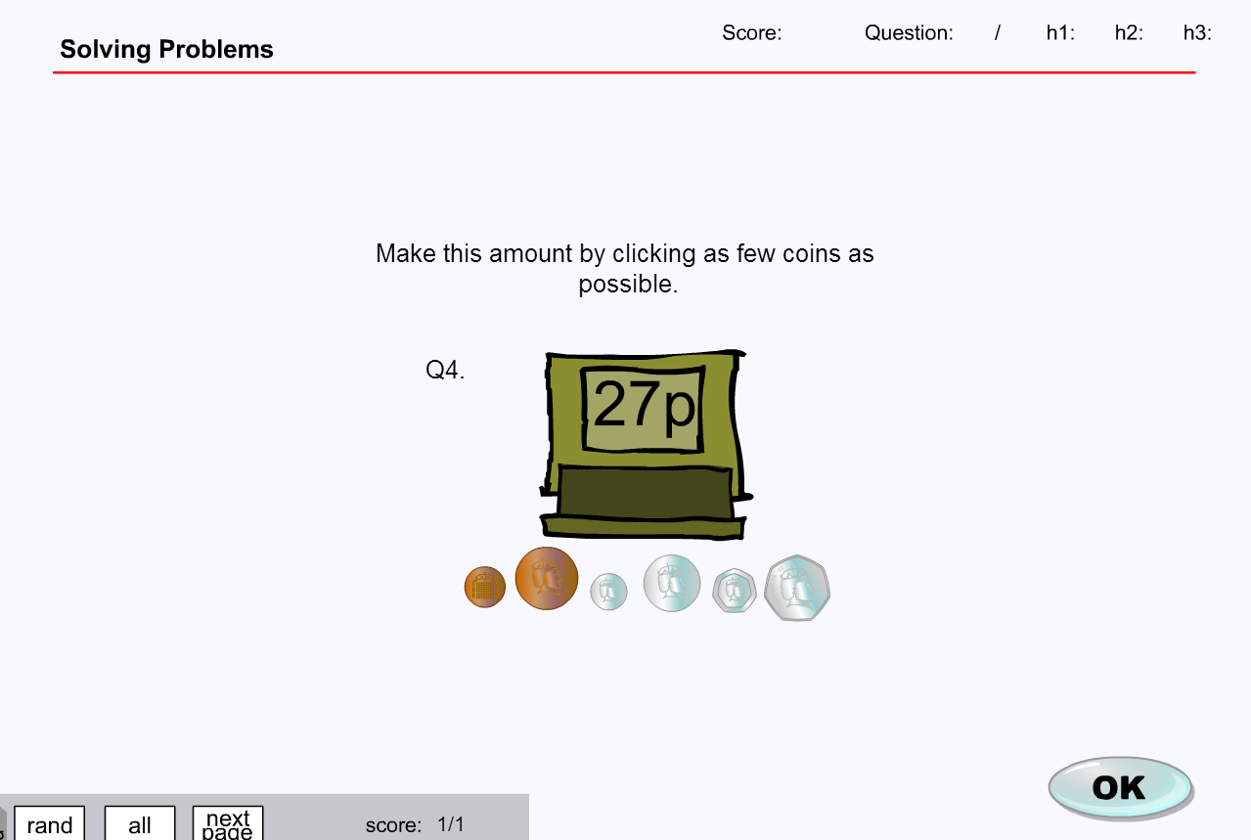

* Replace ‘1, 2, 5, 10, 20, 50p, and 1 pound’ coins with ‘1, 2, 5, 10, 20, 50, and 100 value tokens’
* Replace ‘27p’ with ’27 tokens’
* Answer required will not change with student selecting 1 x 20, 1 x 5 and 1 x 2 token denominations

Question 5

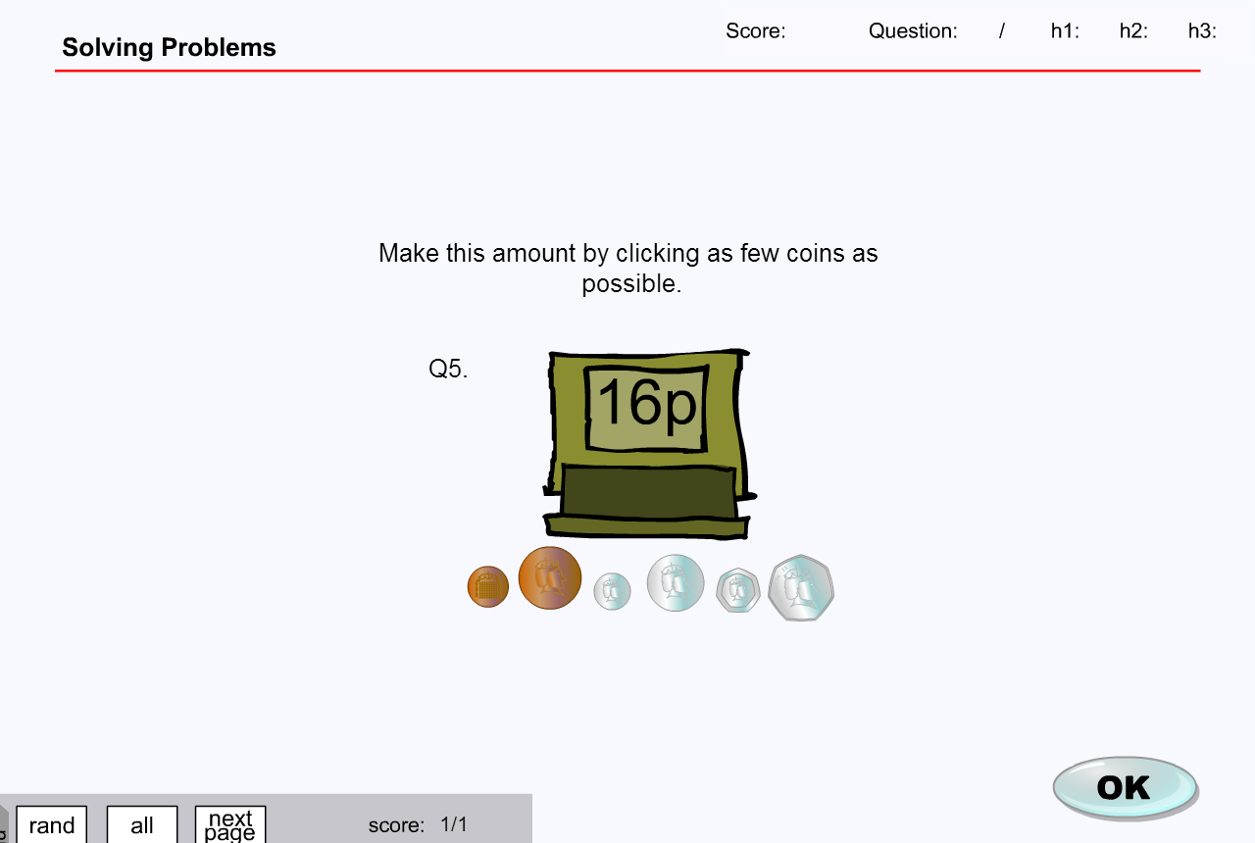

* Replace ‘1, 2, 5, 10, 20, 50p, and 1 pound’ coins with ‘1, 2, 5, 10, 20, 50, and 100 value tokens’
* Replace ‘16p’ with ’16 tokens’
* Answer required will not change with student selecting 1 x 10, 1 x 5 and 1 x 1 token denominations

**MA_GBR_0750NAx0100**

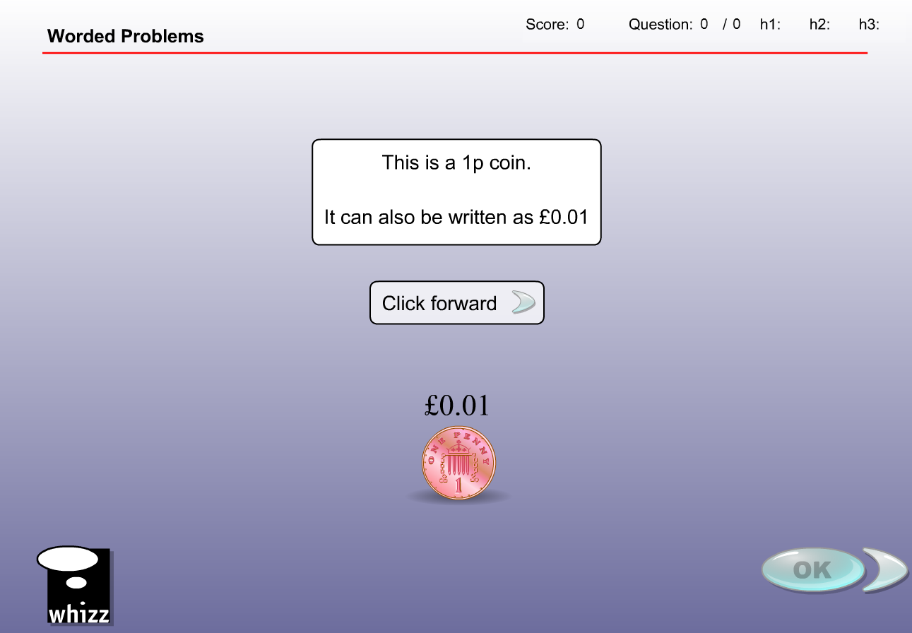

No NZ coin denominations less than 10c so the examples are not possible. Complete content change required as with new denominations, new answers would be required.

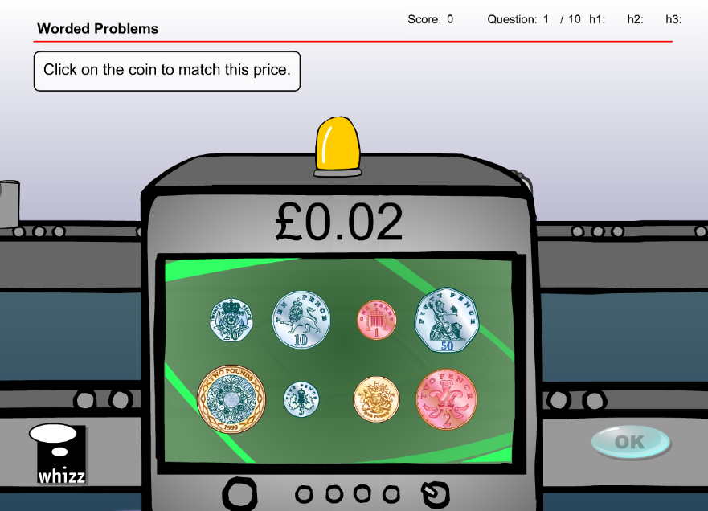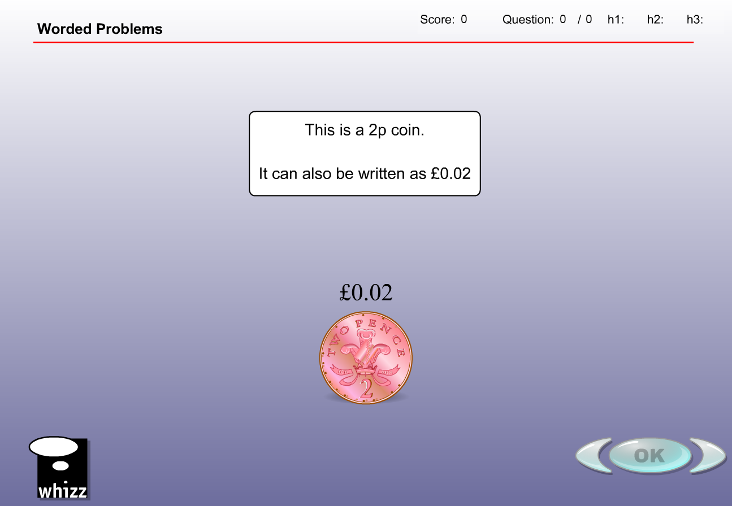

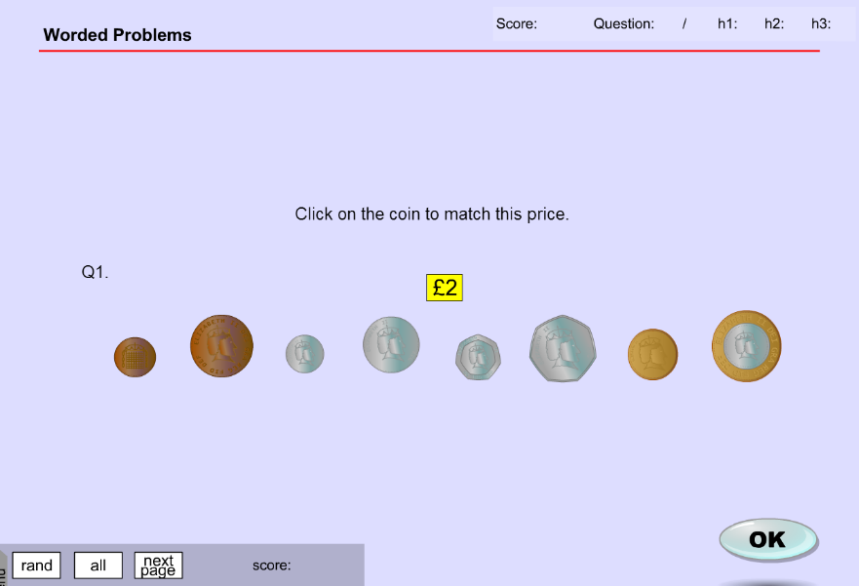

**MA_GBR_0750NAx0100 - fixes**

Involves specific UK coin recognition

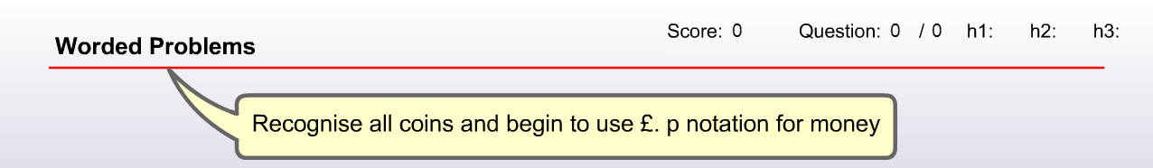

Omit the 1p, 2p and 5p coins. Replace other 5 coins with NZ equivalents. This will give 10 x possible combinations with each coins represented as ‘c’ and each as ‘$’.

10c coin – either 10c or $0.10

20c coin – either 20c or $0.20

50c coin – either 50c or $0.50

$1 coin – either 100c or $1

$2 coin – either 200c or $2

This will give 10 possible questions for exercise and test.

Question 1 - 10

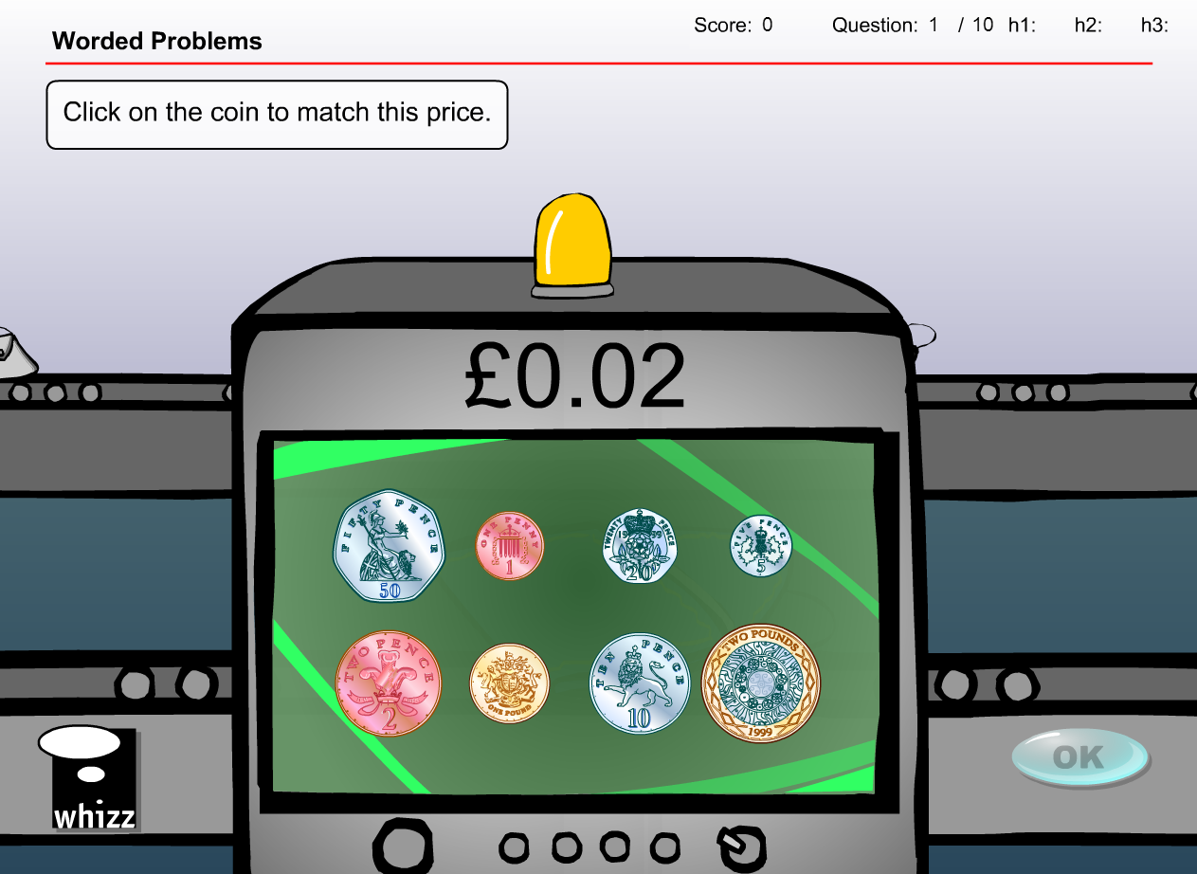

Replace 8 x UK coins with 5 x NZ coins. 10 sample questions listed above.

**Test content has the same issues/solution**

Change available coins to 5 x NZ coins and database of questions can = 10 as per previous suggestions

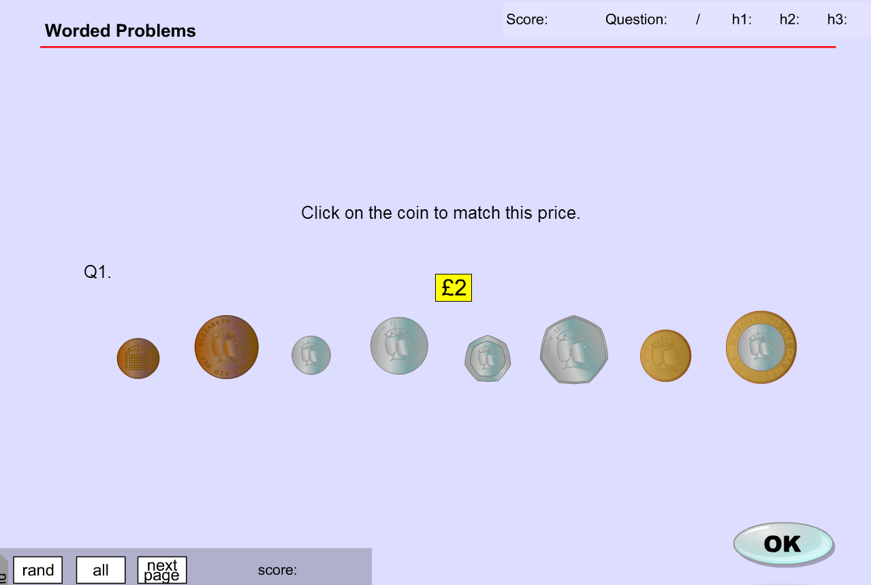

**MA_GBR_0750NAx0200**

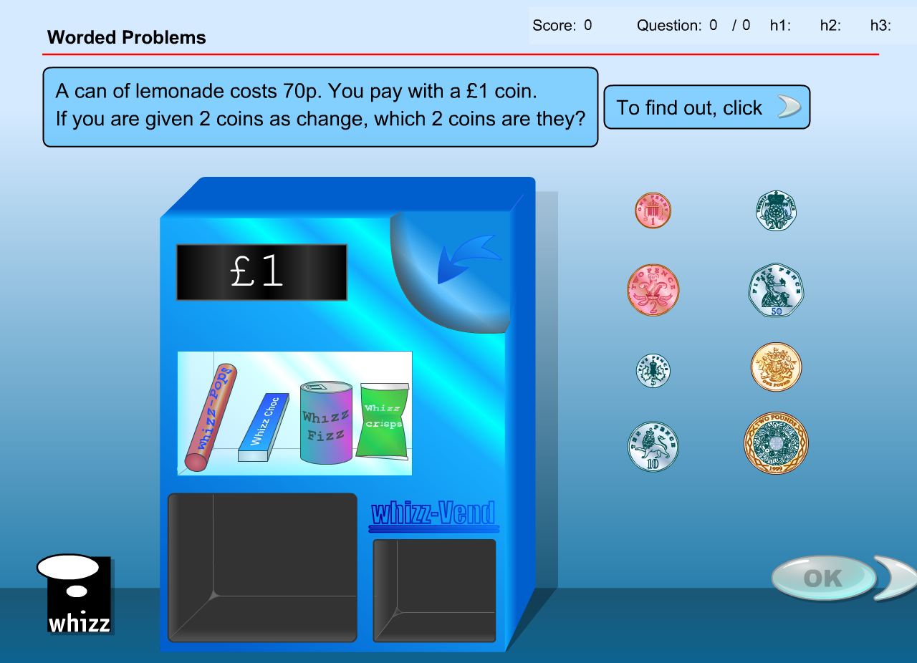

No NZ coin denominations less than 10c so questions and answers would require change. Complete content change required as with new denominations, new answers would be required.

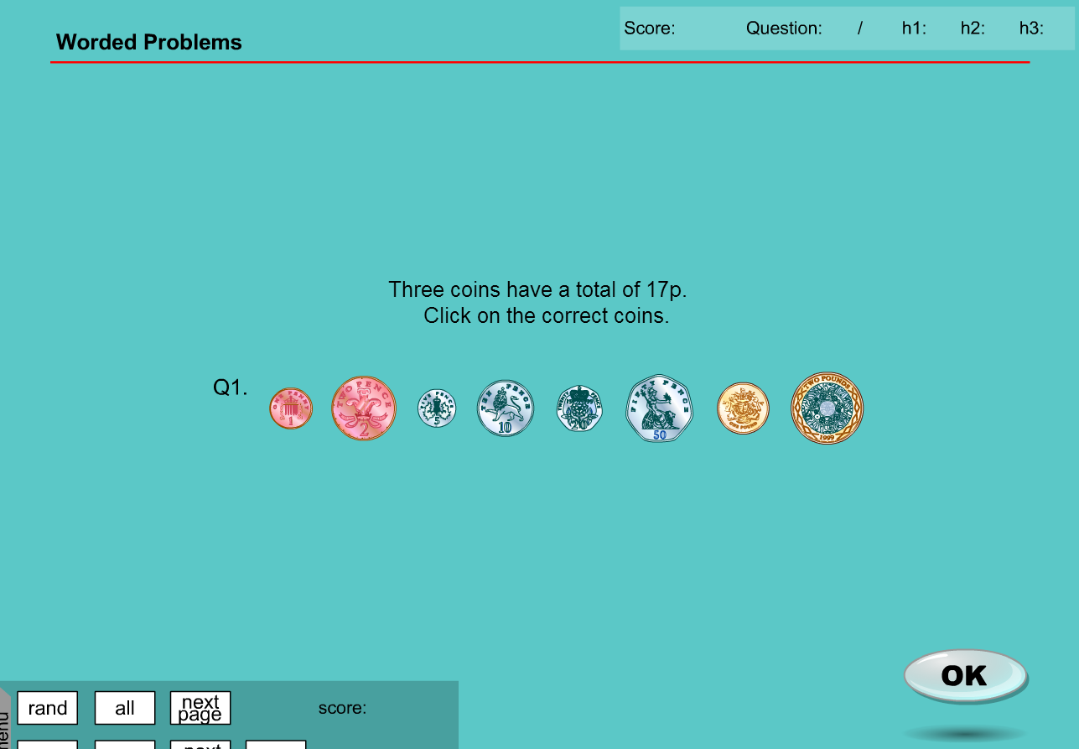

**MA_GBR_0750NAx0200 - fixes**

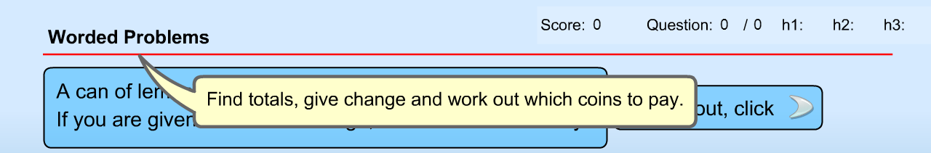

Achievement objective could accommodate coins of different denominations so suggest changing the 8 available UK coins with the 5 available NZ coins. Also chance ‘p’ to ‘c’ and ‘£’ to ‘$’ in questions.

Voiceover is fine as it does not mention currency units.

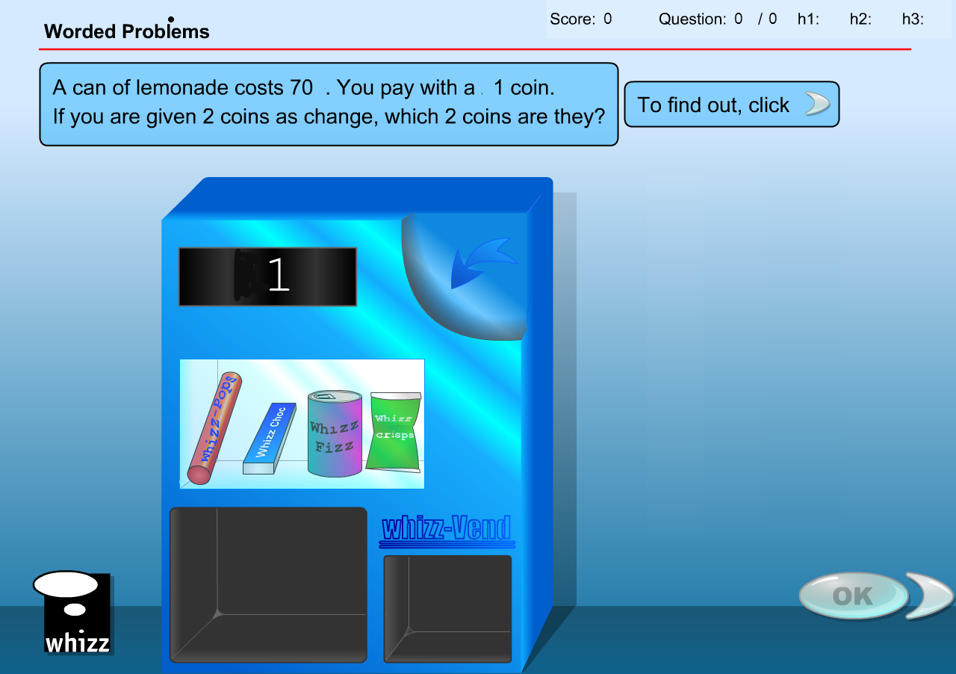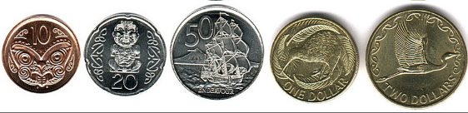

Question 1

* Replace ‘1, 2, 5, 10, 20, 50p, and 1 pound’ coins with ‘10, 20, and 50c, and $1 and $2 coins
* Replace ‘20p’ with ’20c’
* Answer required will not change with student selecting the 10c coin

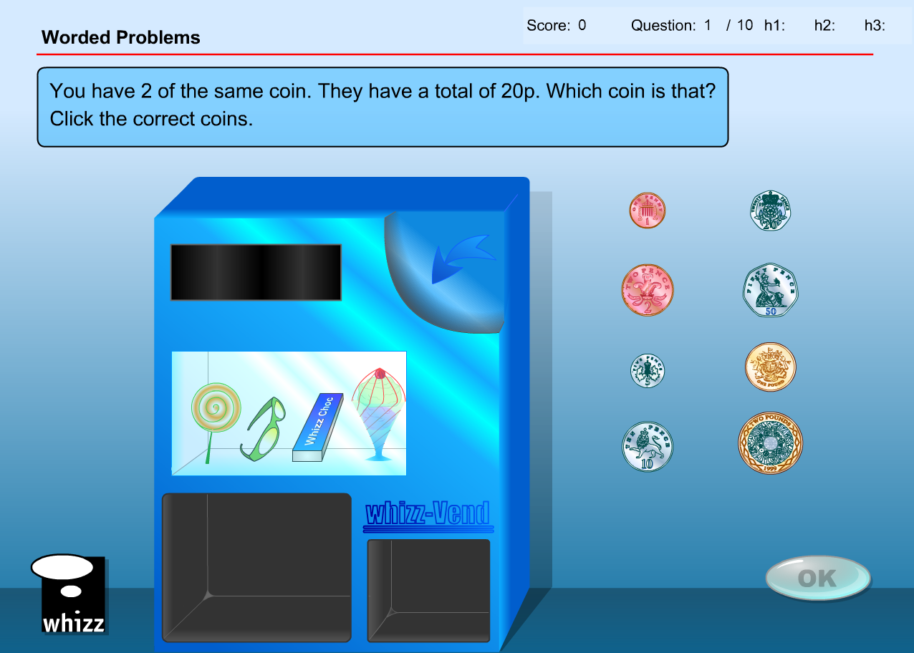

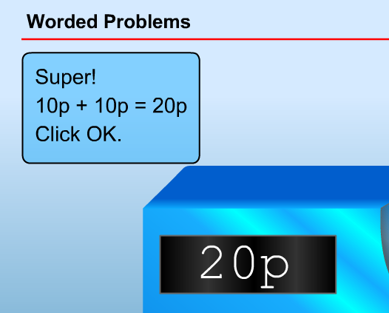

* Answer box will need to say ‘10c + 10c = 20c’
* Answer box will need to say ‘20c’

Question 2

* Replace ‘1, 2, 5, 10, 20, 50p, and 1 pound’ coins with ‘10, 20, and 50c, and $1 and $2 coins
* Replace ‘26p’ with ’80c’
* Answer required will not substantially change with student required to select 3 coins, 1 x 50c, 1 x 20c and 1 x 10c

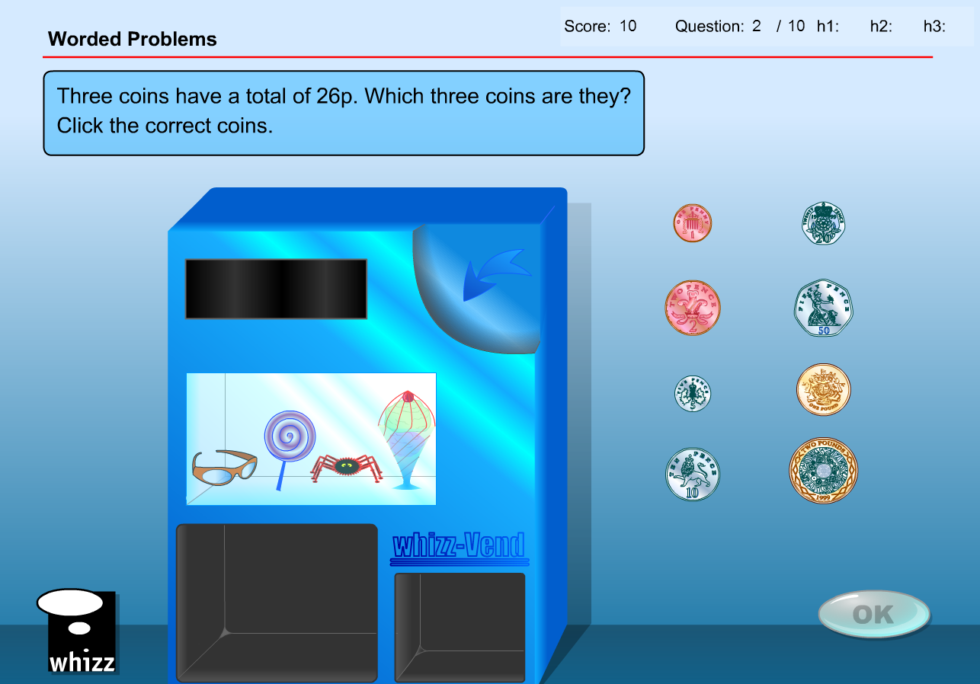



* Answer box will need to say ‘50c + 20c + 10c = 80c’
* Answer box will need to say ‘80c’

Question 3

* Replace ‘1, 2, 5, 10, 20, 50p, and 1 pound’ coins with ‘10, 20, and 50c, and $1 and $2 coins
* Replace ‘7p’ with ’70c’
* Replace ‘10p’ with ‘$1’
* Answer changed to 1 x 20c and 1 x 10c coin

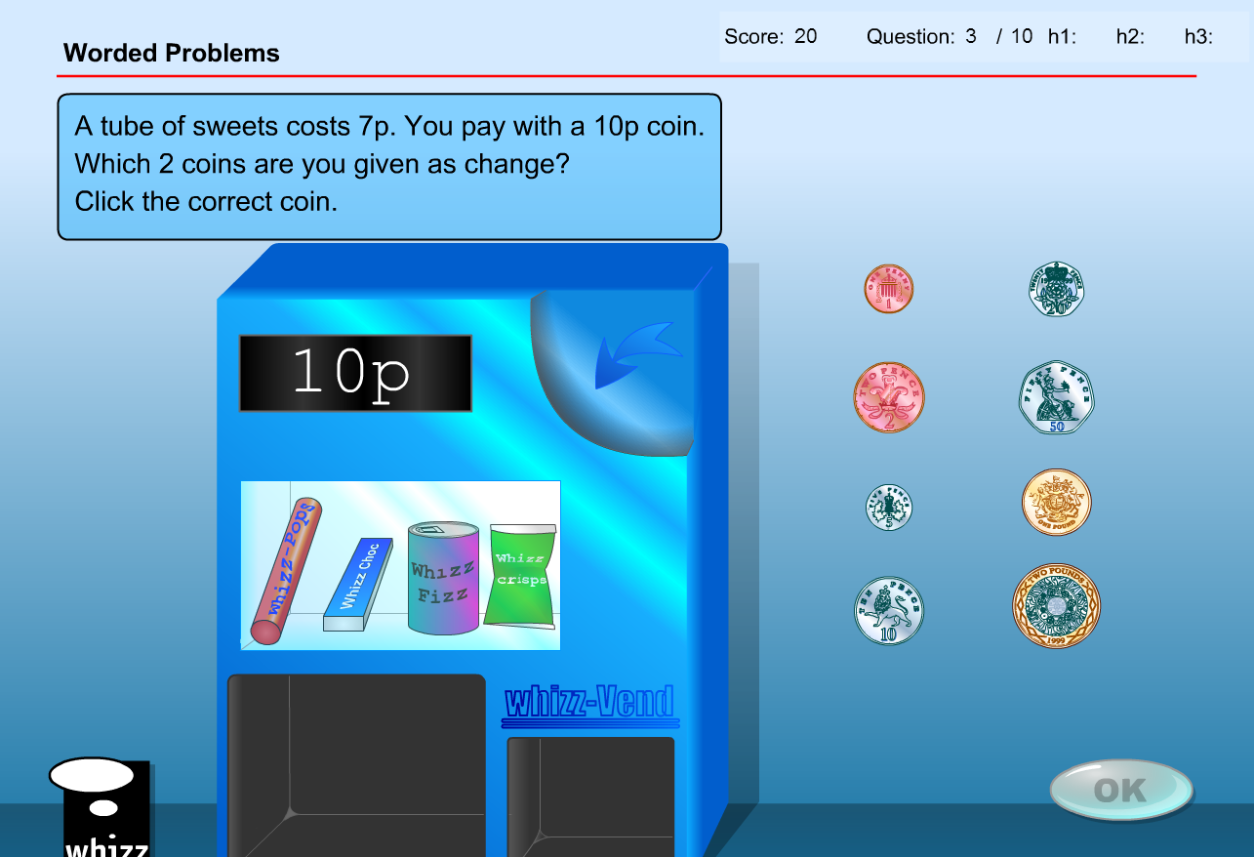

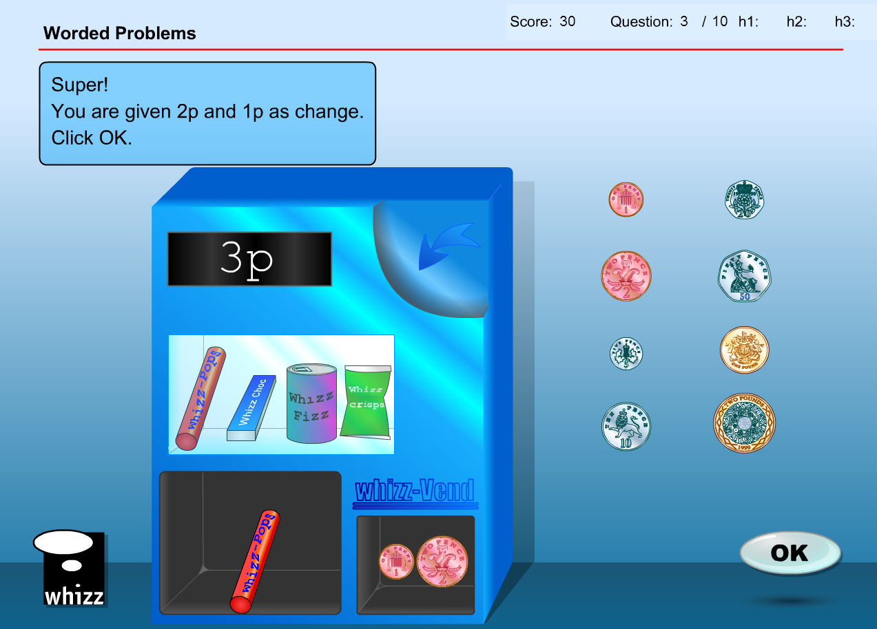

* Answer box will need to say ‘$1 – 70c = 30c’
* Answer box will need to say ‘30c’

Question 4

* Replace ‘1, 2, 5, 10, 20, 50p, and 1 pound’ coins with ‘10, 20, and 50c, and $1 and $2 coins
* Replace ‘£1.30’ with ’$1.30’
* Replace ‘£2’ with ‘$2’
* Answer does not substantially change with student selecting 1 x 50c and 1 x 20c coin

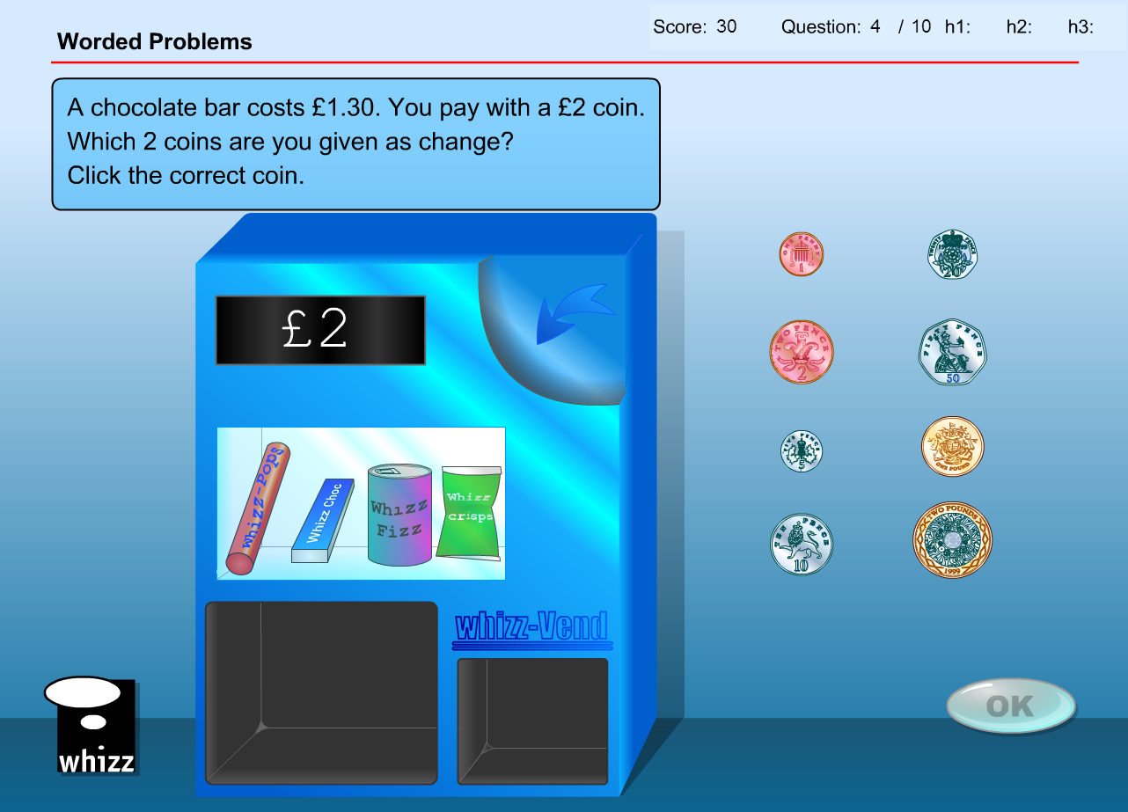

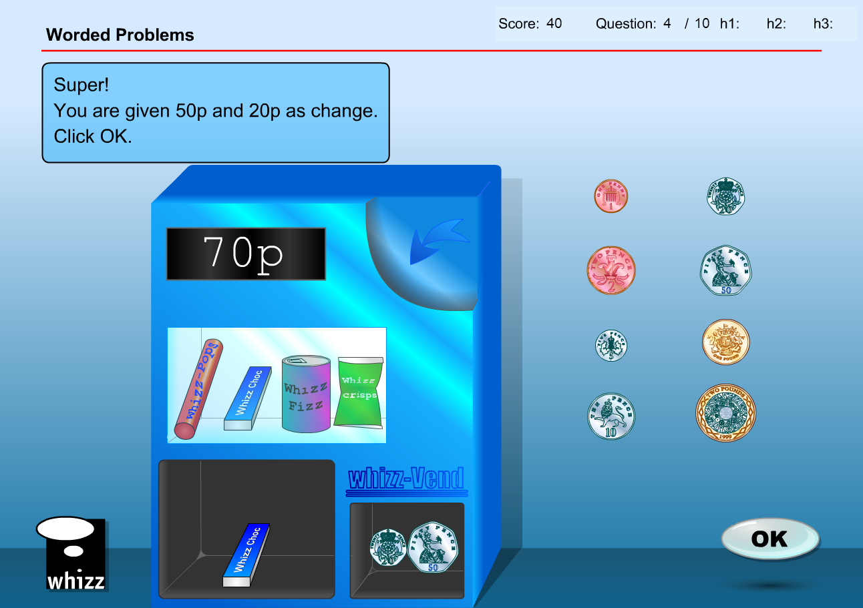

* Answer box will need to change ‘50p’ to ‘50c’ and ‘20p’ to ‘20c’
* Answer box will need to say ‘70c’

Question 5

* Replace ‘1, 2, 5, 10, 20, 50p, and 1 pound’ coins with ‘10, 20, and 50c, and $1 and $2 coins
* Replace ‘£1’ with ’$1’
* Answer does not substantially change with student selecting 1 x 50c

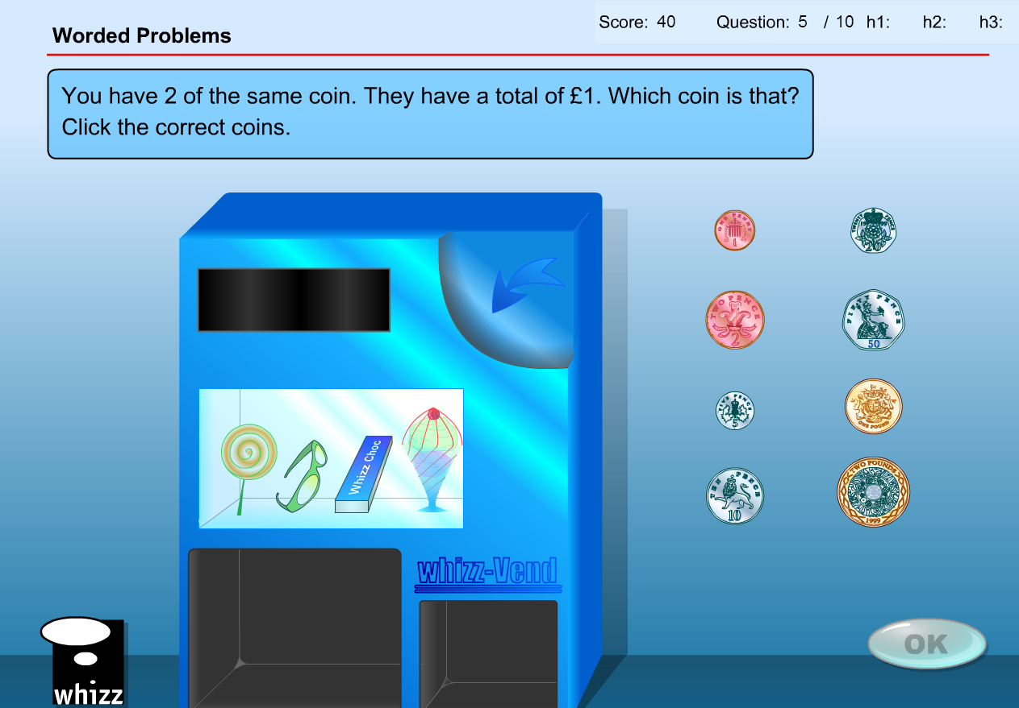

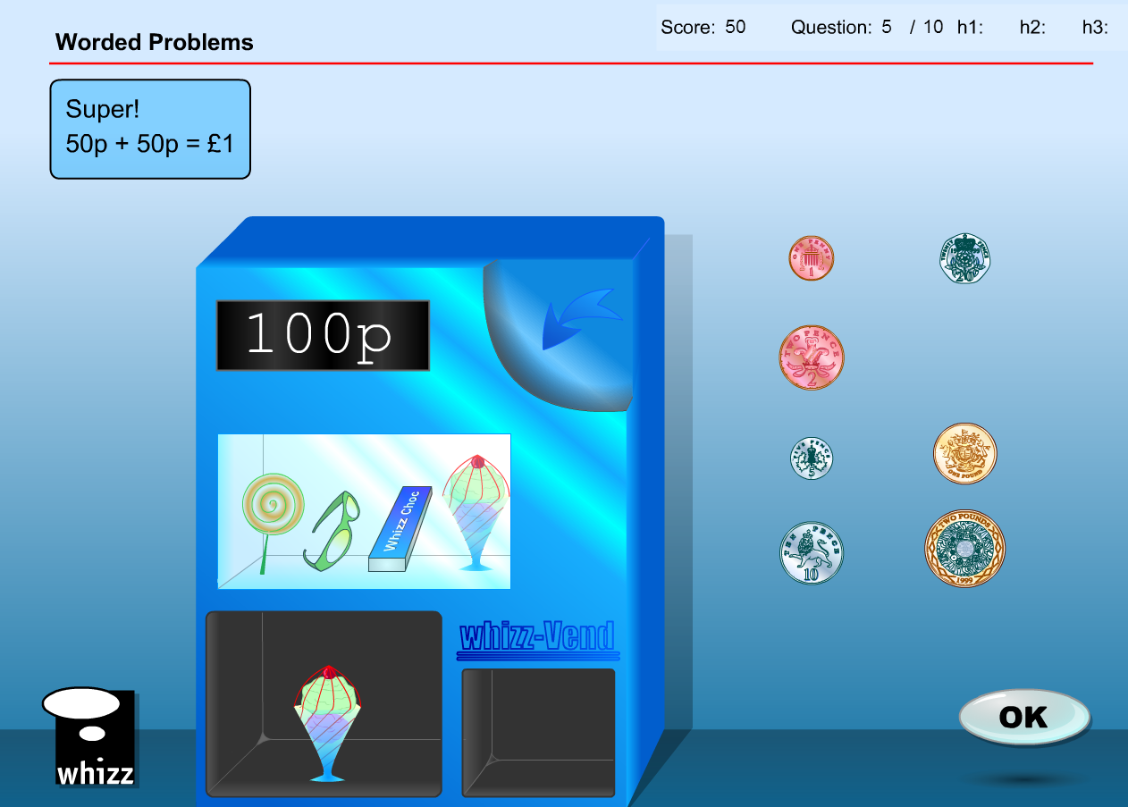

Question 6

* Answer box will need to change to show ‘50c + 50c = $1’
* Answer box will need to say ‘50c’ then ‘50c’
* Final answer will need to display ‘$1”
* Replace ‘1, 2, 5, 10, 20, 50p, and 1 pound’ coins with ‘10, 20, and 50c, and $1 and $2 coins
* Replace ‘40p’ with ’40c’
* Answer does not substantially change with student selecting 1 x 20c

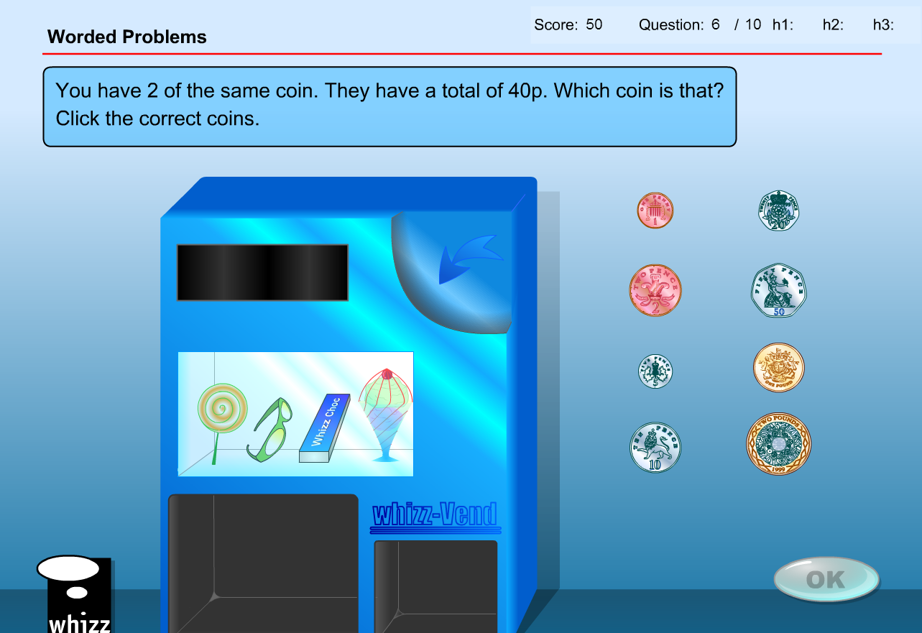

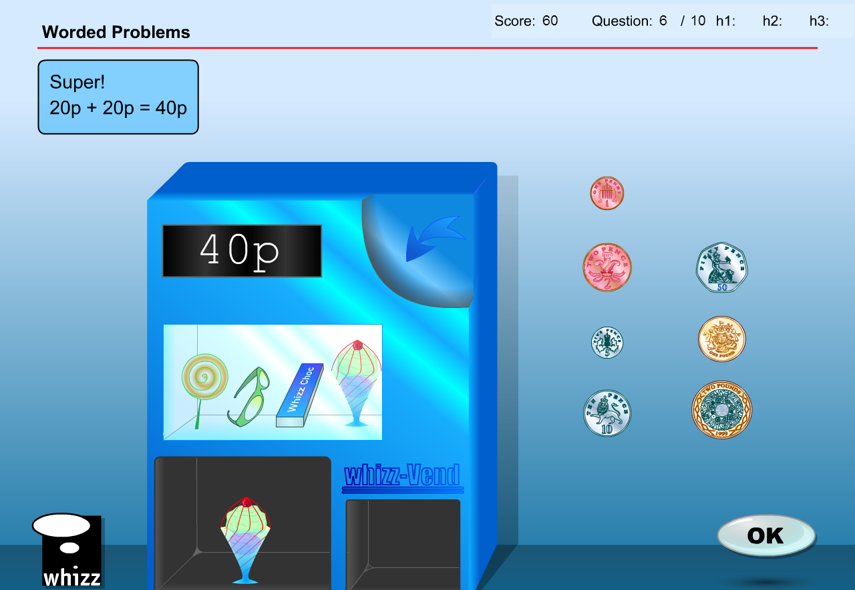

* Answer box will need to change to show ’20c + 20c = 40c’
* Answer box will need to say ‘20c’ then ‘20c’
* Final answer will need to display ‘40c”

Question 7

* Replace ‘1, 2, 5, 10, 20, 50p, and 1 pound’ coins with ‘10, 20, and 50c, and $1 and $2 coins
* Replace ‘35p’ with ’$1.40’
* Replace ‘50p’ with ’$2’
* Answer does not substantially change with student selecting 1 x 50c and 1 x 10c

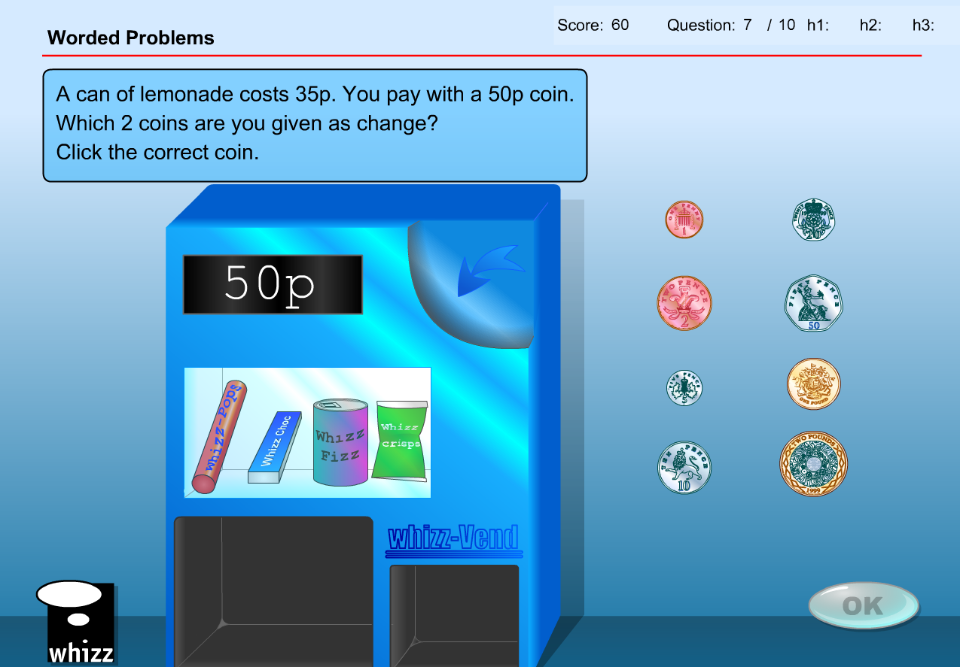

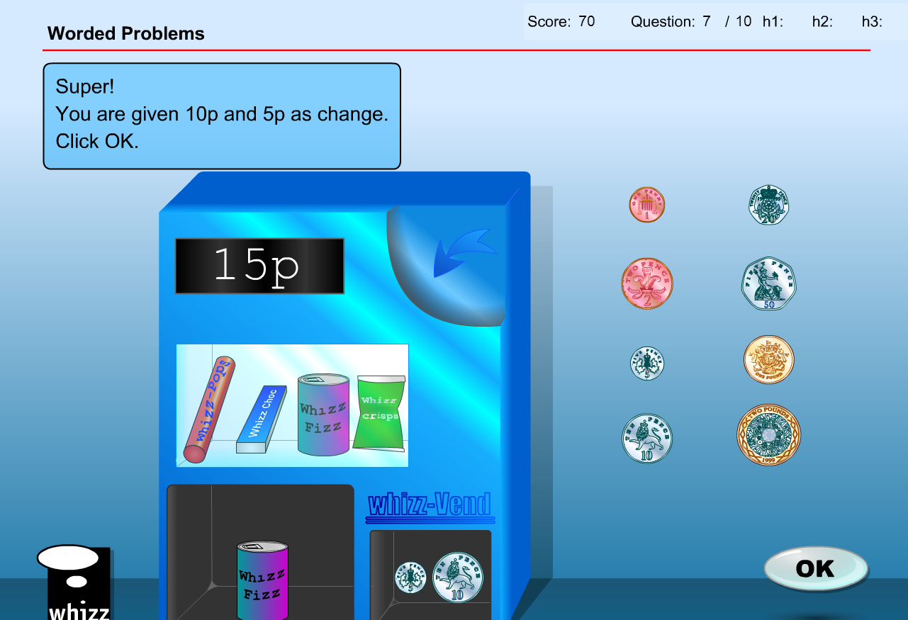

* Answer box will need to change to show ‘50c and 10c’
* Final answer will need to display ‘60c’

Question 8

* Replace ‘1, 2, 5, 10, 20, 50p, and 1 pound’ coins with ‘10, 20, and 50c, and $1 and $2 coins
* Replace ‘16p’ with ’$1.70c’
* Answer does not substantially change with student selecting 1 x $1, 1 x 50c and 1 x 20c

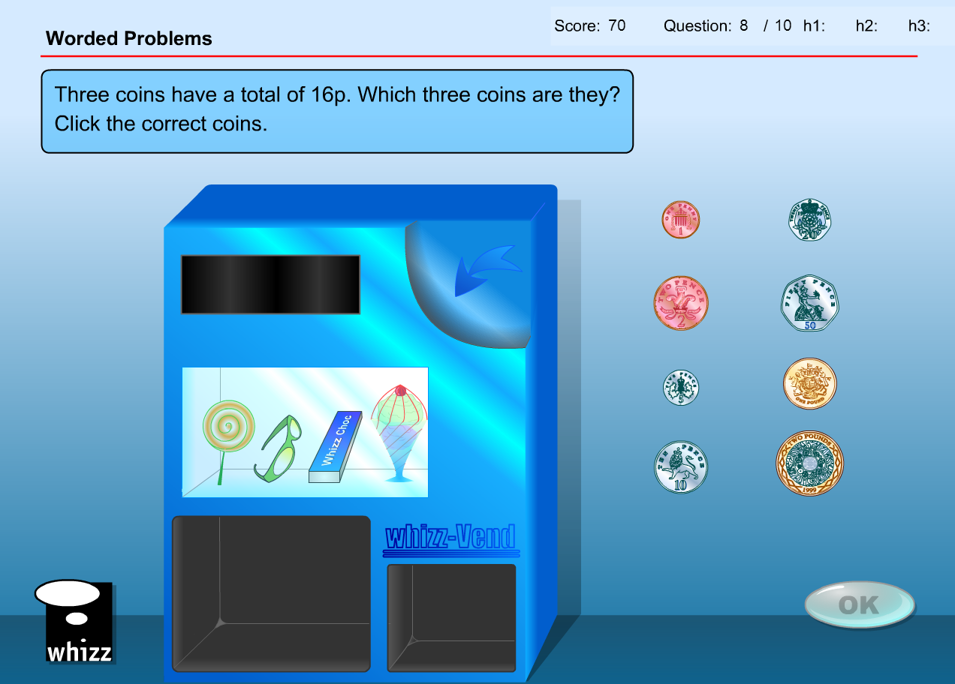

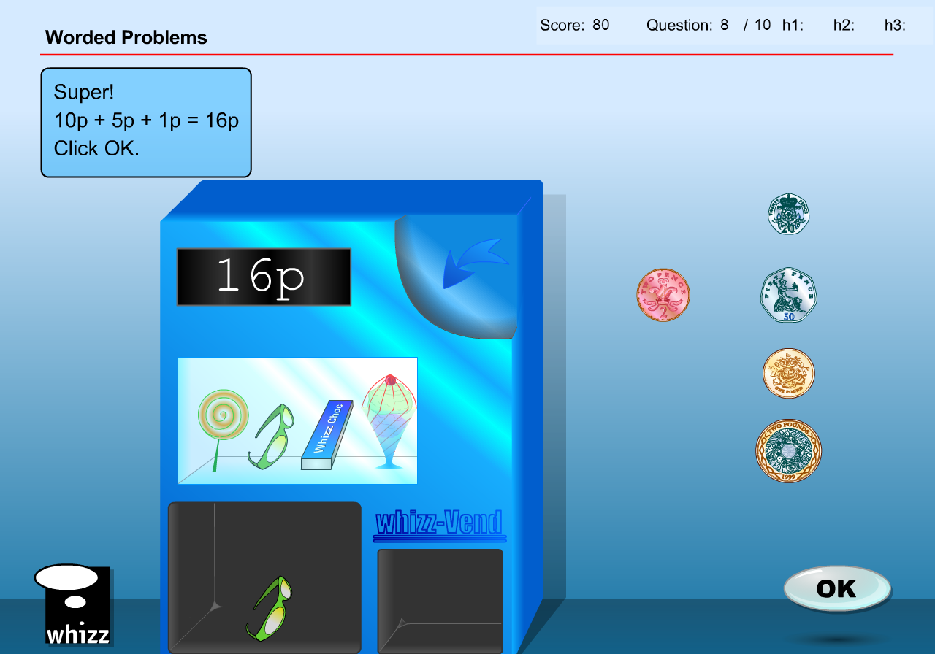

* Answer box will need to change to show ’$1, 50c and 20c’
* Final answer will need to display ‘$1.70’

Question 9

* Replace ‘1, 2, 5, 10, 20, 50p, and 1 pound’ coins with ‘10, 20, and 50c, and $1 and $2 coins
* Replace ‘25p’ with ’40c’
* Replace ‘50p’ with ’$1’
* Answer does not substantially change with student selecting 1 x 50c and 1 x 10c

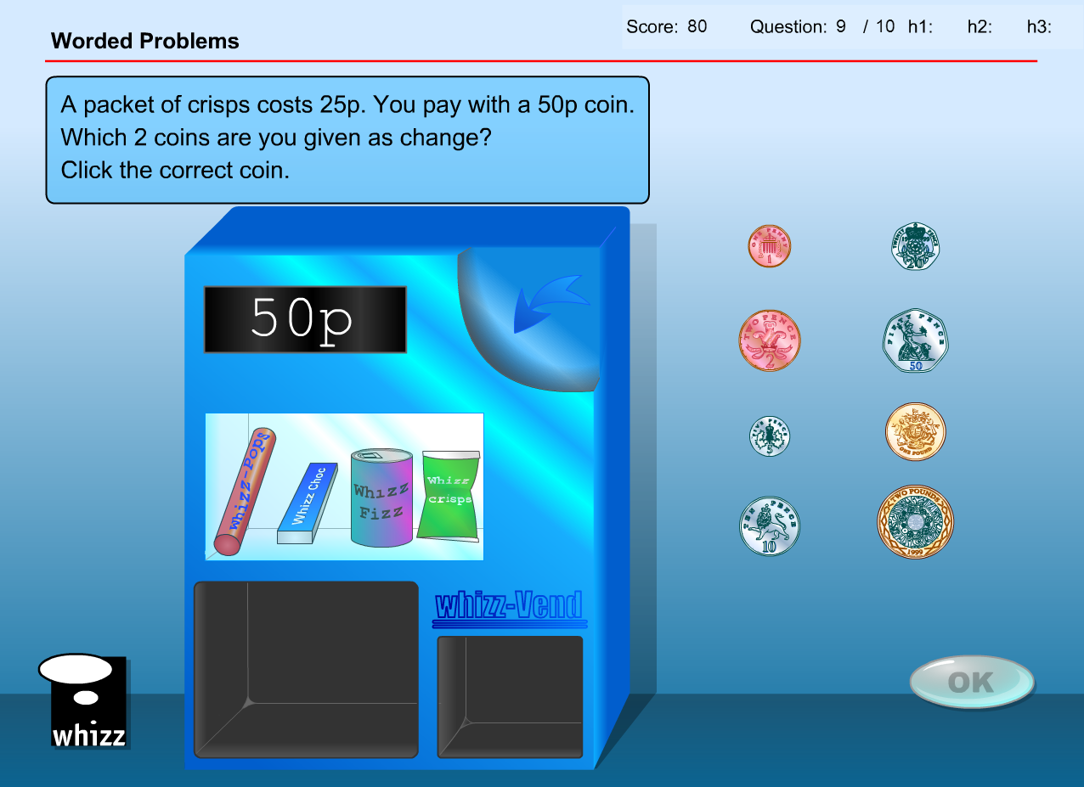

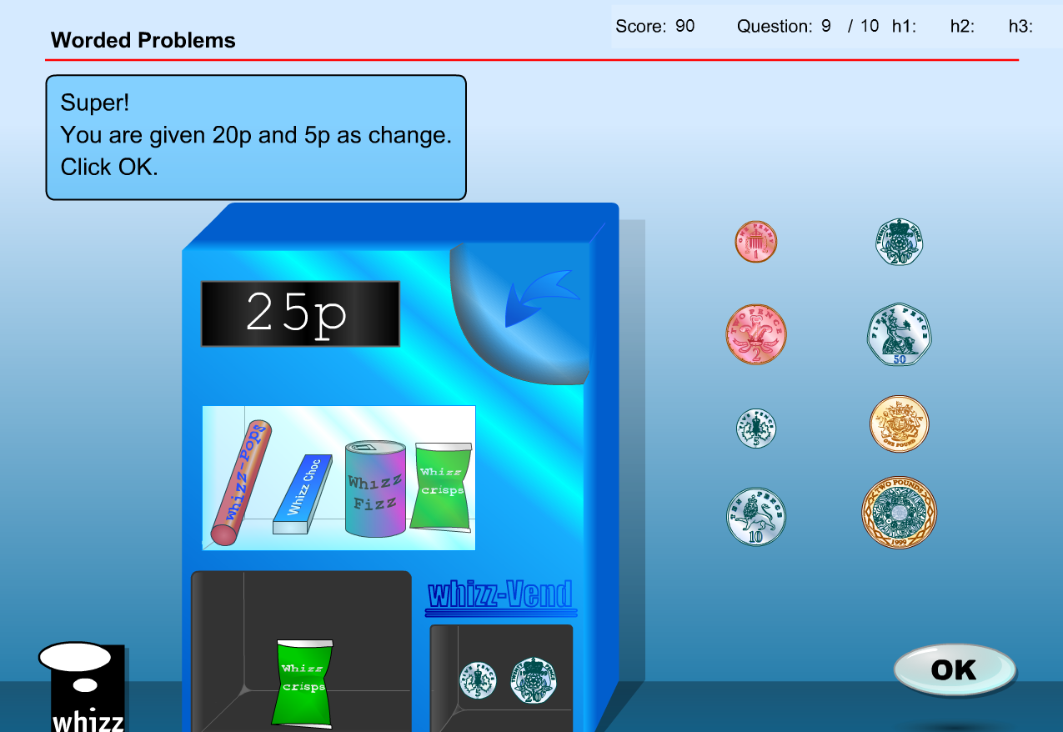

* Answer box will need to change to show ’50c and 10c’
* Final answer will need to display ‘60c”

Question 10

* Replace ‘1, 2, 5, 10, 20, 50p, and 1 pound’ coins with ‘10, 20, and 50c, and $1 and $2 coins
* Replace ‘35p’ with ’$3.20’
* Answer does not substantially change with student selecting 1 x $2, 1 x $1 and 1 x 20c

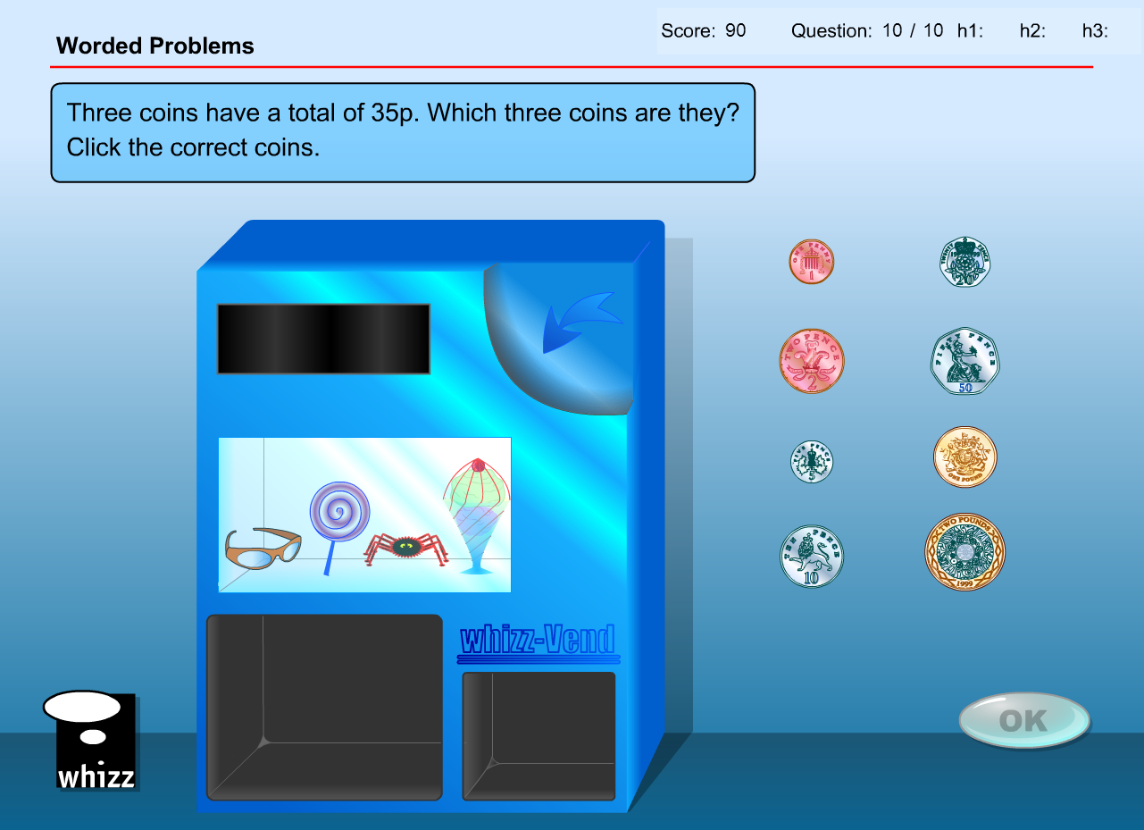

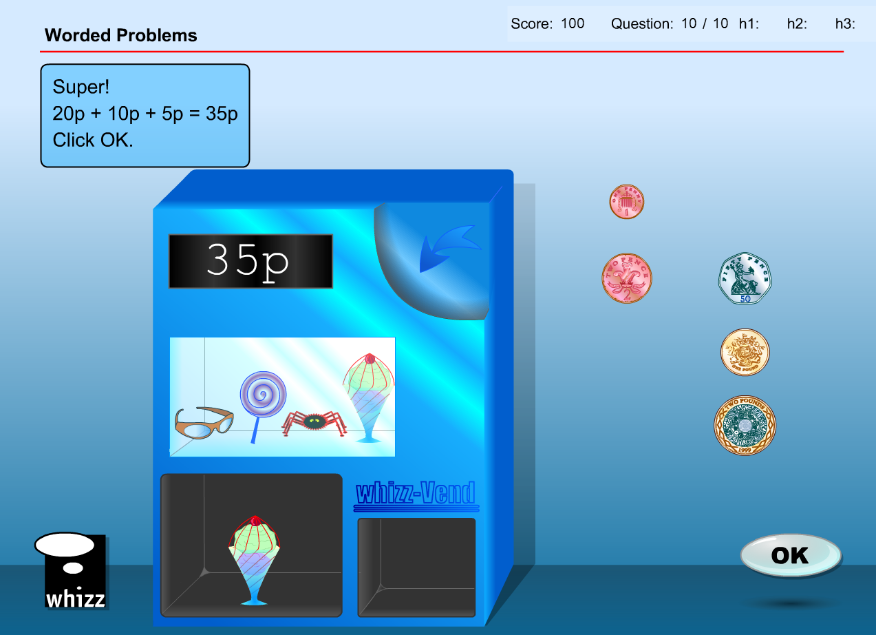

* Answer box will need to change to show ‘$2, $1 and 20c’
* Final answer will need to display ‘$3.20’

It appears as though there are more than 10 questions in the database so other examples could be;

Question 11

* Replace ‘1, 2, 5, 10, 20, 50p, and 1 pound’ coins with ‘10, 20, and 50c, and $1 and $2 coins
* Replace ‘35p’ with ’$1.60’
* Answer does not substantially change with student selecting 1 x $1, 1 x 50c and 1 x 10c





* Answer box will need to change to show ‘$1, 50c and 10c’
* Final answer will need to display ‘$1.60’

Question 12

* Replace ‘1, 2, 5, 10, 20, 50p, and 1 pound’ coins with ‘10, 20, and 50c, and $1 and $2 coins
* Replace ‘£2’ with ’$2’
* Answer does not substantially change with student selecting 2 x $1

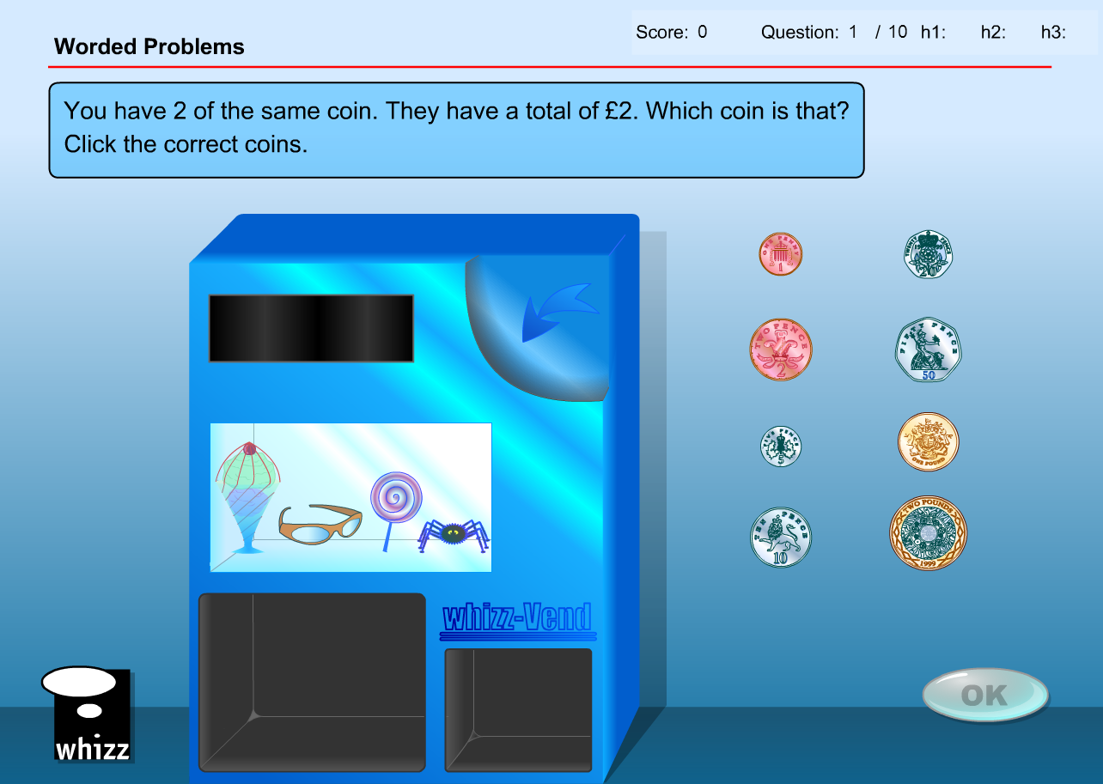

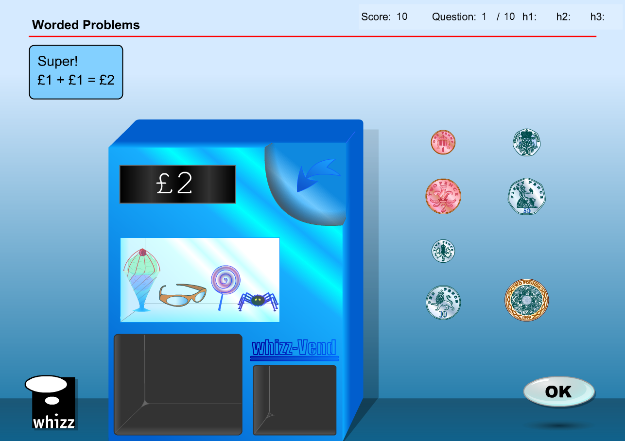

* Answer box will need to change to show ‘$1 + $1 = $2’
* Final answer will need to display ‘$2’

Question 13

* Replace ‘1, 2, 5, 10, 20, 50p, and 1 pound’ coins with ‘10, 20, and 50c, and $1 and $2 coins
* Replace ‘13p’ with ’$3.10’
* Answer does not substantially change with student selecting 1 x $2, 1 x $1 and 1 x 10c

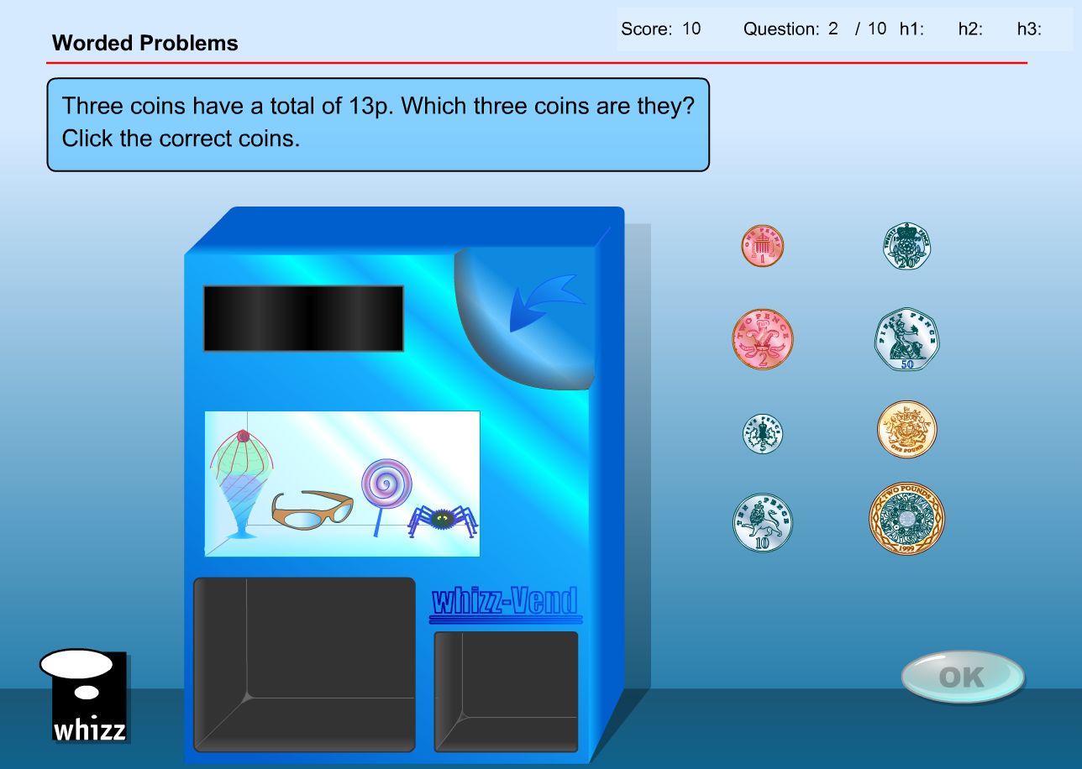

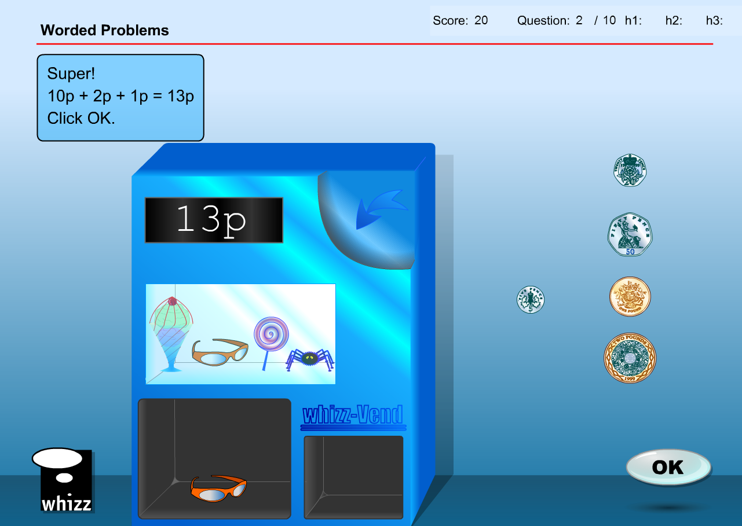

* Answer box will need to change to show ‘$2 + $1 + 10c = $3.10’
* Final answer will need to display ‘$3.10’

**Test content has the same issues/solution**

Achievement objective could accommodate coins of different denominations so suggest changing the 8 available UK coins with the 5 available NZ coins. Also chance ‘p’ to ‘c’ and ‘£’ to ‘$’ in questions.

If there are more than 5 questions in the database I have suggested some extra questions as well.

Question 1

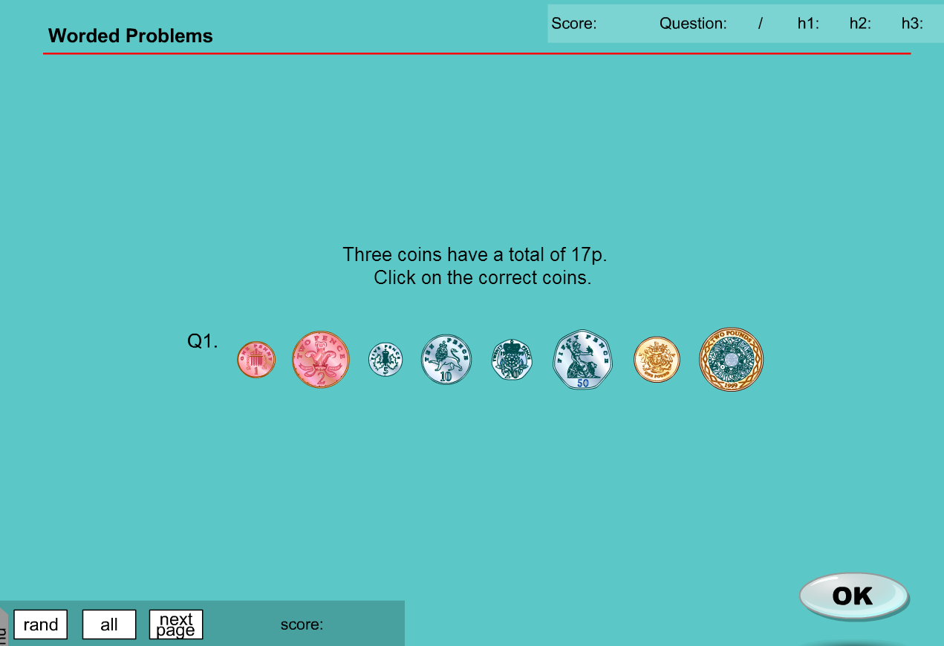

* Replace ‘1, 2, 5, 10, 20, 50p, and 1 pound’ coins with ‘1, 2, 5, 10, 20, 50, and 100 value tokens’
* Replace ‘17p’ with ’$1.70’
* Answer required will not change substantially with student selecting 1 x 20, 1 x 50 and 1 x $1

Question 2

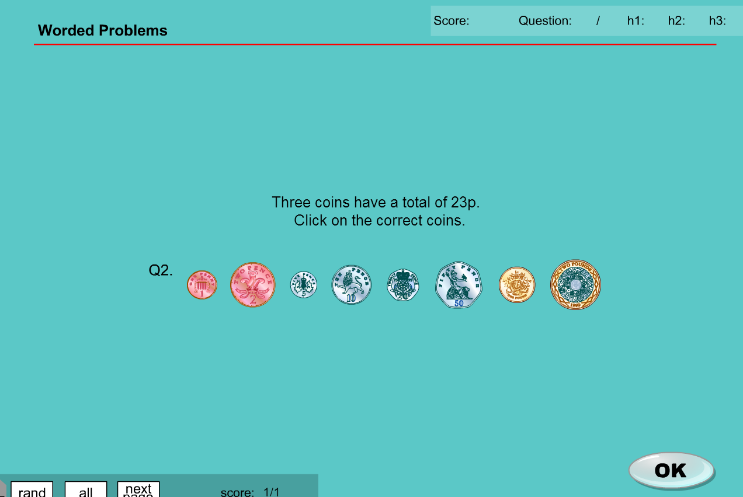

* Replace ‘1, 2, 5, 10, 20, 50p, and 1 pound’ coins with ‘1, 2, 5, 10, 20, 50, and 100 value tokens’
* Replace ‘23p’ with ’$2.30’
* Answer required will not change substantially with student selecting 1 x 10, 1 x 20 and 1 x $2

Question 3

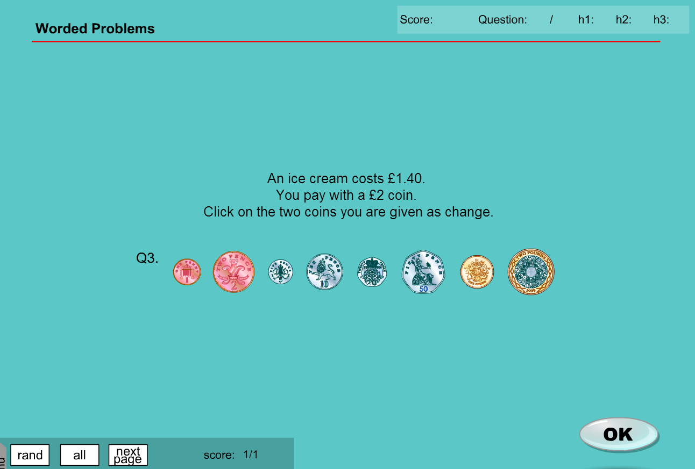

* Replace ‘1, 2, 5, 10, 20, 50p, and 1 pound’ coins with ‘1, 2, 5, 10, 20, 50, and 100 value tokens’
* Replace ‘£1.40’ with ’$1.40’
* Replace ‘£2’ with ‘$2’
* Answer required will not change substantially with student selecting 1 x 10 and 1 x 50

Question 4

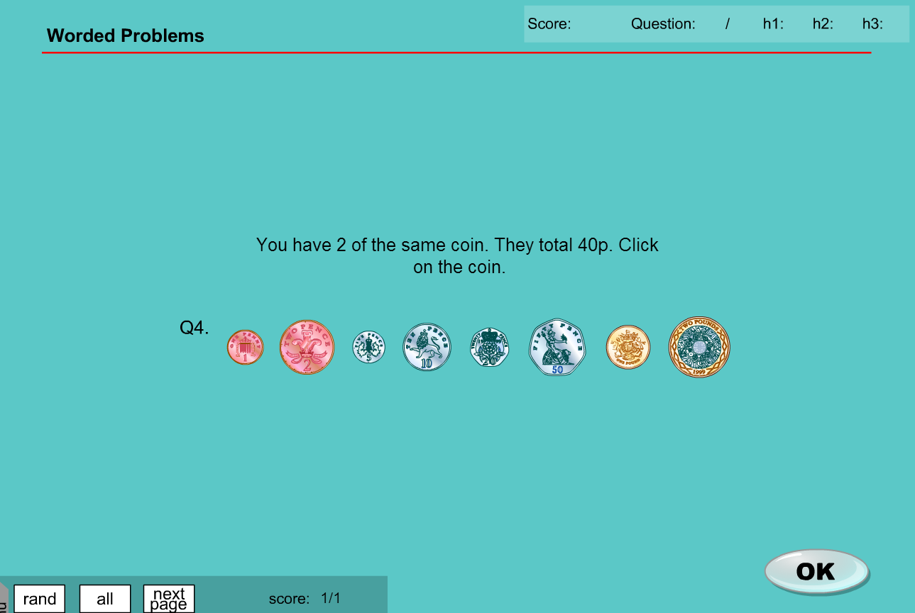

* Replace ‘1, 2, 5, 10, 20, 50p, and 1 pound’ coins with ‘1, 2, 5, 10, 20, 50, and 100 value tokens’
* Replace ‘40p’ with ’40c’
* Answer required will not change substantially with student selecting 1 x 20

Question 5

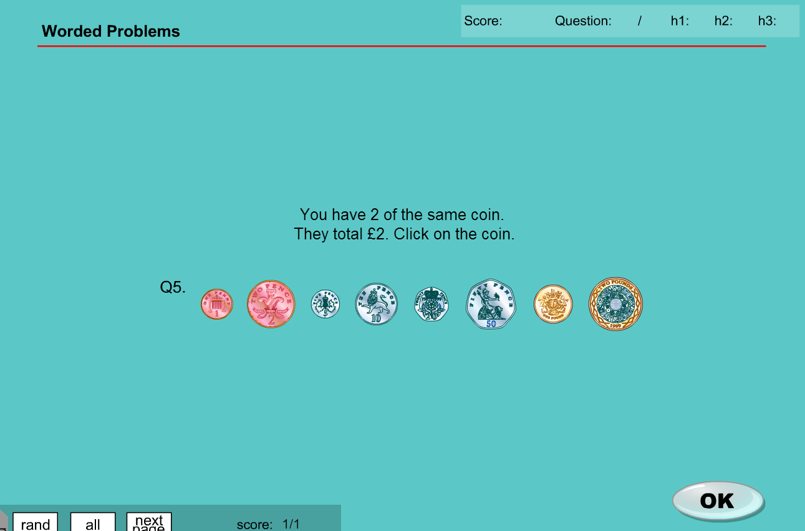

* Replace ‘1, 2, 5, 10, 20, 50p, and 1 pound’ coins with ‘1, 2, 5, 10, 20, 50, and 100 value tokens’
* Replace ‘£2’ with ’$2’
* Answer required will not change substantially with student selecting 1 x $1

**MA_GBR_0850NAx0100**

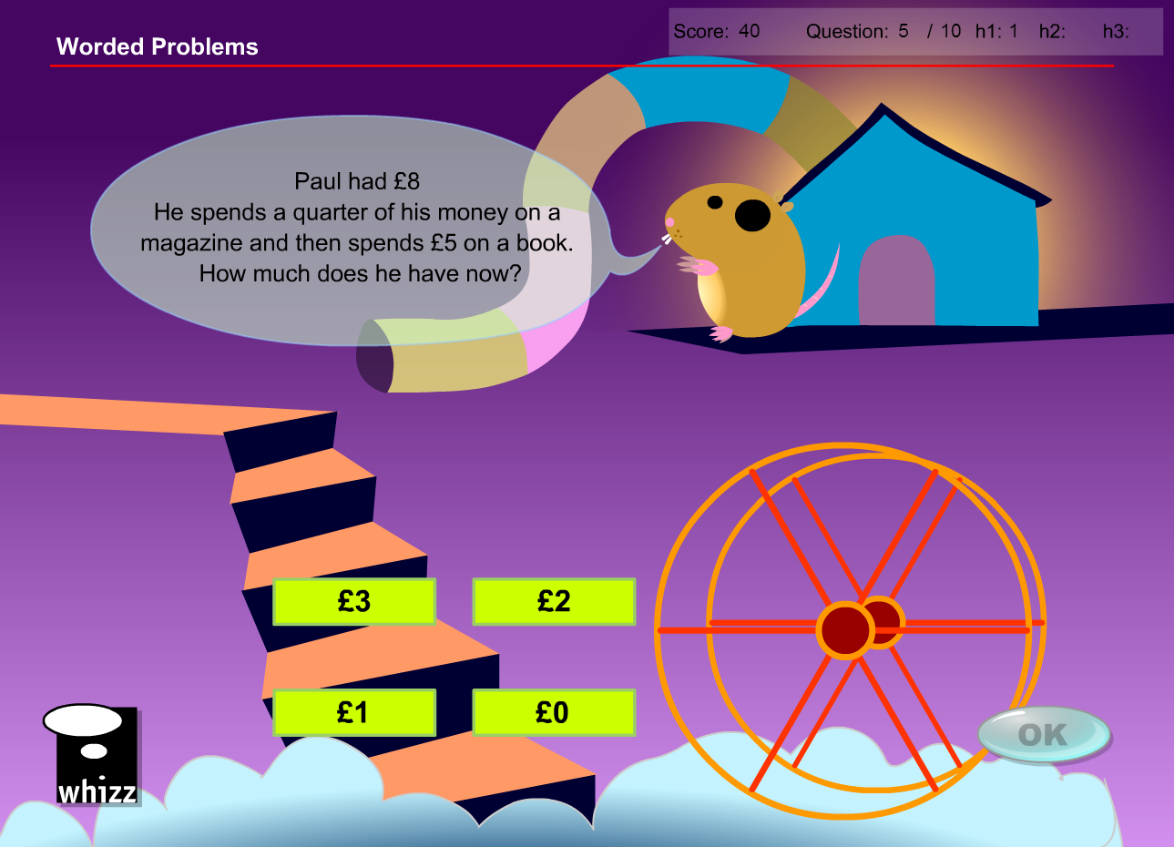

Should only require basic graphic and audio changes as substituting ‘$’ for ‘£’ should result in the same numerical outcomes

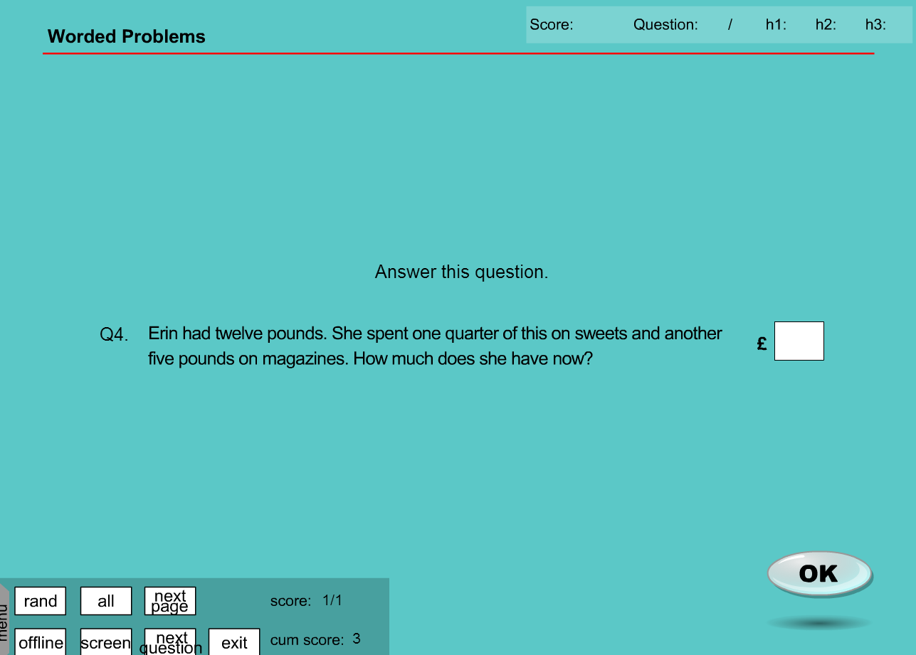

**MA_GBR_0850NAx0100 - fixes**

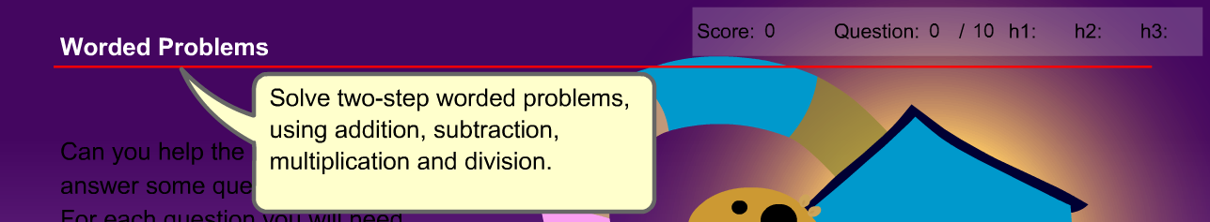

Achievement Objective does not specifically require a money context, and many of the problems are not in a currency context

Question 1

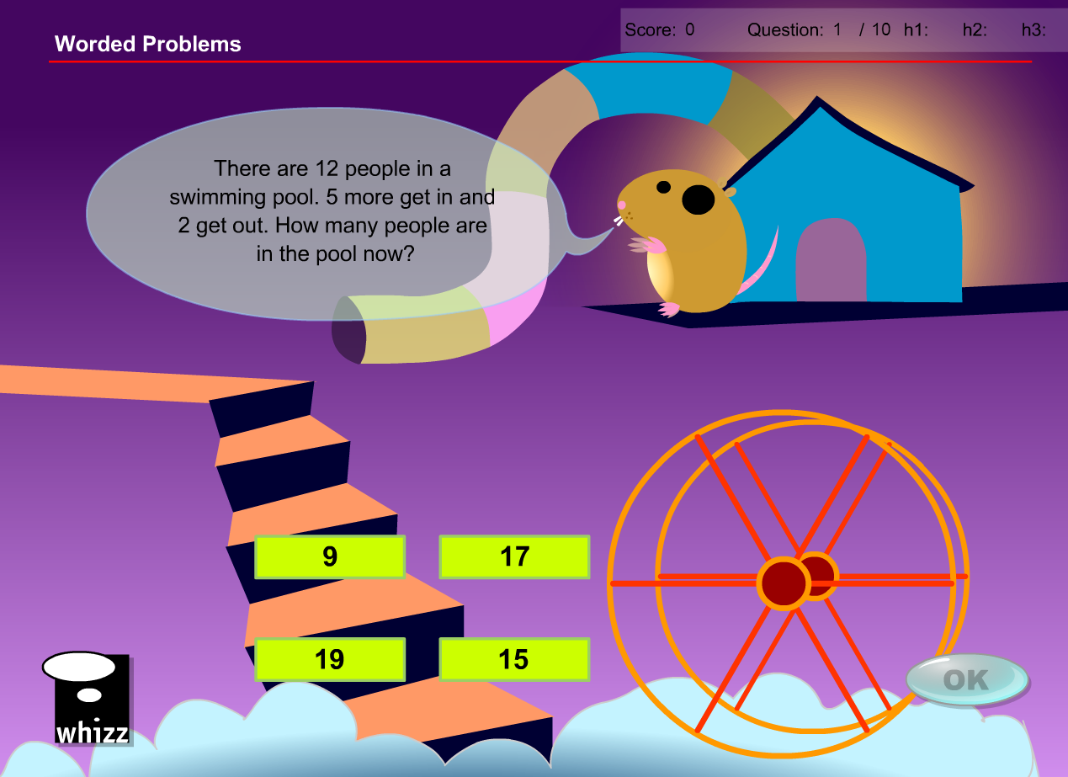

* No change required

Question 2

* No change required

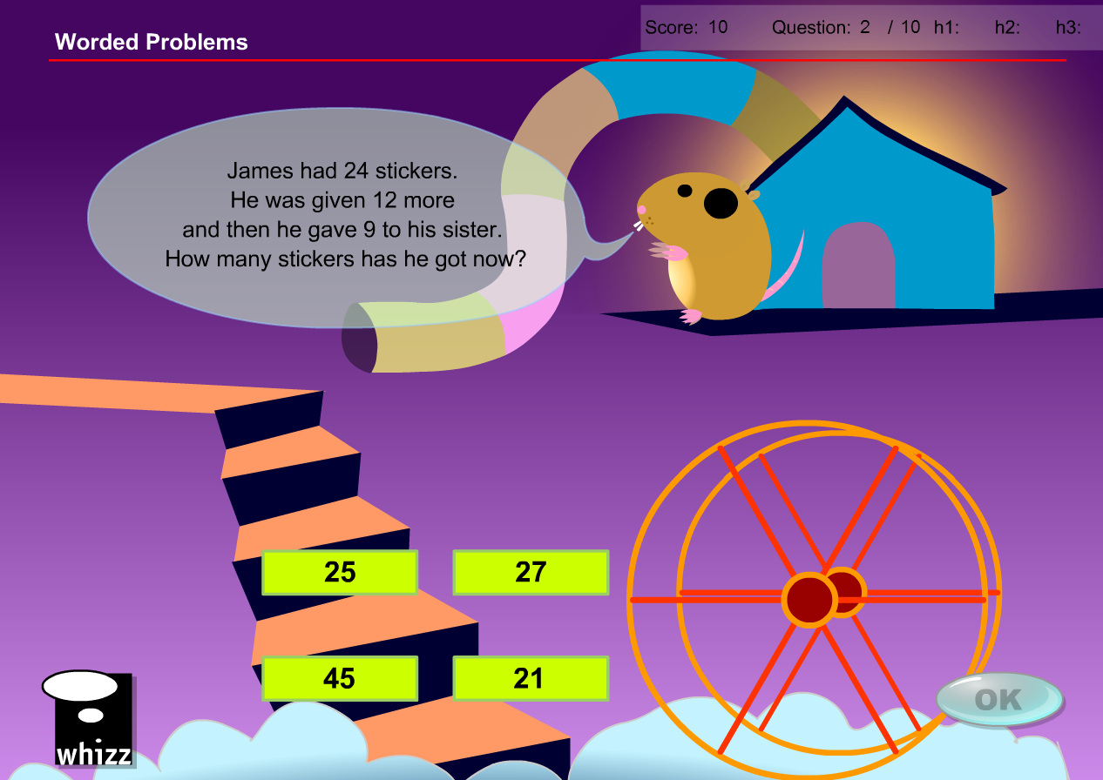

Question 3

* No change required

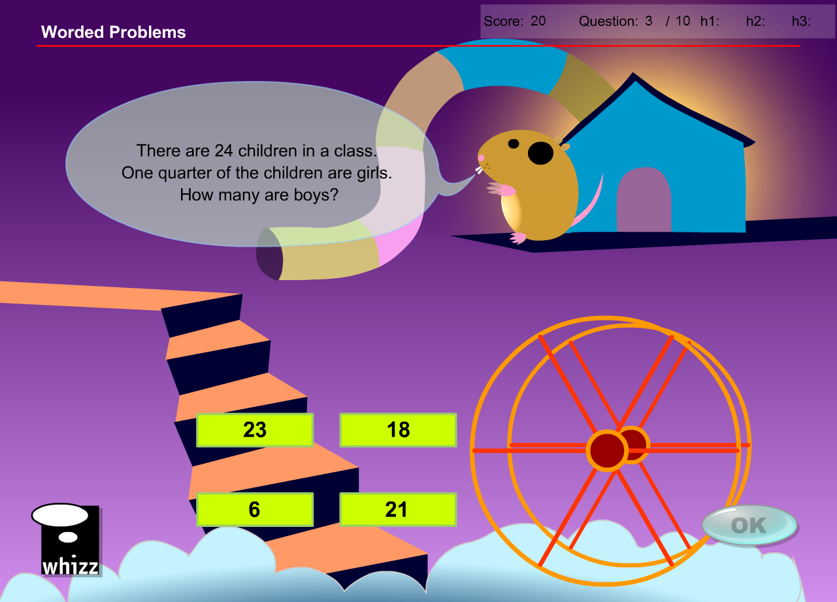

Question 4

* No change required

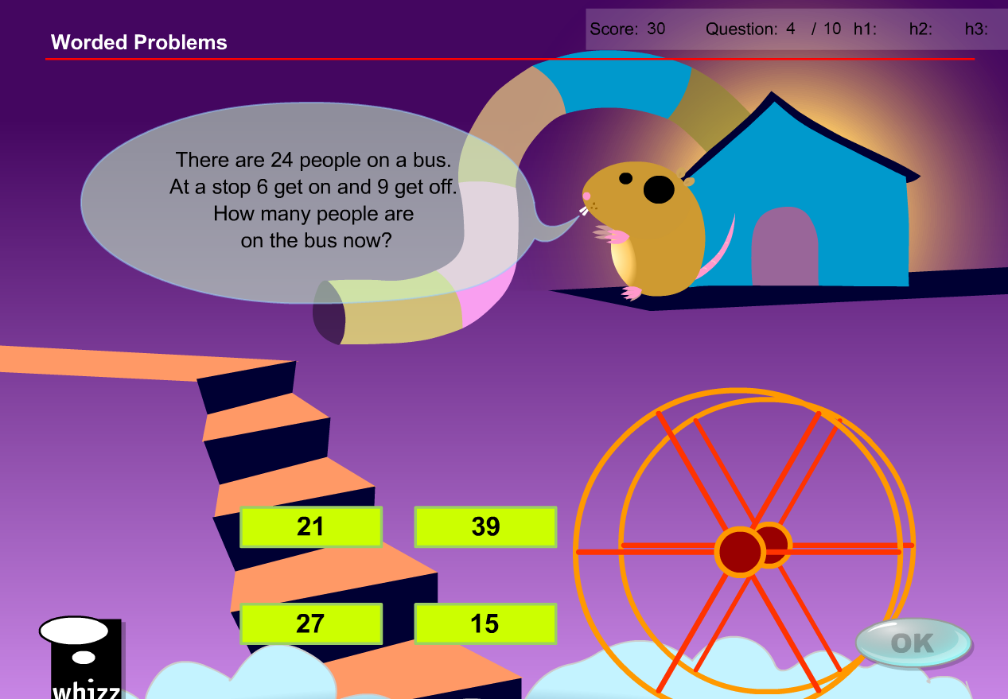

Question 5

* No change required

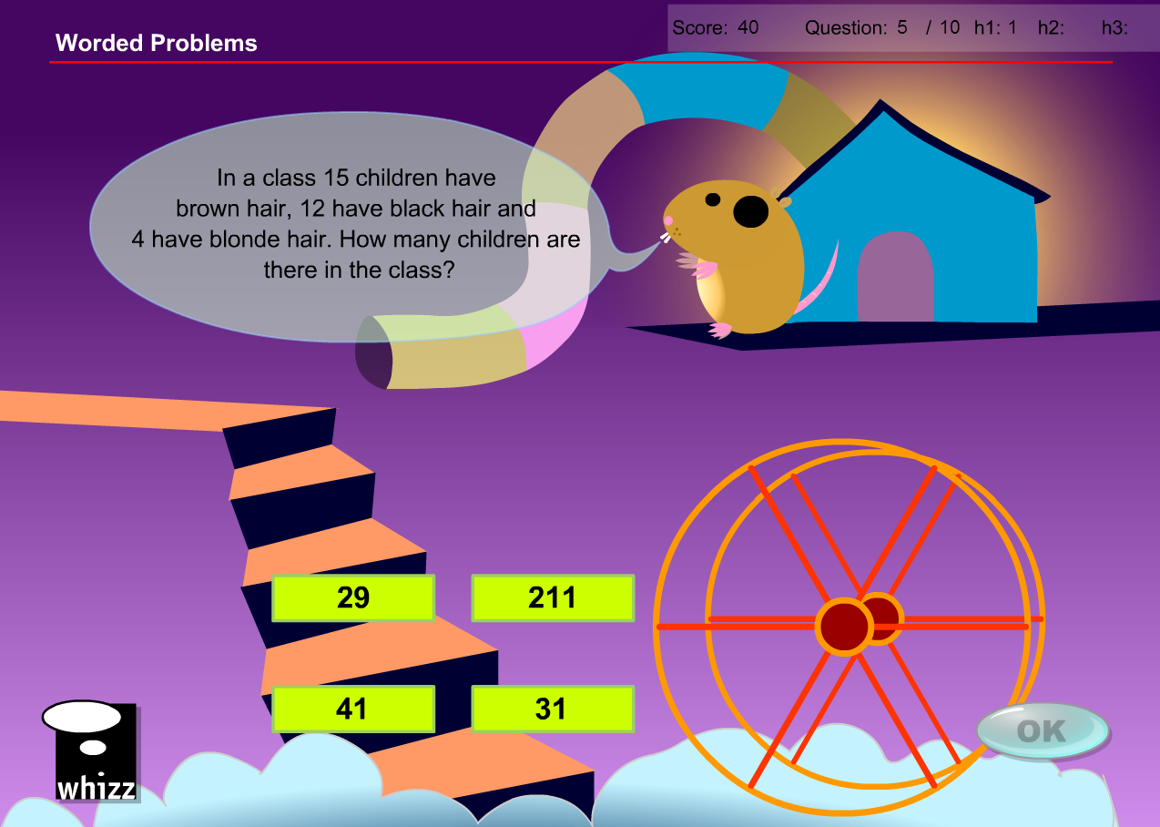

Question 6

* No change required

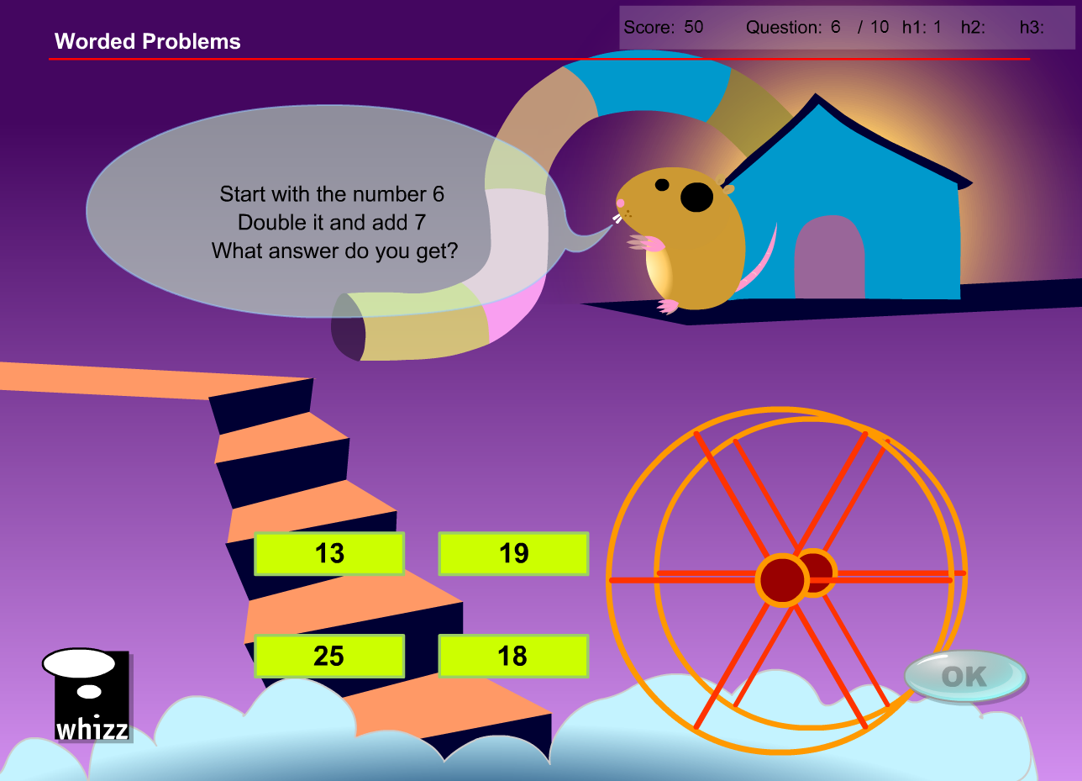

Question 7

* No change required

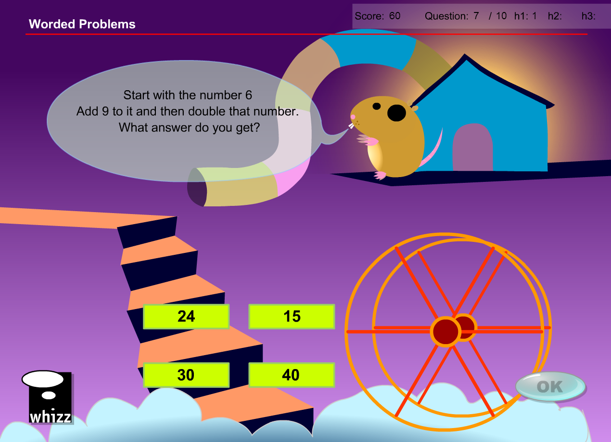

Question 8

* No change required

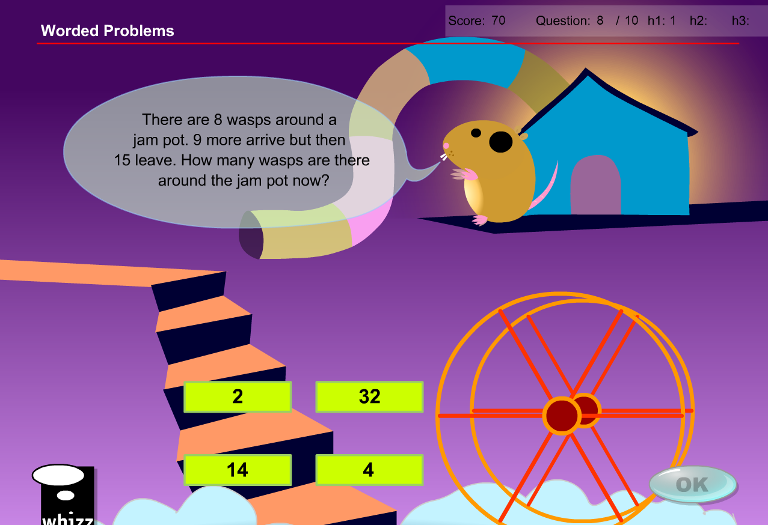

Question 9

* Replace ‘£’ with ‘$’
* Audio talks about ‘pounds’ so perhaps delete audio??

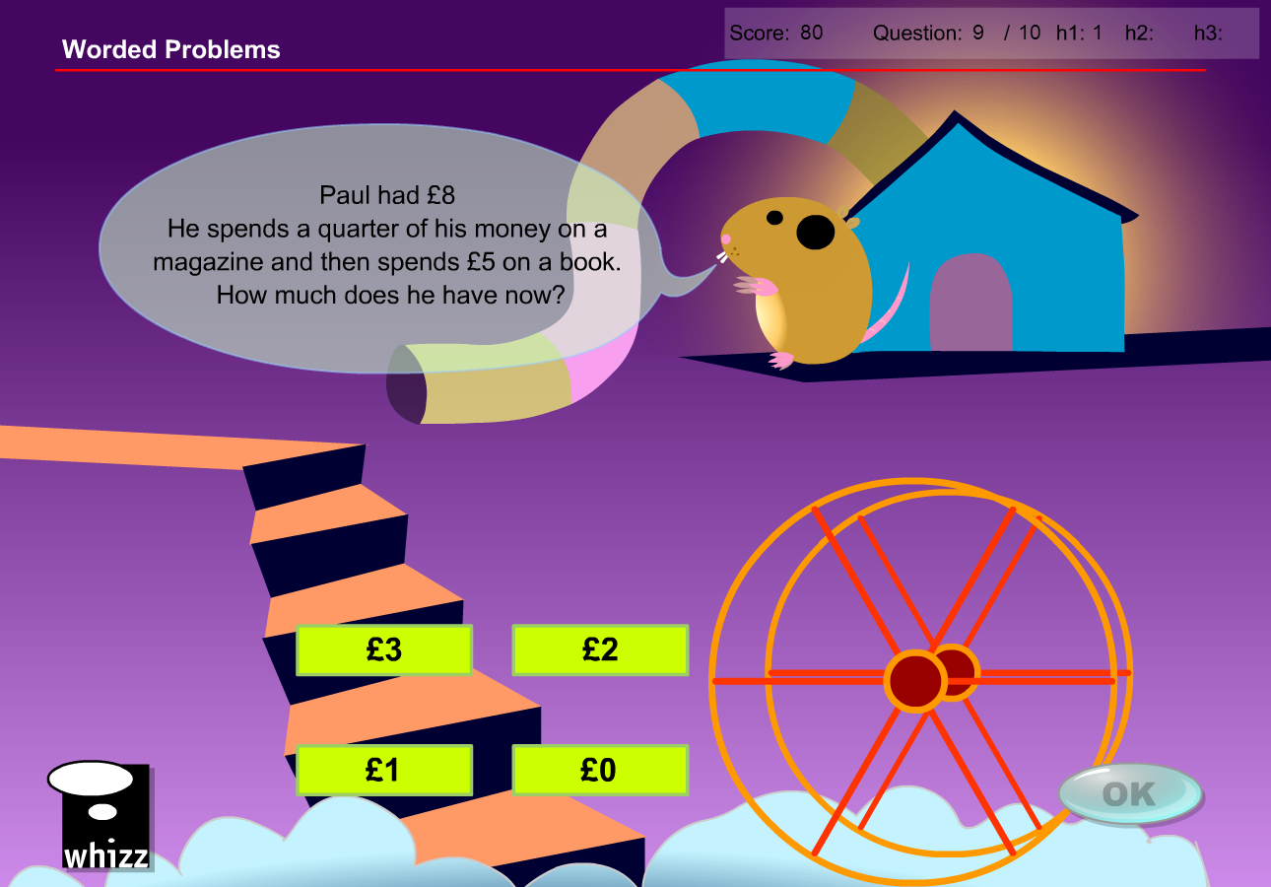

Question 10

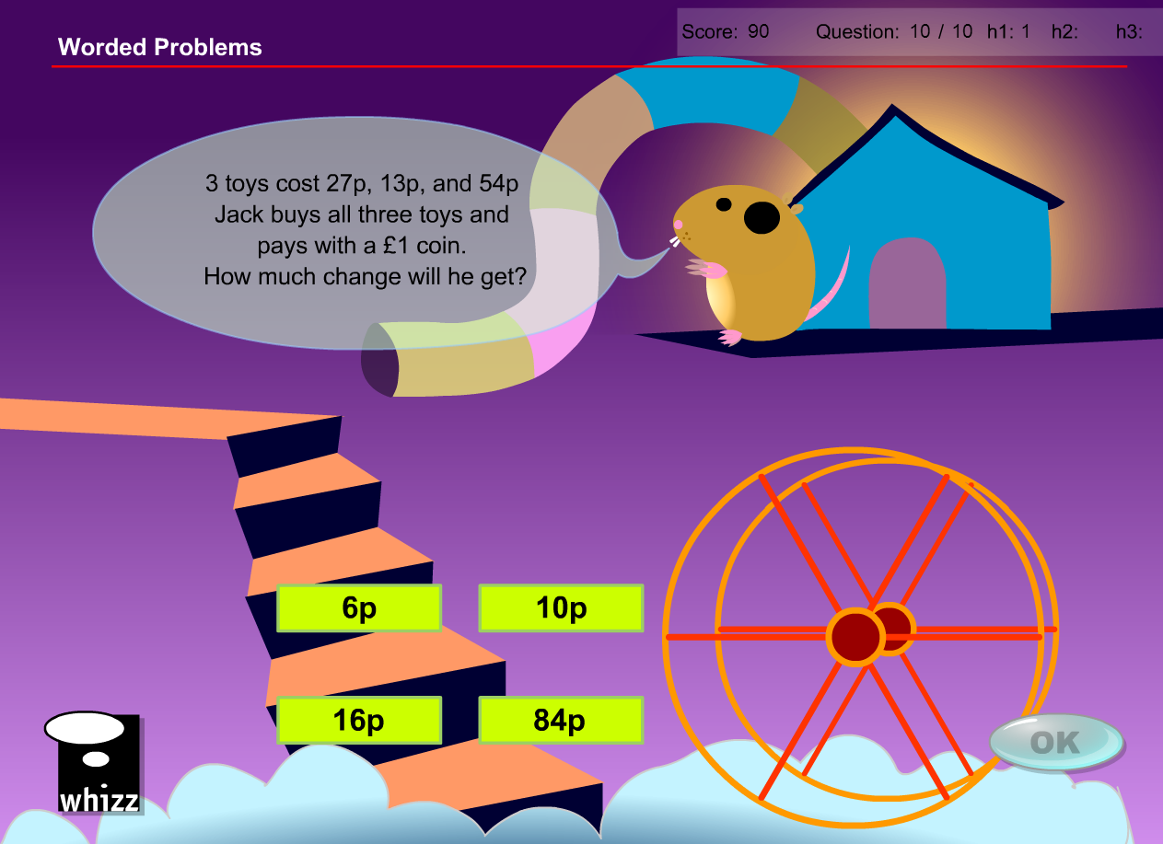

* Replace ‘£’ with ‘$’
* Replace ‘27p’ with $2.70’
* Replace ‘13p’ with ‘$1.30’
* Replace ‘54p’ with ‘$5.40
* Replace ‘£1 coin’ with ‘a $10 note’
* Change answer options increasing all by a factor of 10 and changing ‘p’ into ‘c’
* First answer will still be the correct one

**Test questions – once again most can remain unchanged**

Question 1

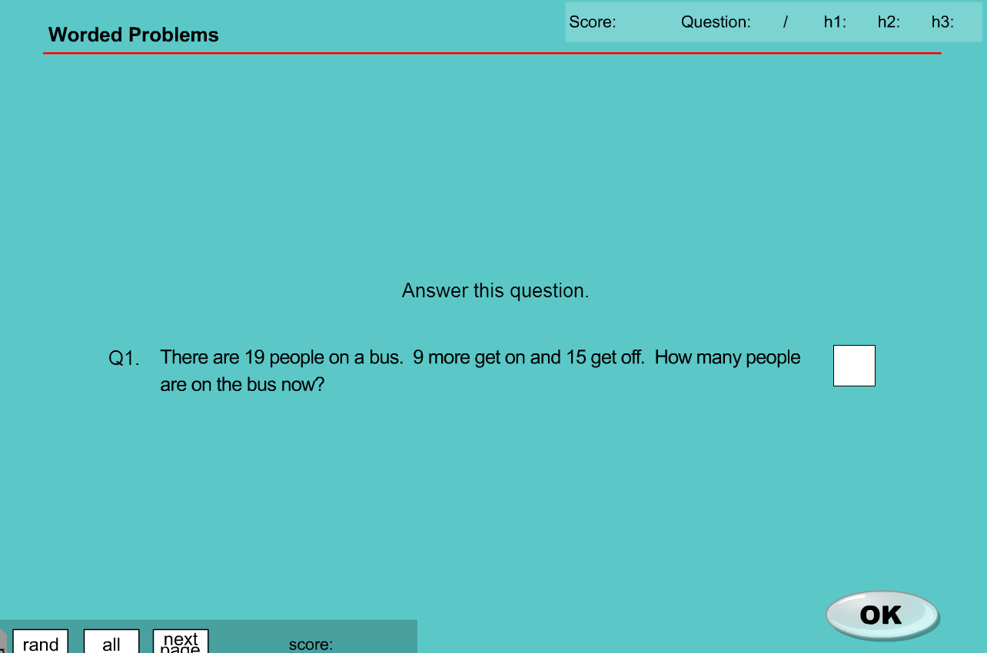

* No change required

Question 2

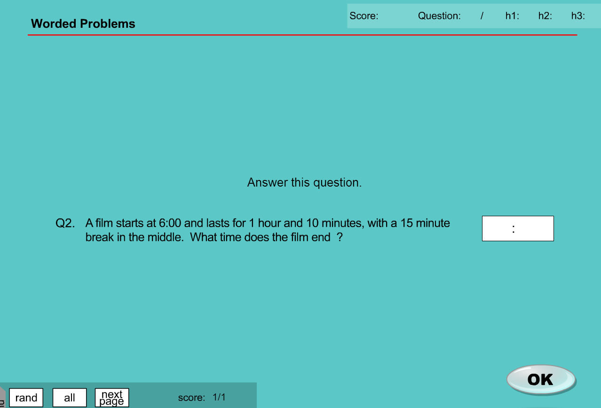

* No change required

Question 3

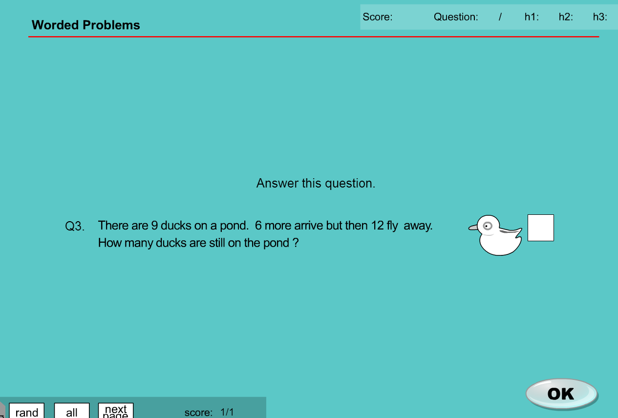

* No change required

Question 4

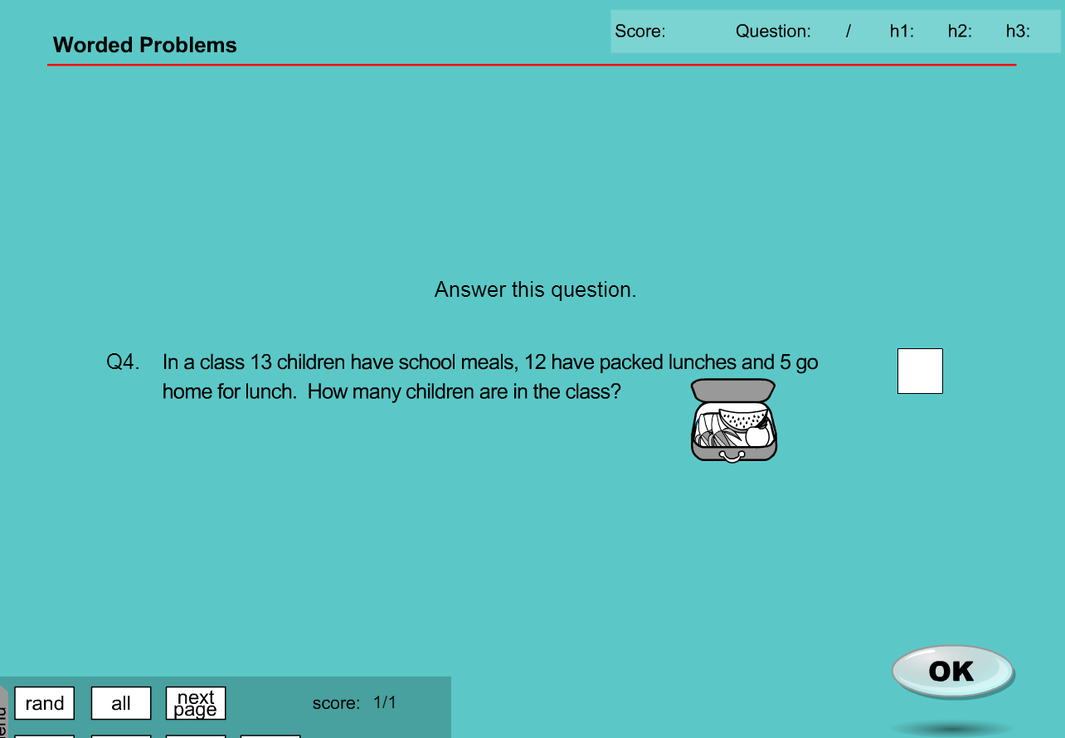

* No change required

Question 5

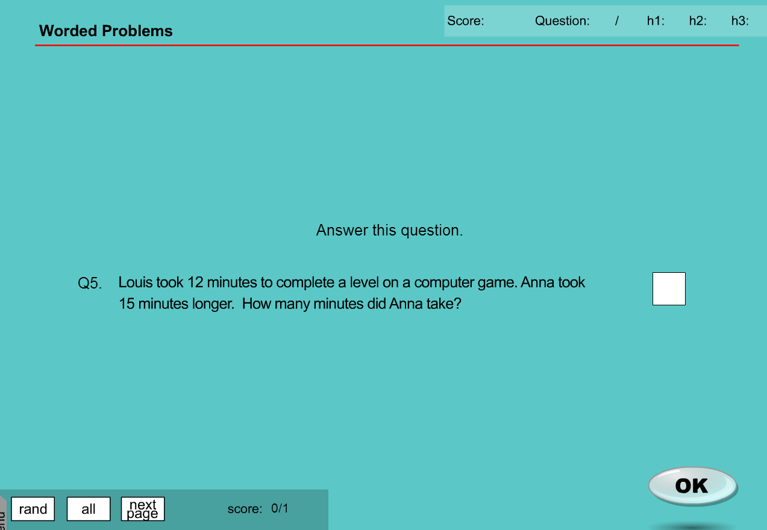

* No change required

It appears as though there are more than 5 questions in the test database

Extra Questions

Question 6

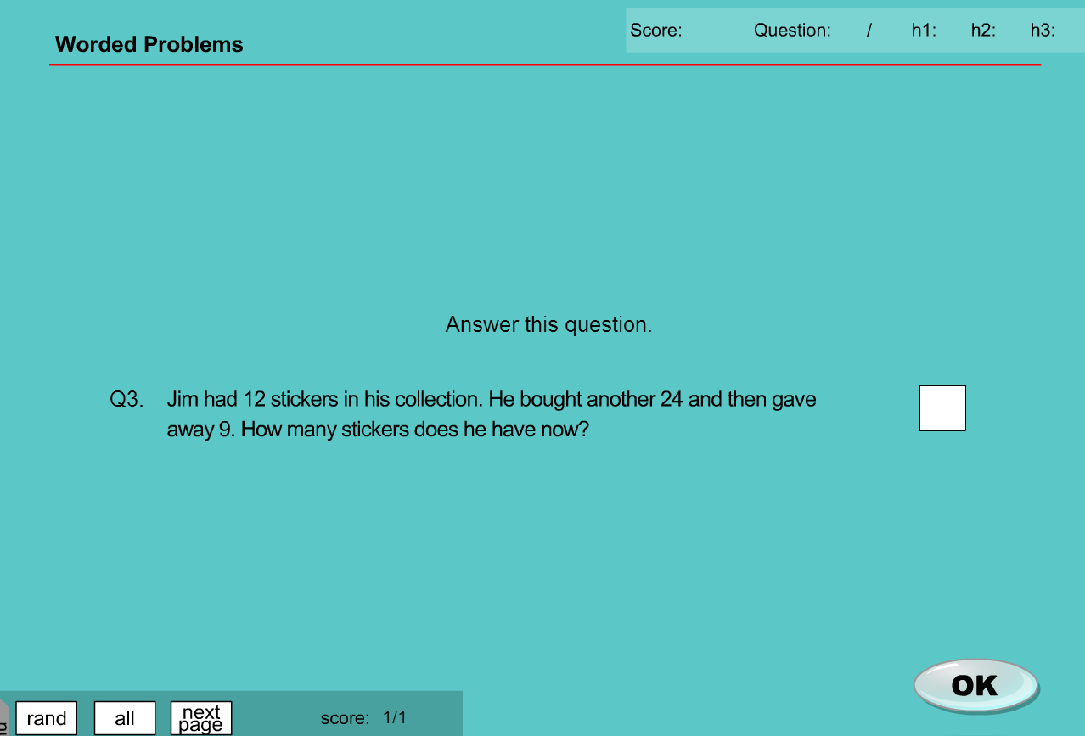

* No change required

Question 7

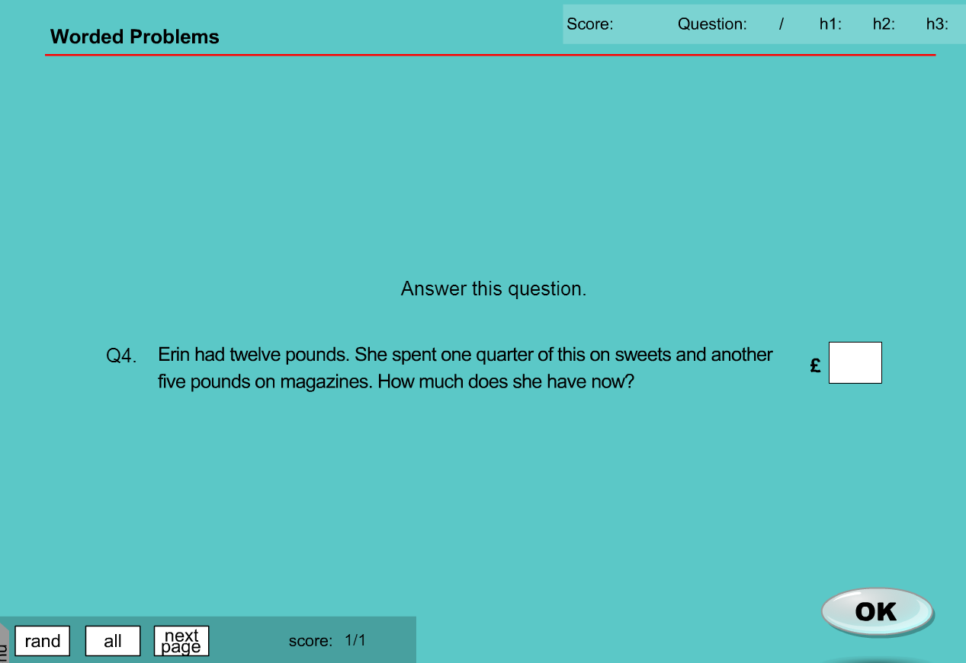

* Change ‘twelve pounds’ to ‘twelve dollars’
* Change symbol in answer from ‘£’ to ‘$’
* Answer will then remain unchanged

Question 8

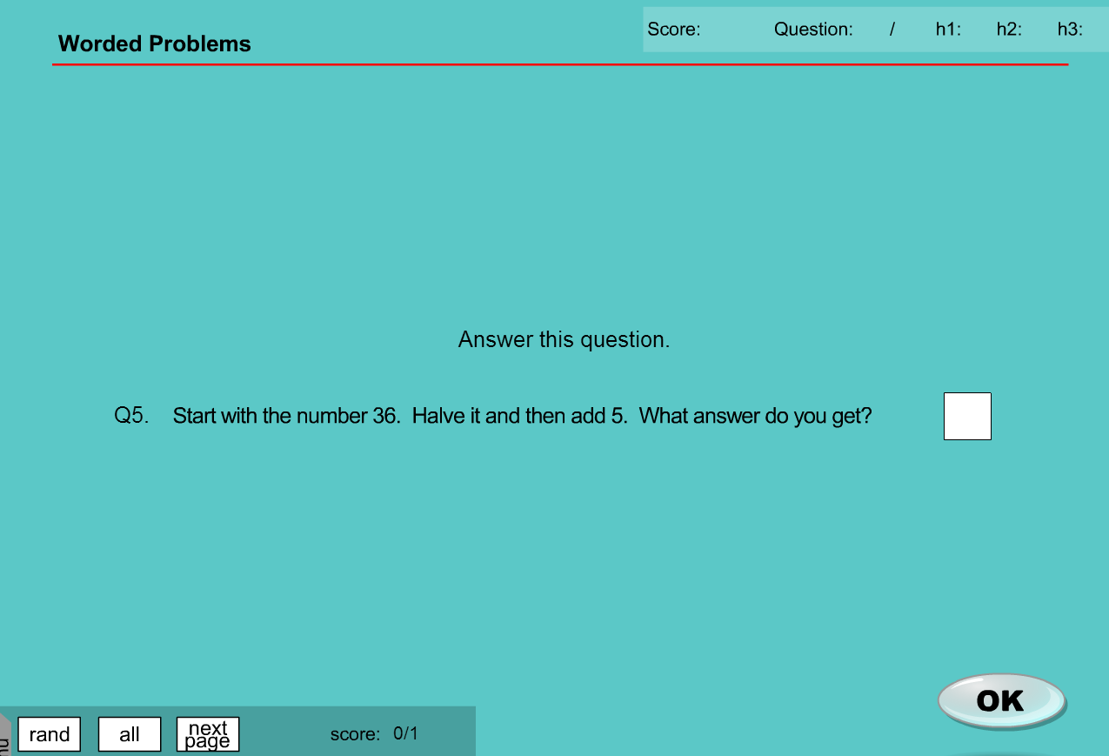

* No change required

MA_GBR_0875KAx0400

* This is recorded on one of my sheets as “not included in localisation” however all content appears to be NZ currency